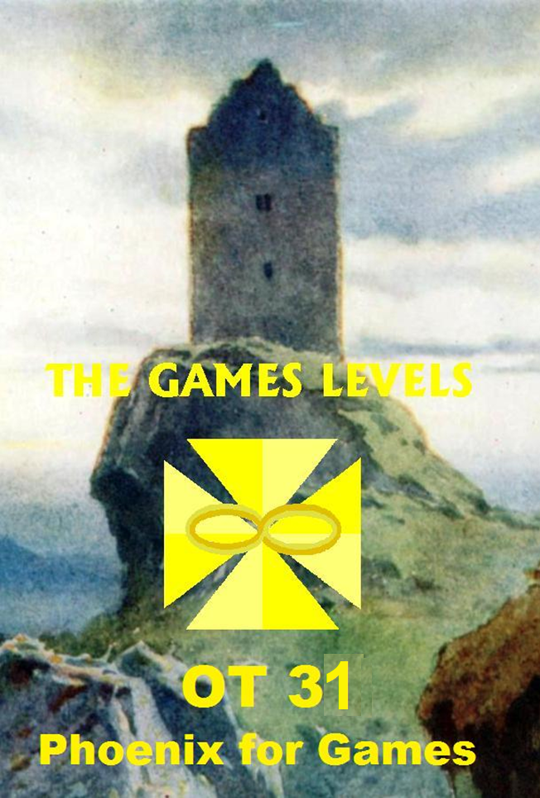
Conteúdo
ULR 20 "LOOPS & LOOP θns" VAST 3
ULR 21 LOOP C/S #1 5
ULR 22 LOOP C/S #2 7
Phoenix for games 9

ULR 20
"LOOPS & LOOP θns"
VAST
1 June 88

To apply viably our Source Training, we must know, what already has been applied and what the result was.
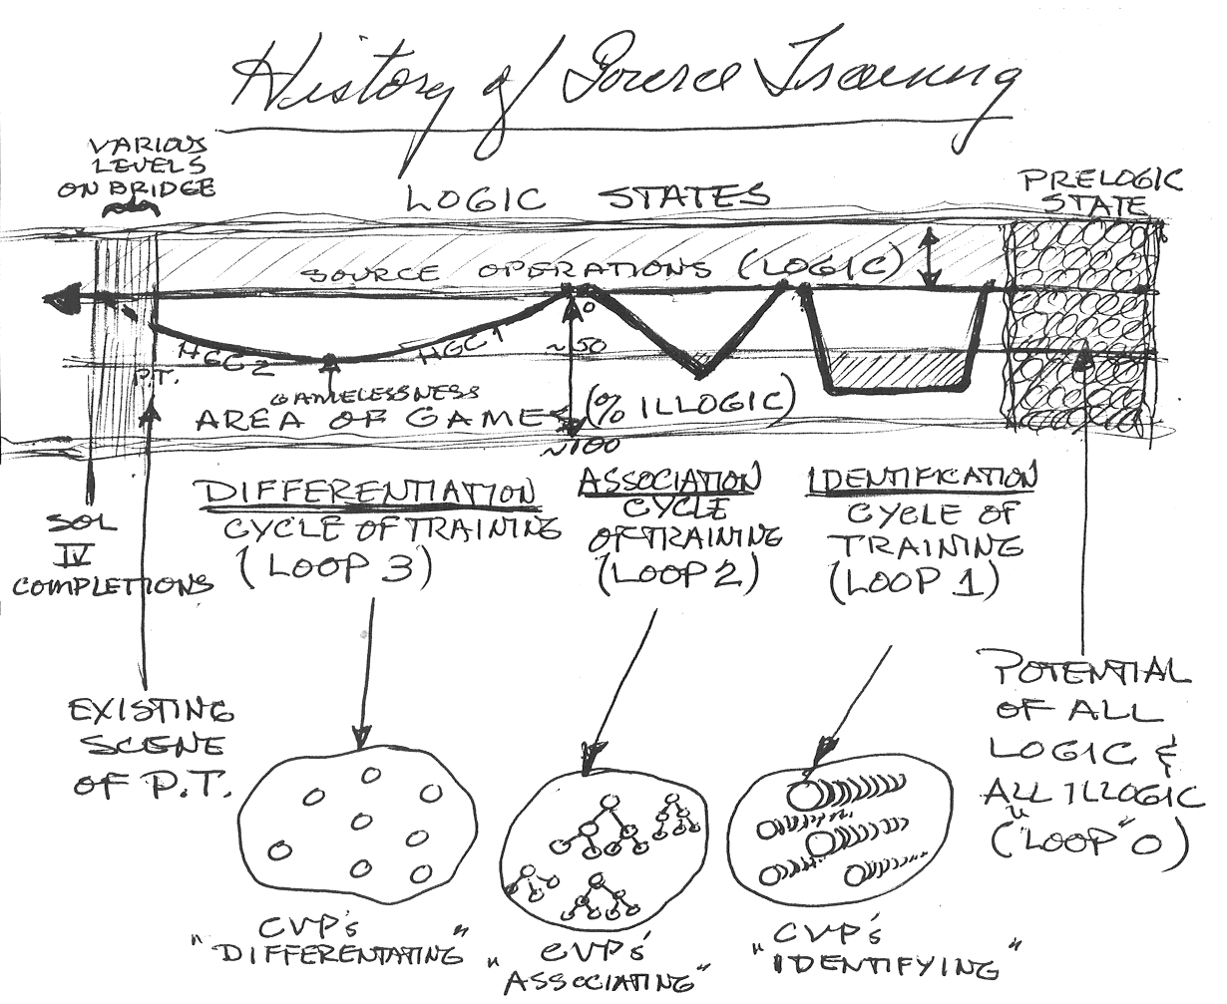(This is only showing players, MOCOs would add
complexity to any of these patterns)
——————————
The 1st application from a Prelogic State of Potentially ALL Logic & Illogic, (sort of a "Native State" of θ), was an IDENTIFICATION GAME CYCLE. From the diagram you can see it went down scale very quickly below even the Gamelessness level, stayed there for some duration and persistence, and then was technically and administratively handled back up to source. It had a non-optimum result. It reminds one of clusters of OTIII and "We are one" postulates and implants. It had 4 "Dynamics".
The 2nd Application from Source Operations Level (above Games) was an ASSOCIATION GAME CYCLE. It also went down spiral but on a gentler, less steep slope. Eventually it also dipped past the Gamelessness level and became "no fun". It was recovered back to SOL with appropriate Tech and Admin. It had 8 Dynamics, and reminds one of Excalibur Plugs and the linking of "families" of θns by CVP mutual creations.
The 3rd Application of Source Training (called Loop 3) is the one we are familiar with from the Bridge, and GSC; GBC levels with HGC's 1 & 2 in it and a bottom point of "Gamelessness". But it was picked up from there by HGC #2 with an ("improvement vector") addition of 4 more dynamics (9, 10, 11, 12) to help get it back to SOL. We are now completing that cycle in Ron's Orgs and by applying the results to all Dynamics. Those who are at this level (VAST) know that we now need 4 more dynamics (13 - Games, 14 - Source Ops (Absolutes), 15 - Logic, 16 - Application) to further optimize and improve the games - which are merely applications of logic to create illogic for its own analysis evaluation, handling, and review. (In other words, how can you have any application (doingness, fun) of total logic unless there is illogic. LRH said "All Games are aberrative (ie. illogical), some are fun" (the Player enjoys his application of logic to handle it.)
——————————
These "Loops" look like a square wave (½ of it), a traingular wave (½), and a sine wave (½). So you might say that we, as Sources, are "tuning up the Game Patterns toward optimum enjoyment".
We can also see that going down spiral to "Gamelessness" is too far into illogic for optimum enjoyment. Both havingness and exteriorization are "at the bottom" at that point.
It didn't help matters at all for Xenu and the Implanters to throw in the old Loop 1 & 2 type activities of identification and association to mess up logical players with clustering and Excalibur Plugs, but now this has been evaluated and handled on the Upper Bridge.
——————————
Now that you have the overall view of the applications, the next games, and the Powerful resolution of this "Loop 3" cycle, should be much easier - and more fun!
Note: The data for this issue was from OTs hitting into remmnants of the Loop 1 & 2 Cycles, the background research into Postulate θns & Sources in Pawn and a close examination of LRH's Pre-Logics, especially #3:
Q3: "The Identification of the Source of that which places matter and energy and originates space and time is not necessary to the resolution of this problem at this time".
Well, I figured that from VAST level, it was NECESSARY and that the TIME for it had come.
Note 2: As you study this issue, you may find "blow-offs" occurring from Loop 1 & 2 MOCOs you "forgot" to handle then.
Just give them the "MOC or free" and Rights of a θn.
Note 3: There will be Programs and C/Ses for Players who arrive at this point and still have incompletes in Loop 1 & 2 - or who have transported entire groups of ASSOCIATED or IDENTIFIED Players and their MOCOs from those Loops to Loop 3 - or who have been hit with similar groups made or transported by Xenu and the Implanter Org.
B. R.
Sr. C/S Ron's

ULR 21
LOOP C/S #1
31 May 88 updated 4 June 88

- Contact any suppressive type Player θn which may be giving the body somatics or a Roller-Coaster feeling by TR0 or "Attention θn?" If you get an idea of yours about what or how the "Loop θns" are suppressing, write it down as a sort of "Stack Wording".
- "Hello!" Tone 40 to the first part of the org. (Or "Wake up!")
- For each individual:
- "What DATUM are you being?" (Do this until you get the LFBD answer or no more answers)
(Datum = anything not pure Source)
- Run V/I on the LFBD or last answer datum.
- "What is the value of (datum)?"
- "Tell me about it".
- "What is the importance of (datum)?"
- "Tell me about it".
If it is his, it will go to F/N VGIs. If not, it will go down tone, so do a Tone 40 Indication of: "That is a wrong item for you!" or "That is not your item!" to F/N VGIs.
- "What policy are you following?" (Repetitive to either F/N or no more answers.)
- Run: V/I on the last answer "policy" the Loop θn is being. (Same as in B)
- Now, the Player θn (Loop θn) will either want to blow and become a player again - or he is being HELD. If he can't blow on "Who?" and "Rights of a θn," then ask: "Who is constantly suppressing you?" or "Who is holding you?" or "Who is commanding that you stay there forever?" or "What senior datum is commanding or holding you?" (One of these will work best for a particular OT or preOT.)
- R-factor: (Given to Loop θn just handled when he gives the datum or θn that is holding him.): "Thank you. I will handle him so you can have your Rights of a θ back". Then trace the line up to the next Loop θn (Player θn) being the "Senior Datum." Do steps 2 - 4 on him.
- When done to the top of the "org board" - come back down and make sure all went free and have their Rights of a θn back. Use any B/CB needed. Check for a lower influence on the Body Org by asking the Body MOCOs: "Have you been commanded to be a datum?" "What was it?" "Tell me about it." (Debrief them) + (Give "MOC or Free") and (Rights of a θn)
Note: Be sure to include the Space MOCOs in the Body Org because that is the most likely place for a datum to be kept which remains hidden and can influence all the other MOCOs.
- Do one "org" piece per session. Free it top to bottom after working up from the first Datum. These are usually only small "orgs". (A datum θn from Loop 2 and a policy θn from Loop 1 could be all there is for one "org". Plus the influence on the body, or course.)
- This C/S is a Review C/S and only auditors who have shown good results on others should be allowed to try it SOLO. These are PLAYERS you are auditing, and they don't even have Loop 3 Cases, so can be very powerful. On a Roller-Coaster OT with Somatics, they can produce heavy somatics during the session. So, closely supervise and if in the least doubt about the Solo Auditor's skill, do it as a Review Session, or Series of Sessions. (Reason: The Somatics can break the TR's and cause a Q & A and failure to finish the cycle. The resulting somatics could never be diagnosed or handled by a "doctor". The only way to do it is to finish the C/S.)
Note: Realize, that if the V/I Process does go to F/N on these Suppressive datums and policy, the Player θn (Loop θn) you are dealing with is an SP or was hatted to be one. If it is Wrong Item for him, he may be just a PTS. (Usually, the "holder" is an SP, or copy of one, from Loop 1.)
Note: This process may produce some amazing body changes and resolve chronic or recurring somatics and provide new perceptions for the OT or pre OT. Run this C/S #1 until there is no more Roller-Coastering and the OT is Stable. The questions "Suppressive Datum?" and "Suppressive Policy?" will F/N to check the EP. And the OT or pre OT will be CERTAIN about his stability. Now he can improve and keep his gains.
B. R.
Sr. C/S Ron's

ULR 22
LOOP C/S #2
4 June 1988

The C/S given in the previous issue handles the "anti-pan determined" datums and policies from Loop 1 and 2. It is similar to Excalibur in that it is other-determined, but on a pan-determined upper harmonic. These "data plugs" are usually only 3 parts: The datum contacted, the "policy holder", and an influence from them in the body on the body MOCOs. (which is giving the somatics)
——————————
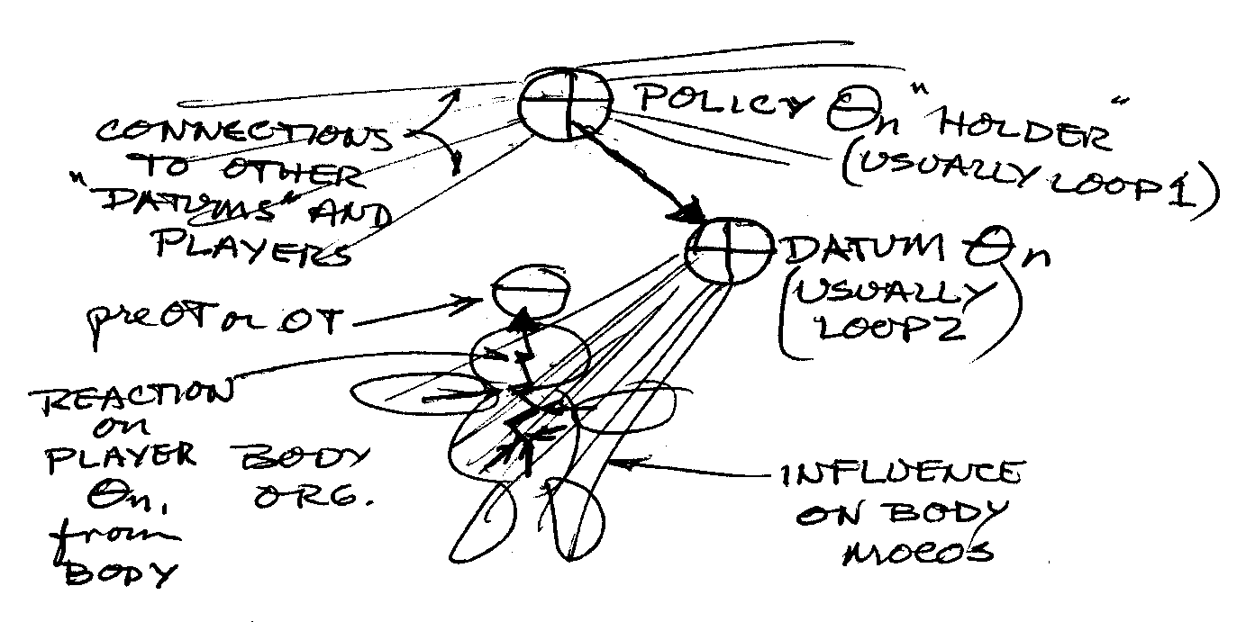
The "Source θn being a Datum" is Associated (linked or held) and usually is from a "left-over" group in Loop 2.
The "Source θn being a Policy" is usually Identification oriented equivalent to Loop1. He may even be a copy of a Player θn in Loop 3, i.e. an SP or Evil Intentioned person in the OT's track history or in P.T. or a betrayed "good guy".
——————————
When all these "Excal type" "Other-pan determined" Loop θns are freed, the next step is to handle any the OT put there or left there himself.

Loop C/S #2
- "What connected DATUM have I created?" (Find it)
- V/I on the Datum.
- B/CB to free it.
- Then "What connected policy have I created?" (Find it)
- V/I on the Policy
- B/CB to free it.
- Then do 1-6 on "disconnected".
- Then do 1-6 on "unconnected".
(Each of CDU 1-6 run to F/N on Questions #1 and #4.)
This is similar to the Phoenix Level on a Pan Determined higher harmonic as it is done by the Player θn himself. Note that he did not create the Source θn being the datum or Policy, but got that Thetan to become the datum or policy he created in Loops 1 &2.
After this series of processes, or after one cycle of #1-6, if needed, the datums and policies found can be indicated as "wrong items" to the Body Org if somatics are present.
Note: When running V/I on a datum or policy, if it goes to F/N VGIs, it is THE PLAYERS OWN CREATED datum or policy. But if it goes down tone or to an ARC Break F/N on V/I process, then he got it from another Player. When this happens or as soon as it is noticed the indicators are becoming "BIs" instead of "GIs", the policy or datum MUST BE INDICATED AS A "WRONG ITEM" or "NOT YOURS" or both. The F/N VGIs will then appear.
——————————
The theory is that the V/I process "TESTS" items. If its run on a player's own item he will be GIs (happy) as he is returning to a state of improved logic exactly as he descended on his own spiral.
If, however, he got the datum from another, it does not compute to him but throws attention over to another's universe and drives him out of session and into an ARC Break from "no auditing on himself". The "wrong item" indication breaks the connection, or "distraction", and returns him to session and the cog that he had misownership on the datum or policy. This gives him new knowledge and a clean space and F/N VGIs on the subject.
——————————
Note: This C/S may also be run on "another" and "others" if needed.
B. R.
Sr. C/S Ron's

Phoenix for games

The games thetans responsible for the playing field, the data loop thetans and the policy loop thetans what should be on the org board in the appropriate position as the head of div. 1 and 2 and 6, the GM holding the div. 3, 4 and 5.
Going into the phoenix you are looking for all kinds of games, types of games, that don’t run as they really should, which are jammed or have been given up or which have been destroyed through interference, or which are done and haven’t been dismantled or cleaned out.
It is a little bit as if you were in a room stuffed with furniture which should be thrown on the garbage and you want to put there new furniture but you don’t do it because there’s no space.
On the other hand one wouldn’t throw out the old furniture because one thinks that they are still needed.
This is a little bit like the MOCOs on the Phoenix 9, 10, 11, it’s like bits and pieces of games which can be seen in the context of bigger games.
The common denominator is been represented by the wording.
The Handling
- Attention and Intention List concerning games
- Find a wording
- 10 rudiments, Blow/Can’t Blow
- In the B/CBs you find the game, you look it from all sides and find the data with the help of which this game is being run. This data are loop thetans which have been created by the source with the only purpose to be a datum. These data loop thetans are under one or more policy loop thetans.
- So then you do the wording of the policy loop thetans, blow the data and the policy loop thetans by V/I. Then you blow the space MOCOs of the playing field to inform all possible involved player thetans about the end of the game and give them the MOCO command and all the rights of a thetan.
- Then you blow the game thetan and get back your theta and for all the rest you do the standard B/CB steps to the EP.
- It seams that here are only a few games on each item that come up maybe only one. It seams that one does not need connected, disconnected unconnected on this level.

