HUBBARD COMMUNICATIONS OFFICE
Saint Hill Manor, East Grinstead, Sussex
HCO BULLETIN OF 7 SEPTEMBER 1974
(Adapted from LRH ED 178 INT of 30 May 1972)

Remimeo
All Staff
All Auditors
All Students
All Scientologists

Word Clearing Series 54

SUPER LITERACY AND THE CLEARED WORD

SUPER—Superiority in size, quality, number or degree.
LITERACY—The ability to read and write.
Almost everyone these days is able to read and write. This was not true a century ago but, with modern stress on education, it is true today.
But is this enough today?
It is an instruction book world. The civilization in which we live is highly technical.
Education today goes into the twenties.
That’s a third of one’s life.
And what happens when one leaves school?
Can he do what he studied?
Does he have all his education or did it get left behind?
Literacy is not enough.
Today’s schools and today’s world require a new ability-the ability to look at a page without any strain and absorb what it says and then apply it right now without any stress at all.
And is that possible?
Am I talking about speed reading?
No. That is just being able to read rapidly. It does not improve the comfort of reading and it does not improve the ability to apply.
What is really needed is the ability to COMFORTABLY and QUICKLY take data from a page and be able at once to APPLY it.
Anyone who could do that would be SUPER-LITERATE.
What happens?
The average person-literate—is able to read words and mentally record words.
Like this:
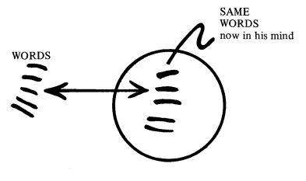
When he writes he writes:
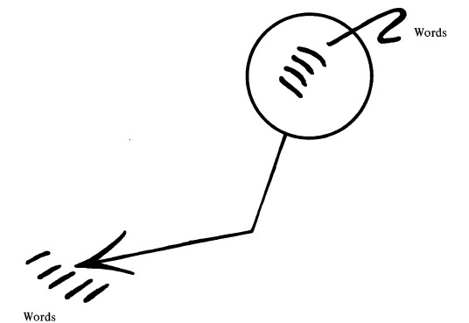
In his mind words are “understood” as other words like this:


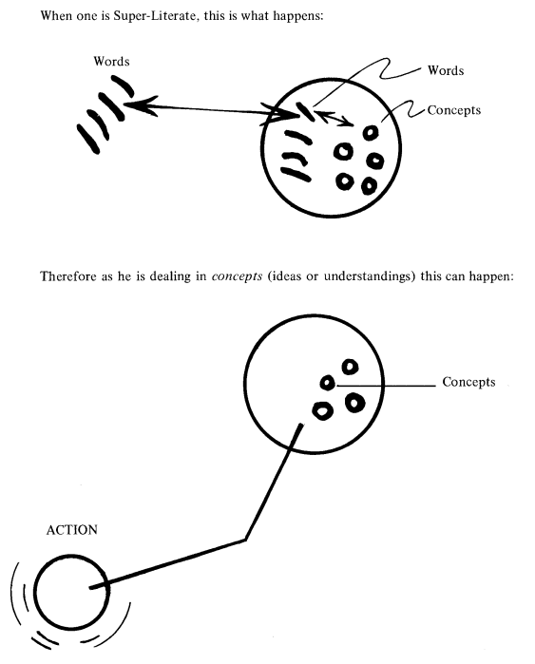
And he thinks in concepts to which he can fit words easily and so can write clearly.
In other words, when one is Super-Literate, one reads not words but understandings. And so one can act.

CONCEPTS
The idea of grasping word meanings conceptually is something new to the field of Linguistics. The endless Semantic circles pursued by Korzybski and company (see Data Series 1, “The Anatomy of Thought”) never really led to the realization that a word and its meanings are embodied in the basic concept or idea symbolized by that word.
That conceptualization of meanings is foreign to dictionary writers and “experts” is evidenced by the fact that definitions are so subject to alter-is and change with the passage of time.

For example, modern definitions of the word “understand” are found to be largely inadequate. A really full and meaningful definition of it could only be found in a First Edition of Webster’s Dictionary of Synonyms, 1942:
“Understand. To have a clear and true idea or conception, or full and exact knowledge, of something. In general it may be said that understand refers to the result of a mental process or processes (a clear and exact idea or notion, or full knowledge).
Understand implies the power to receive and register a clear and true impression.”

CLEARED WORDS
Operating within a society steeped in misunderstood words and mis-definitions, Study Tech is subject to arbitraries. Thus, a CLEARED WORD is defined as follows:
A WORD WHICH HAS BEEN CLEARED TO THE POINT OF FULL CONCEPTUAL UNDERSTANDING.
In Metered Word Clearing this translates as:
F/N, VGIs.
There are many ways and combinations to achieve this EP. Using the word in sentences until the meaning is grasped conceptually is the most common. Diagrams, demos, clay, in fact the entire body of Study Tech and its methods are applicable.
These are vital tools. For use. Protect them and KEEP SCIENTOLOGY WORKING.

L. RON HUBBARD
Founder
LRH:nt.rs.rd
Copyright © 1972, 1974
by L. Ron Hubbard
ALL RIGHTS RESERVED

