

The Book
INTRODUCING
the E-METER
Photographed and compiled
from the lectures and demonstrations
by
L. RON HUBBARD
CLEARING SERIES VOLUME IV
THE AMERICAN SAINT HILL ORGANIZATION
TO THE READER:
Scientology is a religious philosophy with spiritual guidance procedures enabling an individual to attain Total Spiritual Freedom. The mission of Scientology is a simple one - it is to help the individual become aware of himself as an immortal being and to help him achieve and attain the basic truths with regard to himself, his relationship to others, his relationship to the physical universe and to the Supreme Being.
The spiritual counseling procedure used by the Church of Scientology is referred to as auditing or processing. Auditing is a spiritual exercise through which the Thetan (soul) aided by a Minister of the Church seeks total spiritual awareness. Auditing addresses the Thetan and aids him to relieve those encumbrances of a spiritual nature which inhibit the Thetan's native awareness and abilites.
Scientology addresses only the spirit, it is not medicine and does not replace competent medical treatment. If you are physically ill you will be sent to a competent medical practitioner prior to receiving counseling from a Minister of the Church of Scientology.
The Road to toal freedom has indeed come to pass... and is yours for the asking.
BOARD OF DIRECTORS
CHURCH OF SCIENTOLOGY
Published by
The American St. Hill Organization
(A branch of the Church of Scientology of
California, a non-profit corporation in
the U.S.A. Registered in England)
2723 West Temple Street
Los Angeles, California 90026
Copyright(c) 1966,1968 by L. Ron Hubbard
ALL RIGHTS RESERVED
Third Edition
THE E-METER IS NOT INTENDED OR EFFECTIVE FOR THE DIAGNOSIS, TREATMENT OR PREVENTION OF ANY DISEASE
Printed in the United States of America
by Anderson, Ritchie & Simon, Los Angeles

IMPORTANT NOTE
In studying Scientology be very, very certain you never go past a word you do not fully understand.
The only reason a person gives up a study or becomes confused or unable to learn is that he or she has gone past a word or phrase that was not understood.
If the material becomes confusing or you can't seem to grasp it, there will be a word just earlier that you have not understood. Don't go any further, but go back to BEFORE you got into trouble, find the misunderstood word and get it defined.
HOW THE E-METER WORKS
1.  This is a Hubbard Electrometer called an E-Meter for short. Technically it is a specially developed "Wheatstone Bridge" well known to electrically minded people as a device to measure the amount of resistance to a flow of electricity. | 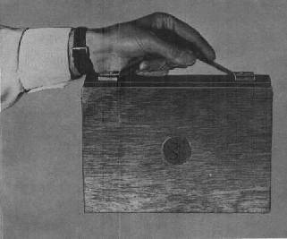

2.  Some materials conduct electricity more easily than others. Wire used in electrical systems is a good conductor. | 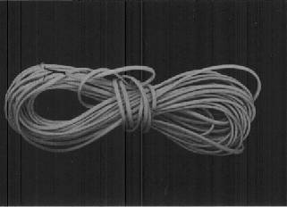

3.  The human body is not such a good conductor and the E-Meter has been specially designed by L. Ron Hubbard to measure the large and minute changes, be they slow or rapid, in the electrical resistance of a human body.  Electrical resistance is measured in ohms.  The resistance of a dead female body is 5,000 ohms and of a dead male body, 12,500 ohms. | 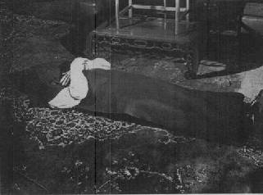

4.  When. however, the resistance of a live body is measured it can be as low as 500 ohms or as high as 1,000,000 ohms. These figures are mentioned as a matter of interest and to show the wide divergence of the electrical resistance of a body when it is inhabited. | 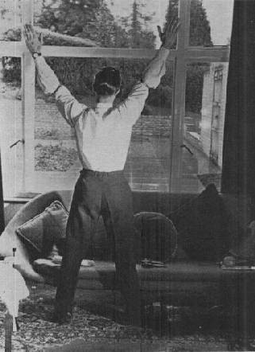

5.  Tests conclusively show that an individual's emotional state, his thoughts, etc., instantly raise or lower the electrical resistance of the body. Thus the meter is an extremely valuable tool in the hands of a trained auditor. The various manifestations and their significances are fully covered in "E-Meter Essentials" by L. Ron hubbard. We in Scientology have come to accept the fact that the E-Meter "talks" to us. | 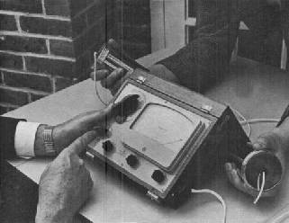

6.
We rarely give much thought to the hours and hours of work and research put in by L. Ron Hubbard, resulting in the perfect instrument - the Mark V - and an exact exposition of what the various reading and changes mean.
Here we see Ron checking a new Mark V against the prototype (on the left). This prototype is kept by Ron in a safe and is used by him from time to time to make sure that the standard of manufacture is maintained. It was made to his exact specifications and assembled in a Mark IV case.
Self Portrait | 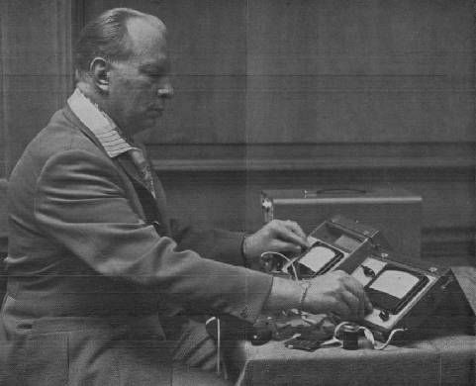

9.  The inner workings are intricate and made to Ron's exact specification. The technically minded will see that it has a "printed" circuit (thus avoiding mis-duplication) and is fully transistorised (no delicate valves or tubes). It is robust but as with all precision instruments should be handled with respect and care. Note: Only half a volt is passed through the body. This is negligible. | 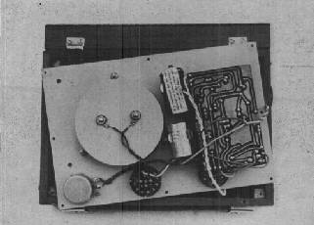

SETTING UP THE E-METER
10.  To familiarise yourself with the mechanical functions first open the lid and detach it. | 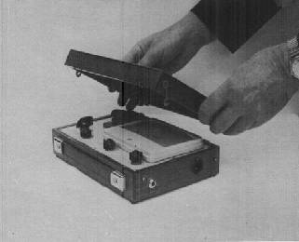

11.  Turn the lid around and connect the hinge pieces together. | 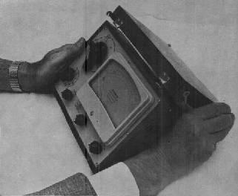

12  Then fasten the hooks on to the studs. | 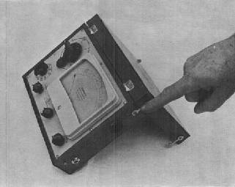

13.  Turn the "Set-Transit-Test" knob to "Test" and the "on-off" switch to 1. The needle should go hard over to the right. | 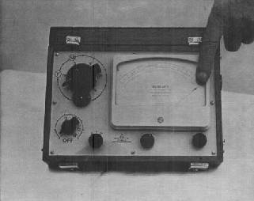

14.  If the needle does not go right over then the battery requires recharging, so to do this you need the "charging lead" supplied with every meter. | 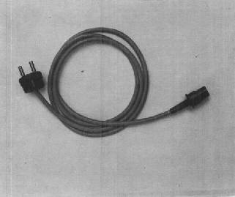

15  Connect the charging lead to the meter and then to A.C. (Alternating Current) mains. This is the usual domestic supply. Leave the "Set-Transit-Test" knob at "Test" and the "on-off" switch at 1. If the voltage of your mains supply is 220/240 volts the meter should be left connected to the mains for 14 hours. If it is 110 volts A.C. the meter should be left for 28 hours. In both cases the battery will be fully charged and will give about 40 hours of use. Do not connect to a D.C. (Direct Current) supply. | 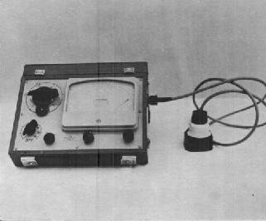

16  Subsequently it is advisable to keep a log of the time a meter is in use so that it can be re-charged in good time. If and when the battery is charged turn the "Set-Transit-Test" knob to "Set". The meter is now operable. | 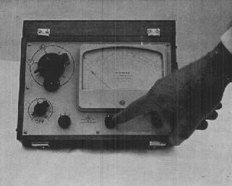

17.  Turn the "Tone Arm" until it points to 2 (F). this is the position of the 5,000 ohms previously referred to. (3 (M) is the 12,5000 ohms position). Now turn the sensitivity knob - it is also the "on-off" switch - to the maximum marked on the dial (16 or 32). The meter shown here is one of the earlier models on which the sensitivity dial is graduated from 1 to 16. (Later models have a dial graduated from 1 to 32.) | 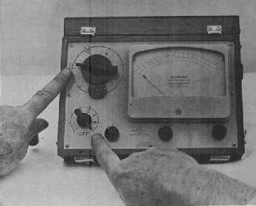

18.  Now turn the "trim" knob - clockwise the needle will go to the right, anti-clockwise to the left. Leave it when the needle is in the "set" position. The meter is now correctly adjusted for use. | 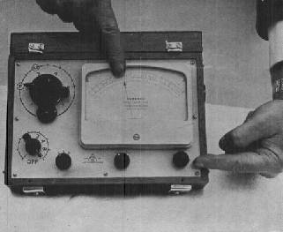

19.  Turn the sensitivity knob back to 1. The needle will only move a small amount, if at all. | 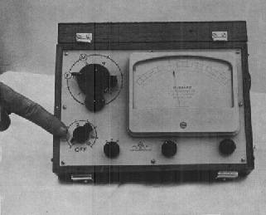

THE SENSITIVITY KNOB
20.  By moving the Tone Arm you will notice that the needle also moves. The Tone Arm, therefore, can control the position of the needle. If you move the Tone Arm clockwise the needle will go clockwise and vice versa. | 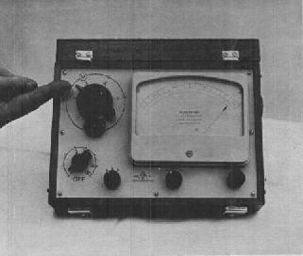

21.  Move the Tone Arm to 1.5 so that the needle is to the extreme left of the dial. Do not move the Tone Arm more than is necessary to bring the needle over to the left. | 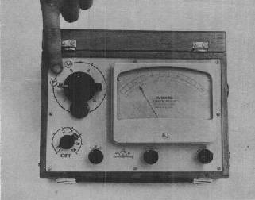

22.  Now move the Tone Arm in a clockwise direction until the needle is just in the "test" part of the dial. Note the Tone Arm is now at 2.5. | 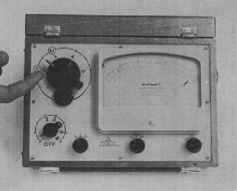

23.  Move the Tone Arm back to 1.5. Put the Sensitivity knob to No. 4 or 8 on a meter that is numbered to 32. | 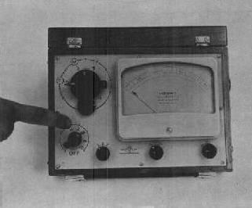

24.  Next move the Tone Arm clockwise until the needle is in the "test" portion of the dial (do not move the Tone Arm more than is necessary). Note the Tone Arm has only had to be moved to about 2.0.  So you see that the needle is more sensitive to the Tone Arm as the sensitivity knob is moved up to a higher number. Try this for yourself by turning the sensitivity knob to a higher number and then notice how much less you need to move the Tone Arm in order to move the needle across the dial. | 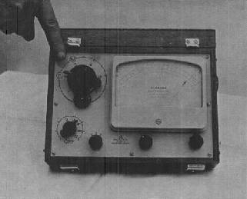

25.  Therefore increasing the sensitivity by putting the sensitivity knob to a higher number magnifies the movement of the needle.  It is important that you understand that the Tone Arm Motion is constant. It is the needle action which is magnified or decreased by the adjustment of the sensitivity knob.  The meter can be made even more sensitive by turning the "Sensitivity Booster" to 32, which will double the sensitivity, or to 64 which quadruples the sensitivity (64 or 128 in later models). | 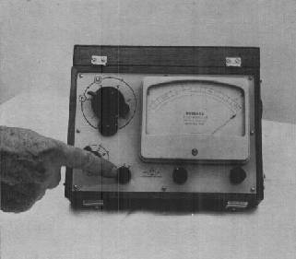

THE NEEDLE

26.  Now turn the Tone Arm to 2.0 and the sensitivity to 1, and the needle will be at "set" again. Take the plug connected to the cans and plug it in to the electrode socket. Place the cans upright on the table so they do not touch each other and you will notice that the needle will go right over to the left. Moving the Tone Arm will not have an effect on the needle. This is because there is almost total resistance to the electric current; the table and the air are very poor conductors of electricity. | 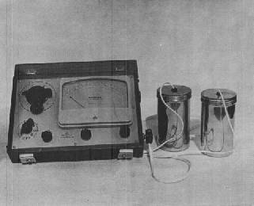

27.  If you touch the cans together the needle will go hard over to the right because there's practically no resistance, the cans and the wire being very good conductors. Do not leave the cans touching for more than a few seconds, otherwise the meter might be damaged. | 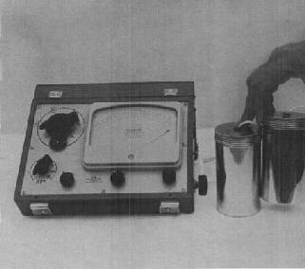

28.  Hold the cans in your hands and get someone to adjust the Tone Arm until the needle is at "set". Note the position of the Tone Arm. Ordinarily "tin" cans with the paper label stripped off are preferred. Although they are less attractive, they give a more accurate response. | 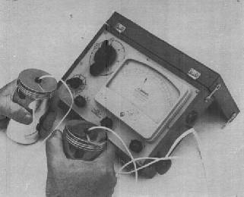

29.  Ask someone else to hold the cans and adjust the Tone Arm yourself so that the needle is again at "set". It is most unlikely that the Tone Arm will be at the exact position as when you hold the cans. If the cans are cold it is sometimes necessary to wait a while for the cans to "warm up" in the hands before the needle settles down. | 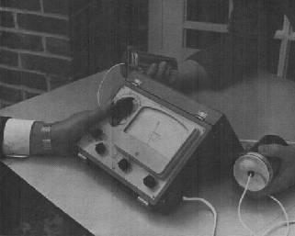

30.  Tell the person holding the cans to squeeze them and when this is done you will see that the needle will immediately go over to the right. When he/she returns to the original grip, the needle will return to the "set" position. | 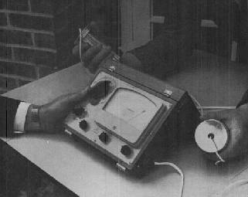

31.  Increase the sensitivity setting to 4 and have the cans squeezed again. You will notice that the needle goes further and more quickly to the right. If on the first squeeze the needle has gone right over, at the higher sensitivity it will hit the pin harder and bounce off maybe several times. This is another demonstration of the function of the sensitivity knob magnifying the movement of the needle. | 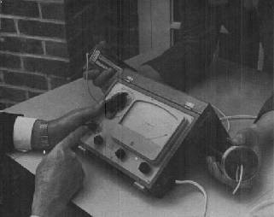

32.  When you have finished using the meter, switch off the "sensitivity knob" and put the "Set-Transit-Test" knob to "Transit". This prevents the batteries running down and protects the needle mechanism during transit. | 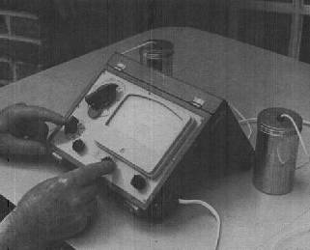

33.  At the bottom of the Tone Arm Dial a very useful device called the "Tone Arm Counter" may be fitted. If you move the Tone Arm about you will notice that the number in the "window" on the right will change periodically. It will increase by sevens until it reaches 98 when it will go to 0 and then continue increasing by seven. This number records the distance of downward movements traversed by the Tone Arm. It is recorded in numbers of divisions - from 4 to 3 would be one division. This information is very valuable and important to an auditor. Its use is fully described in "The Book of E-Meter Drills" compiled by Mary Sue Hubbard. | 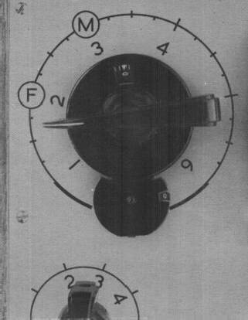

34.  You can test your meter's efficiency from time to time this way. Place the cans on the table so that they do not touch each other. Plug them into the meter. Set the Tone Arm to 6.5. Turn the "Set-Transit-Test" knob to "set". Turn the meter on. Set the sensitivity at 16. Turn "Trim" knob so as to bring needle to "set" position. It is important that the table upon which the meter is standing is firm and steady, so don't lean on or touch it during the test. A slight gentle drift is all right but if it is at all jerky you will know your meter needs attention. | 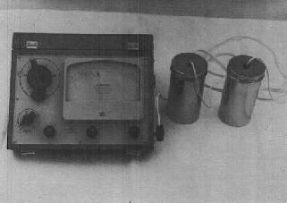

THE TONE ARM

35.  Much useful information can be gained from the position of the Tone Arm. For example, in passing the Class VI auditing requirement for classification at Level VI a check must be done on the E-Meter and the following qualification concerning the Tone Arm must be observed.  If the Tone Arm is at 4.0 - that is all right. | 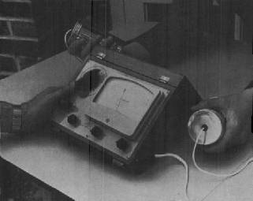

36.  If the Tone Arm is at 4.5 - that is barely passing. | 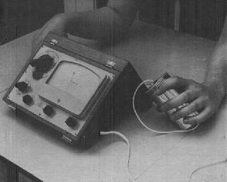

37.  Whilst if the Tone Arm is at 5.0 - that is absolutely not passing. | 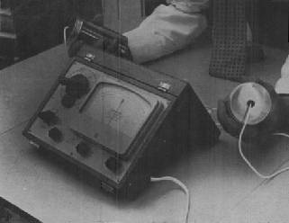

38.  The Tone Arm being anywhere between 4.0 and 2.0 is acceptable as passing. | 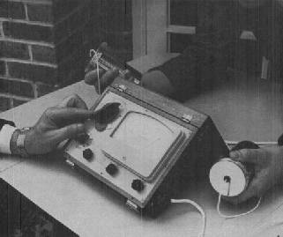

39.  But the Tone Arm below 2.0 is definitely not acceptable as passing. | 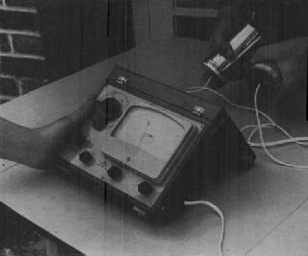

NEEDLE ACTIONS
40.  The successful auditor needs to know his meter very well and be aware of the various actions of the needle. There are ten main needle actions which occur upon a pre-clear being given an auditing question and an auditor should get familiar with these early in his training. First, there is the "Stuck" needle (illustrated in this picture). You ask the pc a question and the needle just stays stuck with no movement whatsoever. This should on no account be confused with a "Nul" needle which is the needle continuing to behave in an action uninfluenced by the auditing question. | 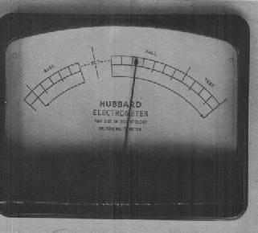

41.  A very important action is called the "Fall". It is a movement to your right as you face the meter. It can take place anywhere on the dial. It can be a short movement or a long movement even necessitating adjustment of the Tone Arm. The movement can be either fast or slow. | 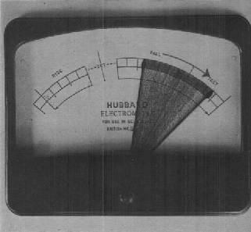

42.  The "Rise" is exactly the opposite to a "Fall" - the needle moves to your left instead of to the right. | 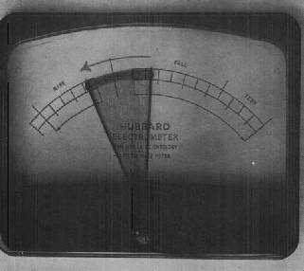

43.  The "Theta Bop" is a small or wide steady dance of the needle. Depending on the sensitivity setting it can be anything from one-eighth to half an inch wide. It is very rapid, perhaps five or ten times a second. | 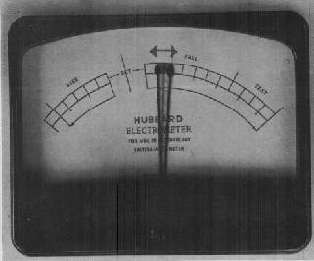

44.  The "Rock Slam" is very spectacular. It is a crazy, unequal, jerky motion of the needle, narrow as one inch or as wide as three inches happening several times a second. The needle goes crazy "slamming back and forth, narrowly, widely, over to the left, over to the right as if frantically trying to escape." The first time you see a real one the chances are you will think there is something wrong with your meter. | 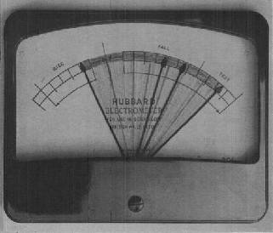

45.  A "stage Four" needle goes up about an inch or two (always the same distance) and sticks and then falls, goes up, sticks, falls, about once a second or so. It is very regular, always the same distance, always the same pattern, over and over, on and on, nothing you say or the preclear says changes it (except Body Reactions). | 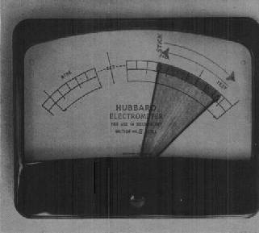

46.  The "Free" or "Floating" needle. The needle just floats over a wide area and anything the pc says or thinks has no influence on the very smooth movement. Further, you will have difficulty in controlling the needle with the Tone Arm just as you would have difficulty balancing a long stick on your fingertip.  It is an important characteristic which should be readily recognised as it indicates a satisfactory conclusion to an auditing activity. | 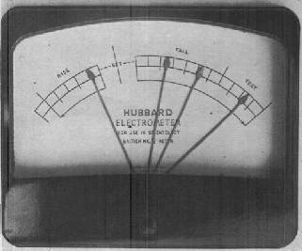

There are three reactions not pictured here - "Nul", Change of Characteristic", and "Body Reaction." These are fully described in "E-Meter Essentials" by L. Ron Hubbard.

47.  In the rare event of the meter behaving badly or ceasing to function - contact your local Hubbard Organization for instructions as to where to send it. Provided the damage is not due to carelessness or breakage the meter will be repaired free of charge for a reasonable period after purchase.  Pack it very carefully before sending. See that it is switched off and the "Set-Transit-Test" knob is in the "Transit" position. Use the original packing carton to send it in. | 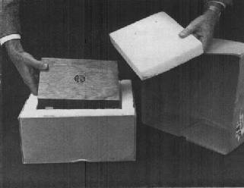

THE END

