B O A R D T E C H N I C A L B U L L E T I N
1 NOVEMBER 1972
Issued 28 March 1974
Remimeo CANCELS
Ex Dn C/S HCO BULLETIN OF 1 NOVEMBER 1972

Expanded Dianetics Series 19
(Series Number Amended)

EXPANDED DIANETIC CASE M

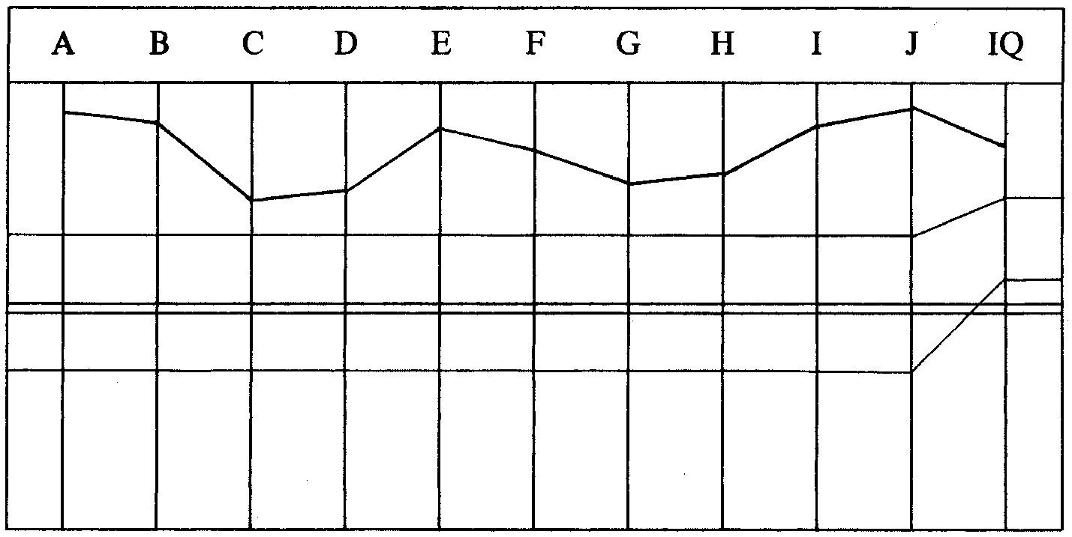

CASE NOTES—
This case OT VII, L-9S, L-10M, is recalled to Flag for auditing.
LRH TIP 3 APR 72 (TECHNICAL INDIVIDUAL PROGRAM)—
“Assignment: On bd for rapid briefing actions and to return as C/O.
Study: Primary RD.
*The Product Pgm and C/S in (______other pc’s) folder which I will C/S.
Promotion Clearing (org is engaged in expensive lists and promo very
poor for cost).
Auditing: As above.”
PROGRAM BY CL XII C/S 4.4.72—
Primary RD.
1. False TA List. C/S 53. WCCL.
2. Method One, Verify/Complete.
3. Product Pgm C/Sed by LRH per TIP.
________________________
*FOOTNOTE: This Product Pgm is an Experimental Pgm which in fact never was run on this
pc. It remains experimental and has not been released.
The above program is done as far as completing Method One which the pc attests. Later LRH sends a note to the Tech Sec.
LRH NOTE 22.4.72—
“Pc is to be run on Exp Dn after Study RD. (Also R3R on goals, etc from L10 will
make him sane.)”
EVAL BY EXP DN AUDITOR 23.4.72—
SITUATION
1. Has just had M 1 verified + C/S 53RRR and handled.
2. He is programmed for Exp Dn after Product RD Exp.
3. There is an outstanding order from you that he do Exp Dn after Study RD.
DATA
Not audited since 13.4.72 (10 days). Audited without FES.
Now lined up and waiting for Experimental Product RD (postulate level processing)
which should be handled after Exp Dn per Tape Exp Dn 1.
HANDLING
1. That his program be revised to the two programs I have written for the case.
2. That I do the Study RD assess and handle (any L&N would be done by Exp
Dn Team Lead Auditor) and the remaining program steps.
3. That steps 1 and 2 of the set-up be done while FES is being drawn up to
prevent delay as they are both necessary and as C/S 53RRR has just been
handled.
EXP DN SET-UP PGM BY EXP DN SPEC 23.4.72—
Has had M 1 verified and C/S 53RRR recently handled.
To prepare for Exp Dn:
1. Study Corr List assess and handle.
2. Clear all words L-3ExDn and R3R.
3. To ExpDn.
EXP DN PGM BY DN SPEC 23.4.72—
0. Find Hav—run before and after each session.
1. 2wc your PT Environment. Note all BD and F/N items. Get attitudes,
emotions R3R Triple.
2. Assess auditing buttons (VIII list C/S 6) attitudes, emotions R3R Triple.
3. LX3, 2, 1 + R3R Triple.
4. Items from L-10 R3R Triple.
5. OCA.
LRH COMMENT—
“OK.”
The auditor assesses the Study Corr List and on the question IQ. “Have you ever cheated on an exam?” the question gets an LF and on the assessment from that point the TA rises to 4.4. The auditor checked O/R and got a response so rehabbed an earlier study release.
AUDITOR’S COMMENT AND C/S—
Cleared Study Corr List and handled ARC Bk.
Ran into soaring TA on assessment, small reads.
Rehabbed the O/R and did Hav to F/N.
Now needs to have the Study Corr List assessed over in-ruds.
1. All ruds to F/N.
2. R-Factor on reassessing Study Corr List—reassess and handle.
3. Clear any words on R3R + L3ExDn.
LRH COMMENT AND C/S 26.4.72—
“Well done.
He hit a w/h and it made the TA soar (by list study).”
(LRH writes on the List against question IQ “Overt withhold caused TA to Soar.”)
“DON’T BEGIN A MAJOR ACTION WITHOUT GETTING FIRST AN F/N.
1. 2wc to F/N.
2. R-Factor on question IQ, there was a question ‘Have you ever cheated on an
exam?’ (Watch for read.) 2wc to F/N.
3. Fly all ruds. But if no F/N on 2 above assess a C/S 53RRR, and return to me.
4. R-Factor: We have to get an F/Ning List on study. Reassess whole list.
5. Handle.”
The next two sessions the auditor handles the Study Corr List.
AUDITOR’S COMMENT AND C/S 27.4.72—
Finished all handling of Study Corr List except 2 L&Ns (to be done by Lead
Auditor) and 2 hours TR 0 on “Gothic Books”. ( 11 B “Can’t you confront books
or printed pages?” What, TR 0 on it for 2 hours.)
Went fine.
1. Rud if no F/N.
2. Handle 8-J and 8-E (two L&Ns).
3. 2 hours TR 0 on “Gothic Books”.
4. Attest Study Corr List complete.
5. Clear all L-3ExDn words.
6. Exp Dn Pgm.

LRH COMMENT—
“Very well done.”
LRH had crossed out 4 above and written:
“Reassess SCL to F/Ning List.
Attest only if it F/Ns. If any reads, handle and reassess.”
The SCL is handled to F/N list and the pc attests. The words are cleared on R3R and the L- 3ExDn and the Exp Dn Pgm is started.
AUDITOR’S COMMENTS AND C/S 2.5.72—
Doing well. Two points:
1. Possible error was I did “Emotions” connected to one area, R3R to F/N list,
then took up next area to F/N list on Emotions without checking for any
remaining attitudes in first area.
2. He is somewhat out of session but is very willing to “supply” VGIs—
They’re there but feels like he is thinking about what to say to please auditor.
Very co-operative. It’s an unchanging characteristic. Probably just needs good
continued auditing where he is at. Example is when listing emotions
connected to (____wife’s name) he had to work on it.
So it will come out in the wash as long as we keep getting him where he lives
0. Fly each rud.
1. Check Hav for effect with can squeeze. Change if necessary.
2. Check for attitudes on first two areas handled (“People who don’t produce”
and “______” wife’s name). List and take to F/N list.
3. Handle all remaining PT Environment buttons—list + R3R to F/N list.
4. Assess C/S 6, attitudes, emotions R3R Triple.
5. Continue program.
LRH COMMENT AND C/S 3.5.72—
“D of P Int. What did Auditor do. How do you feel about your case.
To make up for your ‘no okay to L&N’ you are avoiding standard Exp Dn.
This guy has INTENTIONS. He also has OUT RUDS. He also isn’t in session.
So you’ll just have to match up to the pc’s needs and handle. It isn’t attitudes you
want. It’s intentions.”
D OF P INTERVIEW—
(Not done on meter.)
1. What did the auditor do?
(Hesitation) Auditor audited me on R3R. I didn’t know anything was out on R3R.
(Hesitation.) I think if anything, perhaps the question in regard to environment
maybe my attention wasn’t directed to the right place. Thought it was a good
session. (Pc “ahs” and “you knows” a lot.)
Q on PT Environment I believe I gave what was wanted. That’s the only point, the
original question.
(Hesitation) I don’t know if that’s where the area of charge is. Dianetic auditing real
good. Pictures erasing. It’s cool. (Pc goes thro a lot of mannerisms, hands across
face, arm over head, looking around, tapping leg, fingering things.)
ANYTHING ELSE?
(Hesitation) Only point (comm lag) I think of. I just don’t know if that’s where the
charge is. Don’t believe that’s where the charge is. (Referring to session.) Charge
started earlier than Thursday. He had TRs in. Ran me. Made sure I erased it.
(Hesitation) Maybe the question should have been checked. He probably did. I
don’t recall. He audited me very well. The only thing it could be is the question.
2. How do you feel about your case?
Want to get more into it. (Hesitation) And handle whatever needs handling and do
whatever I’m supposed to do. That’s how I feel about my case.
And oh! I feel I have to take more responsibility and get more charge off my case
that’s all. I feel that the actions that I have are very thoroughly in, couldn’t be
shifted by a crane, (laugh) you know, like, I feel a tank couldn’t take me off my
purpose. Feel I can get from A to B. Want to get more straight to help Scientology.
No big thing.
Pc also mentioned before leaving he needed lots of rest for long sessions.
LRH COMMENT AND C/S 4.5.72—
“Lousiest and almost the least informative D of P Interview seen for some time.
Leaves a C/S digging his wits for data.
But apparently pc has something to handle.
Also he was run on an unreading question.
Also he is in an ARC Bk (sounds sad) or a failed purpose (tired). (Needs lots of
sleep to be audited.)
You can’t audit over a possible ARC Br and a failed purpose is heavy on the case.
This person is also Out-Ethics.
0. R-Factor—you were run on an unreading item.
00. C/S 53RRR handle.
1. Triple Ruds + Overts LD.
2. L&N, check for read. What purpose has failed? to BD F/N item. R3R Triple.
3. 2wc What do you want handled? Mark all BDs and F/Ns.”
LRH PROGRAM 4.5.72—
“Not in session PR GIs ARC Brk LD? Failed Purpose. Hidden Standard. Run on
unreading Item.
1. C/S 53RRR handle.
2. Triple Ruds LD + Overts.
3. L&N What purpose has failed. BD F/N. R3R Triple.
4. L&N What do you want handled.
5. R3R on BD Item.
6. 2wc What do you want handled.
7. R3R on BD F/N Items.
8. All Ev Purps found on case. R3R Triple.
*9. Env Prepcheck from list of 2.5.72 reassessed.
10. HCO PL 3 May 72.
(He has Out-Ethics.)
(Has to be gotten uptone to see them.)”
The next session the auditor alters the C/S, and runs the Triple Ruds first and without any Overts. He then does the C/S 53RRR and gets into list correction.
AUDITOR’S COMMENTS AND C/S 5.5.72—
Corny auditor errors.
Did Triple Ruds before C/S 53—out of sequence.
Omitted “Overt” after LD Ruds. Altered C/S = Out Tech.
Did Triple Ruds out of sequence (F-l ARC Bk, F-l PTP, then 2 & 3 ARC Bk, 2 &
3 PTP, then W/H Triple.)
Proposed cramming attached.
“0. Touch Assist to F/N VGIs (strained a muscle yesterday)” added by LRH.
1. Get correct item on the list of 28.4.72. (SCL 8E. What mystery are you trying
to solve?)
2. L4B to F/Ning list.
3. C/S 53 to F/Ning list.
4. L&N “What purpose has failed” (LRH C/S 4 May 72.)
5. R3R Triple.
6. 2wc “What do you want handled?” Mark all BDs and F/Ns.
* 7.L&N: “What intentions are connected with(BD F/N item)”.
8. R3R Triple.
LRH COMMENT—
“Seen.”
LRH adds Touch Assist to C/S.
“Pulled muscle yesterday and went to MO, this evening, for T. Assist. MO report
attached.”
MO REPORT—
Routed onto MO lines for a leg pain from pulled muscle—from football on the
dock.
The complete C/S was done the next session and the pc says at Exams, “Breathless— Fantastic session.”

LRH COMMENT—
“Very well done. Surprisingly good result.”
The LRH program is continued and completed with a big win and cog.
AUDITOR’S COMMENTS AND C/S 7.5.72—
3 sessions, completed program. He had a big win and cog, “I’m not motivator
hungry any more.” EP Exp Dn?
Also V. mollified but VGI on the L&N 3 May PL.
1. OCA and program.
(Tried to get him to do OCA tonight but he was busy writing up 1st Dyn Danger
Formula. I’m not sure what he needs next but will see from OCA. He could go to
Experimental Product RD.)
OCA GRAPH 8.5.72—
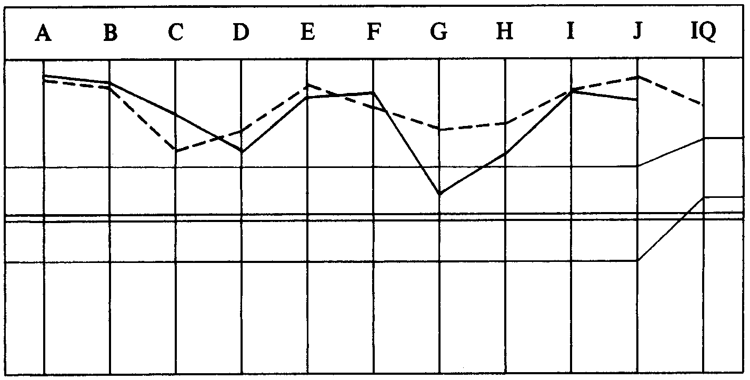

________________________
*FOOTNOTE: List of 2.5.72 is list of BD Items from 2wc on PT Environment.
*FOOTNOTE: Correct listing question is “What intention is connected to (BD F/N item)”.
Asking for plural Intentions is an invalid listing question because it asks for
more than one item.
AUDITOR’S COMMENT AND NEW PROGRAM 8.5.72—
Still low column G—new low, probably more honest than previously. But maybe
ARC Bk.
Exp Dn Pgm.
“0. Hav all sessions” added by LRH.
1. Triple Ruds “on Flag”.
2. Assess: (_____pc’s Org), Los Angeles, USLO, Flag, New York, co-
Executive), Command team, LRH, The Commodore, Postulate checks, crush
sell, Ethics, Tech, Policy, Off Policy, Admin, Establishment, Products,
VFPs, Dissemination, The Public, The people, Scientology, Clearing, the
planet.
L&N Intention connected with reading areas and R3R Triple.
3. After each L&N + R3R, L&N F-2 Intention—”What intention does another
have towards you connected with ( item)”.
Then F-3 “What intention do others have towards others connected with
(_____item)”.
These all done should care for Dynamic 3.
4. Repeat action on: You as a thetan, your mind, your body, your name, your
rank, your case, eating, your life, your language, your communications, your
thoughts, your possessions, your situation.
5. Do the same for: (_____wife’s name), your marriage, your wife, married
women, single women, sex, celibacy, balling, children, offspring, your
family, your mother, your father, your brother, your ancestors, genitals,
masturbation, fornication, future generations, your generation.
That should handle a lot.
6. Then: The Race, The Planet, Mankind, Human beings, humanoids, fellows,
beings, Russians, Americans, Earthmen, aliens, spacemen, other Races.
Handle as in 2 and 3.
7. 2wc How do you feel about your case?
8. Program as indicated.
AUDITOR’S C/S 8.5.72—
OCA still sags on right—probably more honest. But intentions all across the board should be looked at.
“1. Check Flag for read” added by LRH. Triple Ruds on “Flag”.
2. Assess list from Pgm and handle.
3. Continue Pgm.
LRH COMMENT—
“OK as noted.”
The auditor does the C/S and Pgm down to step 4 of Pgm and pc has huge win and so the auditor ends off.
AUDITOR’S COMMENT AND C/S 9.5.72—
Wow, wow. Never seen him like this, so excited. L&N Triple Intentions on “The
Command Team” + R3R and then on “your mind” tore the case wide open.
Some sort of OT valence shift page 45 and 46. RESPONSIBILITY cogs left and
right. (“My responsibility is back.”) He just shifted beingness in a big way. Looks
like we cracked him but good.
I don’t think his OCA would sag anymore.
0. 2wc to F/N “Tell me about your wins.”
1. 2wc “Is there anything you feel you want handled?” to F/N.
2. If all well, OCA and:
3. Experimental Product RD.
LRH COMMENT—
“Very well done. May be unnecessary to go on. This C/S is okay. That may be it.
C/S ok.”
In the next session the pc gives some items he wants handled. At the end the pc says, “To be able to control, control towards survival and optimum conditions.” (F/N VGIs.) “That is really where my head is at, proper control.” (F/N VGIs IND.)
AUDITOR’S COMMENT AND C/S—
Not complete, I guess. He has several areas he wants handled.
I. The body: heat, reaction to hot temperatures, nervous for no reason, lower
back muscles, lower part of body, pains in body.
II. Rollercoasters, losing attention units, resurgence of being—loss afterwards,
diminished life force.
III. Pictures not under control, automatic pictures.
IV. Failed control is the item that F/Ned.
He is noted in the Case Progress sheet as having had the PTS RD in 71, but I see
no record of the session. He has not had it, I am sure. Can be checked with the pc.
The first thing to handle would be the PTS RD. Pre-Flag folders and LA folders not
here.
0. Check if he has had it.
1. Get him to tell you any past S&D items, if any.
2. If none do 3 S&Ds.
3. R3R Triple, Triple Ruds and overts.
4. 2wc “Who he has known this life who has worried or troubled him”. Check
for known before this lifetime. R3R Triple Ruds + overts.
5. 2wc “Been after this LT” if known before, R3R Triple + Ruds + overts.
6. Places and planets known before this LT. Handle as above.
7. Assess PTS Correction List and handle to F/N list.
LRH COMMENT 11 May 72—
“I won’t give you any grade for this session as it’s a goof in Admin, C/Sing and
Pgming.
You must stay on Pgms and complete RDs. (You have decided now to go into
another RD leaving Sanderson RD incomplete.)
You ONLY run items in pc’s wording. Do not change wording. (You changed his
wording to ‘Failed Control’ which he did NOT say.)
You must mark BDs plainly when doing one of these 2wcs for things to handle.
Not all TA actions are marked so one is not sure what read. I am sure the needle
was active. Yet is not noted.
Having found where his attn is fixated you must now follow through.
But he did not answer the auditing question. He didn’t tell you what he wanted
handled. He told you what he wanted to achieve. And you can’t run that! It would
be trying to as-is ambition, which wouldn’t erase and would down curve him and
wreck him.
When you start an RD you finish it.
Now I’m dead ended as a C/S. I have no real reads marked. The pc didn’t really tell
you. So I can’t say what to R3R. It is NOT ‘failed control’. The pc never said a
word about it! You put an item of your own on the pc AND THAT IS A LISTING
CRIME.
Also what’s this ‘E/S’ doing on pg 5 mixed into 2wc for things to handle. You
must not mix up actions.
The report sheet is a false report. And a less experienced C/S would have been
thrown by it.
The part of this which I have been alerted by, in this, and other sessions, is a lack
of program command. This IS a Rundown you are doing. It does have steps. You
do do them in sequence. One must NOT start one thing, break off and start another.
All these are very basic auditing flaws.
Reviewing this it appears we did not end off on the Pgm underway but are 2 or 3
sessions deep on AN UNPROGRAMMED ACTION!
In other words, we are running a case now without a program WHICH IS
ILLEGAL AS HELL.
Apparently things have been done not ticked off on the last 2 programs.
This case isn’t going A to B by a long way.
Get checked out on this in cramming.
Pgm the case. Only you know what you’ve done here. Then I’ll okay it. You have
begun the Sanderson RD. Get checked out on it. Get it completed.
Then a PTS Int and verification.
Let’s finish this case up!”
RE-PROGRAM BY EXP DN SPEC 11.5.72—
1. Complete Sanderson RD. Handle all reading items from last 2wc.
2. If any further H. Std areas show up, to be handled first.
3. PTS Check + RD if indicated.
4. OCA + Program (if necessary).
The auditor does a series of sessions and completes the Sanderson RD.
AUDITOR’S COMMENTS AND C/S 12.5.72—
Went great. No reading answers to 2wc, has at present time nothing he can think of
he wants handled.
He looks good too—a lot younger.
1. Full D of P PTS Check.
2. If needed PTS RD.
3. OCA (if 2 not needed OCA directly).
LRH COMMENT—
“Very well done.”
The PTS Interview is done and the PTS RD completed. LRH adds Metalosis RD and this is done to a good result.
AUDITOR’S COMMENT AND C/S 19.5.72—
Went fine on Metalosis RD with some great cogs. Realised after the session hadn’t
made sure there was nothing missed so took him in for another 2 minutes and asked
him. He was very happy and calm.
OCA: He has regained an honest, high G trait.
I recommend he be OK’d to fire at this time.
1. Declare Metalosis RD.
2. Declare Exp Dn Complete.
3. OK to fire.
LRH COMMENT—
“Very well done.”
The pc goes through the lines on his declare cycles successfully. The auditor however finds an action not done on the pc’s TIP and rushes a query to LRH.
AUDITOR’S QUERY 20.5.72—
In error I overlooked that his original TIP called for the Experimental Product RD
and I proposed OK to fire without this.
LRH COMMENT AND C/S 20.5.72—
“No. Abandon the TIP. His failure is that he fails to get Ethics in on others and fails
to understand Exchange.
1. 2wc on how he’s doing now.
2. L&N to BD F/N item (clear words) ‘What would be the consequences of
getting Ethics in on others?’
3. R3R Triple any item.
4. 2wc How do you feel about Ethics now? (If reservations, end off the session
for a C/S.)
5. HCO PL 4 Apr 72 pg 4 & 5 as marked.
(a) Clear the Words PRODUCT, EXCHANGE, DYNAMIC, Dyn 1, 2, 3,
4, 5, 6, 7, 8. (Clear 1 as a spirit, body as 5.)
(b) Have him draw a big chart of numbered dynamics in 2 columns vertical:
1--------------> 1Draw in arrows only
1<-------------- 1 as he does them.
2 2
2 2
3 3
3 3
4 4
4 4
5 5
5 5
6 6
6 6
7 7
7 7
8 8
8 8

(c) Go through the exchanges. What does he exchange with his own 1st
(spirit).
1--------------> 1
What does it exchange with him.
1<-------------- 1
(d) Keep this up to huge cog.”
The auditor does the C/S to a tremendous win.
AUDITOR’S COMMENTS AND C/S 21.5.72—
Now ready to fire for real.
Valence shift, cogs on all Dynamics, responsibility level soaring, and I have never
seen him so present. Now that he’s here he can go.
0. Declare Exch by Dyn RD Completed.
1. OK to fire.
LRH COMMENT 21.5.72—
“ Very well done.
It might interest you to know that I brought him back from (_____) just to set him
up to rem and run Exchange by Dyn—step 2 of my last session C/S.
Your C/S is correct.”

AUDITOR NOTE 21.5.72—
(__________pc) has completed his auditing and his OCA is good.

He looks very good also.
Request ok for him to fire to (__________).
LRH COMMENT 21.5.72—
“OK. Wonderful job.”
PC’S SUCCESS STORY—
Expanded Dianetics. Well, what I did was expand immensely by doing Expanded
Dianetics and erasing formidable chains which once shackled me to reactive areas—
now totally blown. Especial acknowledgement to my auditor and to LRH who
charted the newly discovered “Terra Incognita”.
OCA GRAPH 19.5.72—

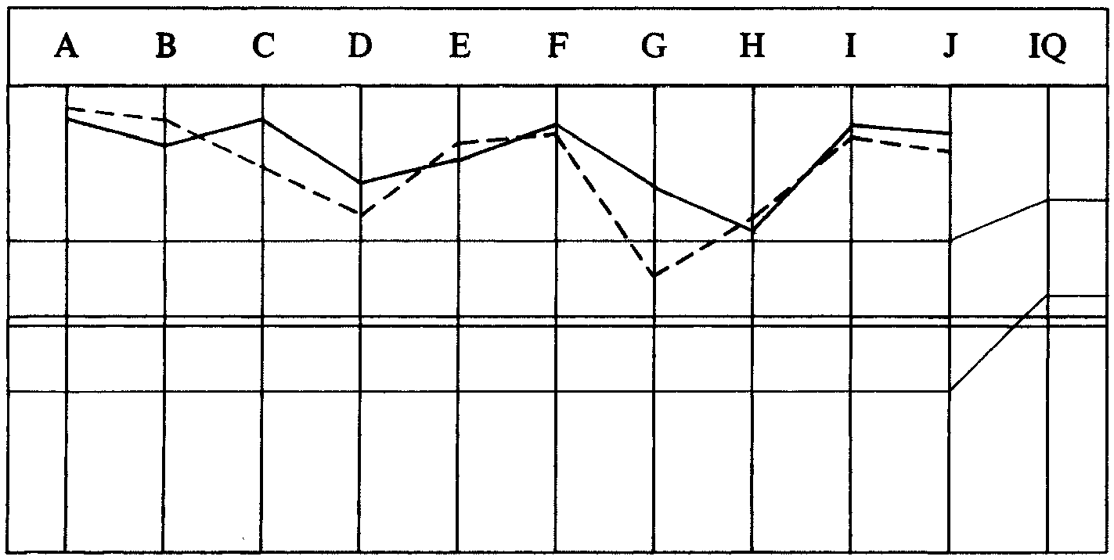

TOTAL NO. OF SESSIONS: 24.
TOTAL HOURS IN THE CHAIR: 67 hrs 09 min.

Compiled by:
Flag Dn Spec Team
for the
BOARDS OF DIRECTORS
of the
CHURCHES OF SCIENTOLOGY

BDCS:WS:MM:ntm.rd
Copyright © 1972, 1974
by L. Ron Hubbard
ALL RIGHTS RESERVED

