Ex Dn C/Ses
Ex Dn Auditors Issued 28 March 1974

B O A R D T E C H N I C A L B U L L E T I N
30 OCTOBER 1972

CANCELS
HCO BULLETIN OF 30 OCTOBER 1972

Expanded Dianetics Series 18
(Series Number Amended)

EXPANDED DIANETIC CASE L

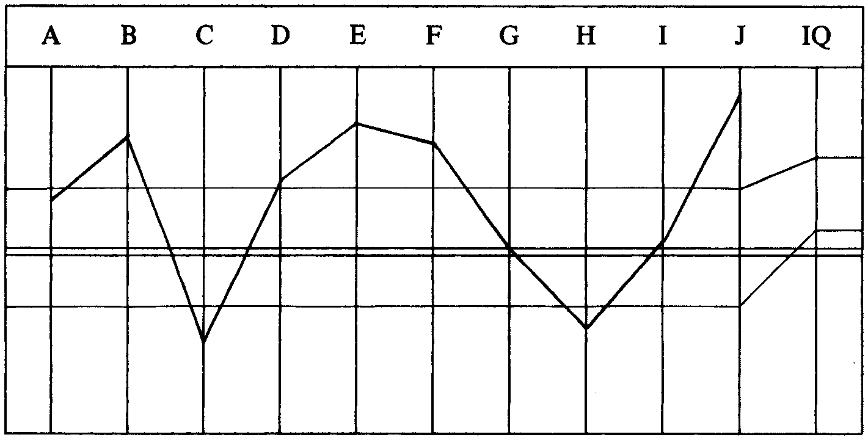

CASE NOTES—
Pc Va. Chronic sickie—chronic skin trouble—constantly in Ethics trouble. 0.5 on
Chart of Human Evaluation—thereabouts. OCA is in the white on both left and the
right.
He’s had quickie W/C M 1 and a quickie Drug Rundown. Not nearly enough
Dianetics. Has an almost continual Low TA.
EXPANDED DIANETIC PROGRAM BY DN SPEC 2.4.72—
1. Hi-Lo to F/Ning list. (LRH added “Cleared”.)
2. Complete Primary Rundown. (a) W/C M I—Word Clear W/C M 1 C/g 1 and
WCCL first. (b) Continue with steps 3 and 4 of Primary Rundown —
complete Rundown.
3. Complete C/S 1.
4. W/C each word in R3R commands and each word in the L-3B.
5. Triple Assess: Post, action, missions, Ethics, Comm Evs, Conditions, Study,
doctors, medication, sickness, 2-D. Run the attitudes and emotions R3R
Triple—cont to F/Ning list.
6. Assess Cl VIII list (auditors, auditing, etc) adding Solo and Clearing. Assess
attitudes and emotions on best reading item, list and do R3R Triple to F/Ning
list.
7. Do a new W/F. (a) Take all emotional stresses, losses and deaths R3R Triple
Narrative. (b) If attitudes to illness and treatment reading—run R3R Triple.
8. Clear and assess (in turn) LX3, LX2, LX1 and handle R3R Triple.
9. New OCA and reprogram accordingly.
The pc is under Comm Ev and so it is some time before he is sessionable.
AUDITOR’S C/S 18.5.72—
Should be out of Ethics tomorrow. Time to start.
1. Clear all words on Hi-Lo.
2. Hi-Lo to F/N list.
LRH COMMENT AND C/S 18.5.72—
“There’s an out of seq in the Pgm.
The Prim RD and WC1 are out of seq here. He won’t get them done and he
hasn’t started.
This is a very bad OCA and a bad (low) TA. C/S 53RC is better now than
Hi-Lo.
1. Clear all wds on Hi-Lo.
2. Hi-Lo to F/N list.
3. Hav.
4. Clear C/S 53RC.
5. C/S 53RC to F/N list.
6. Hav.”
LRH PROGRAM 18.5.72—
“Bad OCA. Low TA. Blames seniors. Lots Hav and Tch Assist.
1. Hi-Lo to F/N list.
2. C/S 53RC to F/N list.
3. Clear WCCL and handle to F/N.
(3a. 3 May 72 PL added by auditor 21.5.72 okayed by LRH.)
4. Complete C/S 1. Include every wd in R3R.
5. Draw Flows Quadruple.
6. Draw bank and Clear.
7. Assess PT Env List (see 2 Apr Pgm).
8. Class VIII List (see 2 Apr).
9. Clear all words Sanderson RD. Incl ‘Handled’.
10. Sanderson RD. (Crossed out by LRH.)
* 11. PTS Int.
* 12. PTS RD.
* 13. D of P disconnect.
* 14. Can’t Hav RD.
_________________________
*FOOTNOTE: Correct order per HCO B 17 Apr 72, C/S Series 76, “C/Sing a PTS
Rundown” is:
1. PTS Int 3. PTS RD
2. Disconnect 4. Can’t Have RD
15. Metalosis.
16. OCA and Interview.”
PROGRAM BEGUN 19.5.72—
Auditor spends the session clearing the words on the Hi-Lo, ending off with
Havingness.
AUDITOR’S COMMENTS AND C/S 19.5.72—
Went well.
Apparently previous auditors had him wipe hands a lot, as at first he’d do so about
every 5 minutes. Then he relaxed and quit.
TA went low but no real problem.
1. Hi-Lo to F/N list.
2a. Hav.
2. Clear C/S 53RC.
3. C/S 53RC to F/N list.
4. Hav.
5. Clear WCCL.
6. WCCL to F/N.
7. Hav.
LRH COMMENT—
“Very well done.
Auditors whose TRs are out substitute a towel. (Joke)”
The Hi-Lo and C/S 53RC are completed in the next three sessions. The 3 May PL,
C/S 1 and clearing steps of the Pgm are done.
The next session the C/S 6 list was clean so auditor goes onto Sanderson RD. The TA flies up and the auditor handles somehow to F/N, using C/S 53RC and WCCL. Also pc tired so 2wc’ed “Failed Purpose”.
LRH COMMENT AND C/S 30.5.72—
“Well done on sess.
Admin ghastly. Sending you to Cramming to get Admin straight as I can’t really
C/S it as don’t have data from W/Sheets.
1. Clean up the rest of C/S 53RC. Get F/Ning list.
2. Finish WCCL Clearing.
3. Hav.”
The auditor does the C/S 53RC to a good win for pc.
AUDITOR’S COMMENTS AND C/S 30.5.72—
Yesterday’s session I 2wc’ed “Failed Purpose”. It should be L&Ned. He may have
already given it. There is a lot of stuff there. Sorry about last session went over last
part again.
1. C/S 53RC F/N list.
2. Ind pc will L&N for Failed Purpose. Be alert he may have already
given it.
3. L&N Int connected to it. R3R Triple.
4. Check “loneliness on post” for read and interest.
(See this session W/S pg 4.) R3R Triple.
5. Get EAIs on “last (leader) removed yesterday”
(pg 31, 29 May W/S). R3R Triple.
6. Get EAIs on “want it running now it hasn’t been”
(pg 27). R3R Triple.
7. “We need a leader” (pg 30) handle as in 5 and 6.
8. “Moving people all got changed except me” (pg 26). Handle as above.
9. “Still have to repeat process” (pg 29). R3R Triple on EAIs.
10. “Wanted to go back to Ops” (pg 25) handle same.
11. “I just want it going” (pg 29) handle same.
12. “No leader, no team at all” (pg 29) handle same.
13. Check “so lonely” for read and int. R3R Triple.
14. Check “was sad” for read and int. R3R Triple.
15. Hav.
I did not do 2 of your C/S as I’ve cleared WCCL. I’m not sure what I did in admin that showed that.
LRH COMMENT AND C/S 31.5.72—
“Well done.
You finished the temporary repair caused by an area upset.
You’re cleaning cleans with this C/S. The situation ended with restoring (old boss)
to Post. This wd be a Q&A C/S.
DON’T VEER OFF PGMS. PGMS MEAN SOMETHING.
1. 2wc to F/N.
2. Class VIII List RD.
3. Hav.
To D of P for PTS Int.”
AUDITOR’S NOTE TO COMMODORE 1.6.72—
Pc unsessionable 2 days, due to missions. He has been good abt informing Tech
Services.
I don’t think he is trying to get out of session.
I thought you should know this.
He’ll get session tomorrow.
LRH COMMENT—
“OK. Maybe he hit an EP. He’s doing great or was when I last had contact.”
The auditor continues with the Pgm. On step 10, PTS Interview, done by the auditor in session, no PTS person is found. The auditor goes on to the PTS RD, does 2 S&Ds and runs the items Triple R3R, Ruds and overts. However pc goes to the Examiner and his TA had dropped to 1.6.
AUDITOR’S COMMENT AND C/S 2.6.72—
Red Tab. I don’t see a session error it went great.
1. 2wc “Is there anything in your last session you did not feel right about”.
Handle as needed.
2. Cont PTS RD.
LRH COMMENT AND C/S 3.6.72—
“Both items are inflow. Could be on same list.
You had it 1st Item on list. Usually the case.
There may be a listing error. You should have grabbed pc at Examiner. He’s on a
hot spot on post.
1. R-Factor: We have to correct the last session.
Assess:
Out Ruds
Wrong List
Session Error
Post Upset
Wrong Item
An overt to put it on list
Auditor overwhelmed you
Item was missed
Another Item has yet to be found
+Did both these Items belong on same list
(It is 3 S&Ds not 2 )
+Probably it’s the last one
2. Handle the above, L-1C if auditor, L4B if list.
3. C/S 53RC—Handle.
4. Hav.”
The auditor does the C/S.
AUDITOR’S COMMENT AND C/S 4.6.72—
Nothing was wrong. Maybe Examiner.
He’s doing great!
PTS RD DONE.
1. D of P Disconnect.
2. Can’t Hav RD.
3. Hav.
LRH PROGRAM 4.6.72—
“All right. We have him where he lives.
He has mainly Org terminals as his SPs. So by flow study that makes him what?
Accounts for earlier Aide failures.
1. Auditor’s C/S 4 June 72 complete Can’t Have RD.
2. 3 May 72 PL. Preface in the last couple of years.
3. Find all Ev Purps ever run or found even if D/Led (L-10 L-10M
W/Sheets etc). Note 2 Apr Pgm. Look at W/Sheets to see if any gotten
off.
4. R3R Triple on those that read.
5. L&N Triple for Ev Purps per L-10 list actions ‘Multiple Flow’ if not
done.
5a. Pc not had it so do L-10 Multiple (added after the next session).
6. R3R Triple on 5a. (We MUST get this guy straight. Could cost us a
million if we flub it as he is handling Orgs!)
7. PTS Corr List. Any additional terms + Can’t Have.
8. Metalosis.
9. OCA & Int.”
The auditor does the C/S and the 2 L&N lists of 3 May PL. The pc is F/N at the end of session but TA 1.5 at Examiner. Auditor has re-exam with different Examiner and pc says, “The session was fantastic and thought it was great. Handled s’thing that’s been bugging me for years.” TA 2.3 Wide F/N.
AUDITOR’S COMMENTS AND C/S 4.6.72—
He loved the C/S, 3 May PL especially.
I don’t know what the scene is with (_______Examiner). Every time pc has been
red-tab (_______) was Examiner.
I checked, nothing wrong, sent him for new exam with different Examiner.
1. 2wc to F/N.
2. Continue with LRH Pgm 4 June 72.
3. Hav.
Note: He’s never had L-10 of any sort. I found Ev Purp on an Int Corr List. He is
Va.
LRH COMMENT AND C/S 5.6.72—
“C/S not correct. Pc never had L-l 0 Multiple or Single. (LRH alters Pgm and adds
step 5a to it.)
Not well done because of admin. I can’t read the W/Ses. The auditor does not put
down what the pc was talking about. So I can’t work it out to C/S it.
I can’t make this session out at all. Can’t see what the pc was saying. Doesn’t make
any sense at all.
Clarifying words is not the problem here. What incident did the pc run? What was it
all about? That’s what a C/S has to know. The pc cd be jumping chains, anything,
as there’s no data.
1. 2wc to F/N.
2. R3R Trip on the PL 3 May 2 Items.
3. Do Multiple Flow Evil Purposes from L-10 Sheet.
4. R3R each.
5. Hav.”
The C/S was done and the Pgm continued over many sessions. At the end of the Metalosis RD the pc attests and is sent for a new OCA.
PC’S SUCCESS STORY—
For about the past 6-8 months I’ve had one kind of pain or another in my guts—
something so bad I couldn’t sit still for more than a few minutes.
But now after the RD it’s gone—completely! like magic.
It’s a big difference not to be in pain and this is a real win.
OCA GRAPH—
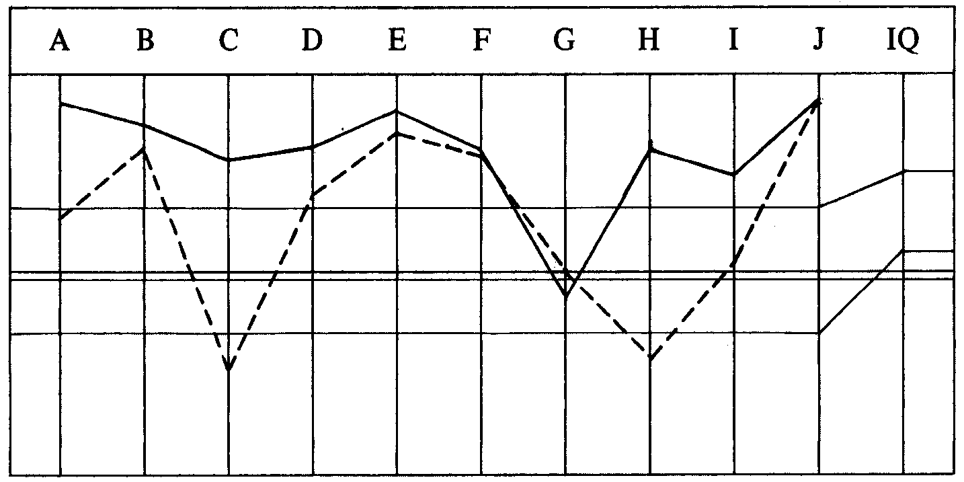

The graph is much improved but still down on the right. The pc is currently having more Exp Dn to handle this.
TOTAL NO. OF SESSIONS: 24.
TOTAL NO. OF HOURS IN THE CHAIR: 39 hrs 43 mins.

Compiled by:
Flag Dn Spec Team
for the
BOARDS OF DIRECTORS
of the
CHURCHES OF SCIENTOLOGY
BDCS:WS:MM:ntm.rd
Copyright © 1972, 1974
by L. Ron Hubbard
ALL RIGHTS RESERVED

