B O A R D T E C H N I C A L B U L L E T I N
25 OCTOBER 1972

Remimeo
Ex Dn C/Ses Issued 28 March 1974
Ex Dn Auditors
CANCELS
HCO BULLETIN OF 25 OCTOBER 1972

Expanded Dianetics Series 16
(Series Number Amended)

EXPANDED DIANETIC CASE J
OCA GRAPH—

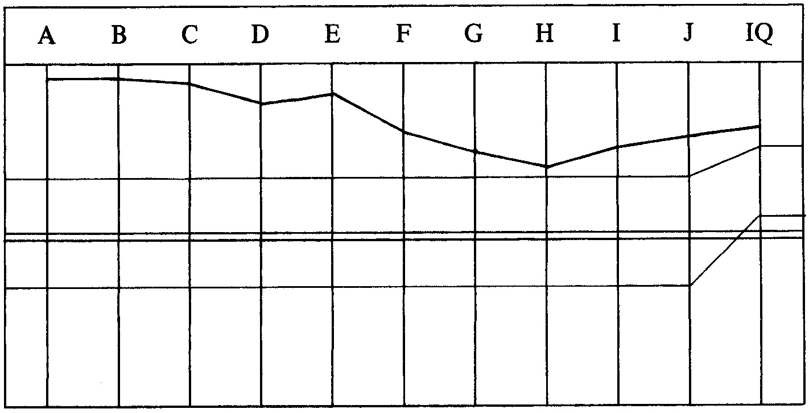

CASE NOTES AND EXPANDED DIANETIC PROGRAM BY EXP DN SPEC—
She’s OT IIIX and still easily overwhelmed. She’s had very little Dianetics run.
Needs her Ev Purps run out R3R Triple. Falsely high OCA. Reported still
misemotional on work and study.
0.Clear all words in L3ExD & R3R.
1. C/S 1.
2. Run all Ev Purps in L10 R3R Triple.
3. 2wc PT Environment, note all BD items.
4. Take up BD items in 3 and get intentions and emotions connected— R3R
Triple.
4a. Run the Goals Processing out—R3R Triple narrative.
4b. Handle intentions connected.
5. Assess C/S 6 get intentions connected—R3R Triple to F/Ning list.
6. Emotional Stress White Form—handle emotional stress R3R Triple.
7. Clear and assess LX3—handle R3R Triple.
8. Clear and assess LX2—handle R3R Triple.
9. Clear and assess LX1—handle R3R Triple.
PROGRAM STARTED 28.4.72—

Pc finishes her C/S 1 and the L10 Evil Purposes are checked and turn out “no
interest” and PT Environment is started.
AUDITOR’S COMMENT 29.4.72—
She told me a couple of times how she didn’t like running Dns because it was “slow”—but she sure blew a lot of grief charge on what we ran today.
LRH COMMENT—
“VERY WELL DONE.
She is dispersed so has to work fast and frantically.”
PT Environment is completed. Pc has been continually mentioning 25 hrs of Goals
Processing she received. 4a is added to the program. Next session auditor
completes the rest of the program, most of it turns out “no interest”.
AUDITOR’S C/S AND COMMENT 30.4.72—
We ran out her Goals Processing but it’s not handled yet. She says she can handle
anything but that area and she tends to not-is it in and out of session. She also got
bored in session—I checked ARC Brks (didn’t check PTP & MWH). Turned out
later to be a MWH concerning the fact that the area had not gone yet.
1. 2wc to F/N.
2. Havingness.
3. Get what intention would make one hold onto Goals Processing.
4. Run best reading item R3R Triple.
5. Recheck interest on White Form and LX lists.
LRH COMMENT AND C/S—
“WELL DONE.
(C/S would get her messed up as it’s an outlist situation really an engram but she
has attention on it.)
0. L4B Method 5. ‘On your goals list.’
00. Handle.
Do your C/S.
She is rather critical. More withholds than that, I think. Also get in the who what
did he do steps of M W/Hs when you meet a MW/H.”
Upper class auditor does list correction. L4B of above C/S only.
AUDITOR’S COMMENT—
Seems like she might have blown the thing on her goals list at last.
LRH COMMENT AND C/S 2.5.72—
“Thank you, Very Well Done.
Back to ______ for Exp Dn.

1. 2wc to F/N.
2. (6 of Pgm) Emotional Stress White Form.
3. Handle emotional stresses R3R Triple.
4. Havingness.”
Auditor does the above C/S and continues with LX’s.
AUDITOR’S C/S AND COMMENTS—
I don’t know about this one. She’s making gains—they are quite apparent but she just gets bored stiff and dopey during Dianetics. “It’s too slow.” There’s something holding her viewpoint of Dianetics in place. So:
1. 2wc to F/N.
2.L3EX DN Rundown to F/Ning list.
3. If all OK continue LX1.
4. Havingness.
LRH COMMENT AND C/S AND PROGRAM 4.5.72—
“Well done.
We’ve strayed off the rails here. Tired, dopey = stuck in something or failed
purpose.
I see we’ve not run her L10 Ev Purps.
0. Touch Assist.
1. 2wc What do you want handled? Note BD F/N items.
2. Hav.
See Pgm.
PROGRAM
Not really responding. Like to feel tired and dopey. Probably out ethics.
Plenty touch assists and havingness:
1. LRH C/S of 4 May 72 What do you want handled?
2. Intentions connected to it L&N. R3R Triple.
3. Want handled? Intentions R3R Triple.
4. Want handled? Intentions R3R Triple.
5. L 10 Ev Purps Interest or no interest.
Pgm then as needed.
C/S 53RRR if another BER. Then May 3, 72 P/L.”
Auditor does above LRH C/S. Pc doesn’t want anything handled, but mentions quite a few different things (see next LRH Pgm).
LRH COMMENT, C/S AND PROGRAM 5.5.72—
“Well done.
She says she objects to slow auditing indirectly by saying she likes it fast.
There are things to be handled. SHE IS NOT IN SESSION.

1. 2wc Who would I have to be to audit you.
2. What are you willing to talk to me about.
2a. GF Method 5 Handle.
3. Method 4 on ‘Early words in auditing’. Clean each to F/N.
4. Havingness.
PROGRAM
Doesn’t like auditing.
‘Feeling slightly abnormal.’ ‘Space not totally clean’ BD. ‘Auditing would be an
overt’ LFBD. ‘Don’t feel deserve auditing.’
Lots of Havingness.
A missing piece of Sanderson Rundown—get her in session!
1. LRH C/S 5 May 72 (to get in session and get GF & early Mis U’s on auditing
handled).
2. ‘Auditing as an overt’ R3R Triple. Check ‘Abnormal’ for a read R3R Triple.
3. Get intentions re Space L&N. R3R Triple on item.
3a. Huge black mass orbiting around head Intention on, L&N. Added by LRH
6.5.72.
4. 2wc on what she wants handled.
5. Handle with intention and R3R Triple.”
Auditor did steps 1, 2, 2a of LRH C/S. Pc mentions black mass circling round head. Pc has some tremendous wins on clearing up some misunderstood words. Auditor’s C/S is to continue LRH C/S 5.5.72 and Pgm.
LRH COMMENT—
“Very Well Done.
That’s better. The W/S’s however adds a step to Pgm that black mass circling
around is what she wanted handled. Should have been a suggest here. Bit of a
puzzle how to fit it in. But as it’s now come up we can tackle it directly.
I added it to Pgm.
Your C/S is OK.
This is a classic Ex Dn session situation you’ve just handled.”
Auditor does Method 4 on early words in auditing. The pc goes to the Examiner and says, “It’s like everything is back in place where it belongs, it’s perfect.” Dial F/N VGIs.
AUDITOR’S COMMENT AND C/S—
She’s a product. All the remaining stuff she wanted handled blew entirely on
clearing up these words.
1. Declare EXP DN PGM complete.
2. Finish PRD.
The pc attested to Exp Dn complete.
SUCCESS STORY 7.5.72

My overall win was a complete free Scientology and Dianetics track which goes
back 11 years.
It’s like starting all over again with a lot of know-how. Many, many other wins too.
I used to do things thru a screen of somatics and attitudes galore.
All gone.
Understanding restored and much much more.
A 100 thanks to_______(auditor) and the Commodore.
FINAL OCA—
Pc did not take a new OCA at this time.
Note. This is an error as an OCA must be taken prior to a pc attesting Exp Dn.
TOTAL NO. OF SESSIONS: 11.
TOTAL NO. OF HOURS IN THE CHAIR: 19 hrs 25 min.

Compiled by:
Flag Dn Spec Team
for the
BOARDS OF DIRECTORS
of the
CHURCHES OF SCIENTOLOGY
BDCS:JH:WS:MM:ntm.rd Copyright © 1972, 1974
by L. Ron Hubbard
ALL RIGHTS RESERVED

