B O A R D T E C H N I C A L B U L L E T I N
22 OCTOBER 1972
Issued 28 March 1974
Remimeo
Ex Dn C/Ses
Ex Dn Auditors
CANCELS
HCO BULLETIN OF 22 OCTOBER 1972

Expanded Dianetics Series 14
(Series Number Amended)

EXPANDED DIANETIC CASE G

OCA GRAPH 6.5.72—

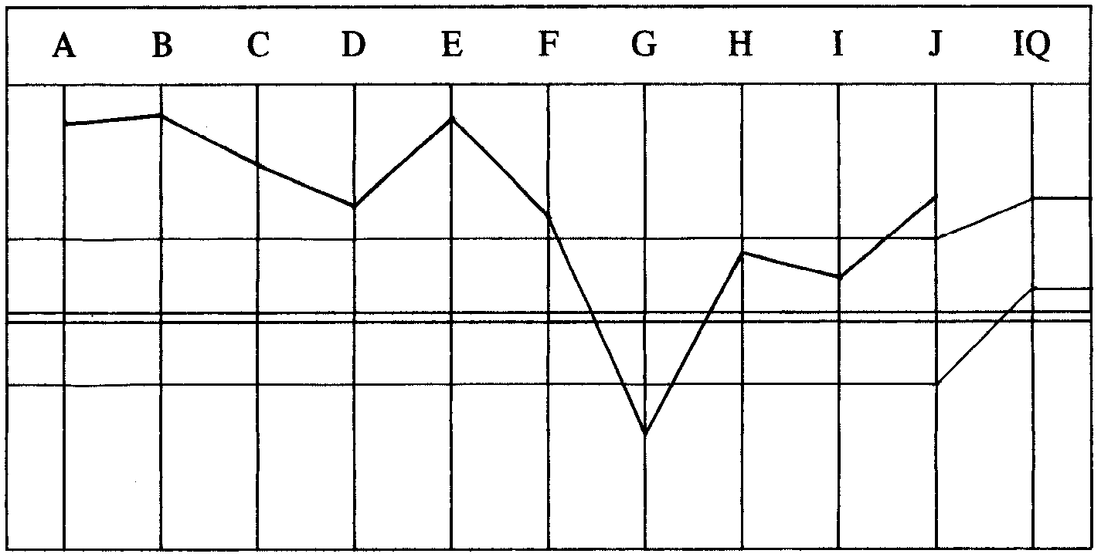

This pc had come to Flag for an FCCI. (Flag Case Completion Intensive.) She had been audited by a Cl XII Auditor on set-ups and higher level processing. The pc’s case level is OT VI.
NOTE BY THE CL XII C/S TO LRH—
Dear Sir,
The pc has “finished” OT III Exp VGIs, good D of P Interview but OCA down,
from what it was after L-9SX.
Have done a new Pgm (she wants Dn and Exp Grades before she goes home) and
first C/S.
Pgm calls for Exp Dn on her L-9S items. Prior to that a repair to catch the ARC Bks
(dropped graph).
This is OK.
LRH COMMENT 7.5.72—
“OK. (On pgm.)
More honest graph really, but ARC Bk rule holds.”
SET-UP PROGRAM BY CL XII C/S—
1. Assess: Auditors, auditing, solo, Adv Courses, Flag, Wins.
2. L1C on reading items.
3. M4 for misunderstood words in Auditing.
4. W/Clearing Corr List to F/N List.
5. GF M5 and handle.
6. To Exp Dn Pgm.
The above set-up Pgm was done to good result and some longstanding misunderstoods were cleared up on the pc.
EXP DN PGM BY DN SPEC 8.5.72—
Set-up program complete. Has chronic aches and pains to be handled with Exp Dns.
0. Havingness each session.
1. R3R Triple Ev Purps.
2. 2wc PT Environment noting all reads. Take up reading areas. Handle R3R
Triple and get any Attitudes and Emotions connected.
3. Emotional Stress White Form—emphasis on losses.
4. Clear and assess LX3, LX2 then LX1. Handle reading items. R3R Triple.
5. 2wc Body Problems wants handled. Get As, Es and Is connected. R3R
Triple.
6. New OCA.
Added: Pc discovered terminal PTS to.
7. Triple Ruds.
8. Clear and assess PTS Rundown Corr List and handle.
9. Can’t Have Rundown.
10. OCA taken here not at 6.
The program is started and completed to Step 2. The pc at Exams says, “I had a beautiful session. I feel so good, so good. I feel identified. So me.”
AUDITOR’S COMMENTS—
We’re really hitting right where she wants handling. Handling long-term failed help
and somatics. (Note exam.)
She’s really winning!
(I put her on footplates today, she loves them and no more TA hassles or attention
on cans.) LRH -—”Great!”
LRH COMMENT—
“Very well done.”
The next session the WF handling is completed and the LX lists are begun.
The pc says at the Examiner, “Everything is alright. So much gone! Not there any
more! Just computing. I wouldn’t have missed coming to Flag for all the World.”
AUDITOR’S COMMENT—
The last exam speaks for itself. She’s doing very well!
LRH COMMENT—
“Very well done.
You should frame it! You’re doing a good job.”
The next session Step 4 of the program is completed and 5 done.
AUDITOR’S COMMENTS AND C/S—
She feels that there is nothing else she wants handled. We unblocked her ears
among other things. She wants to go home and train and start auditing. She felt
handled after yesterday’s session.
0. New OCA.
1. D of P Interview.
2. Pending results continue Pgm or Declare Exp Dianetics Complete.
LRH COMMENT—
“Hey a Product!
Very well done!”
Pc declares. Then next day 13.5.72 the Host rushes a note to the C/S.
NOTE FROM HOST TO C/S—
(Pc) has just come to me a little griefy with a headache (after completing her
Expanded Dns yesterday).
She says she knows she is PTS. She says she knows it is not “_____” but it may
be her CPA (Certified Public Accountant) “_____”
She itsa’d a bit and remembered he sat on the board of the Mental Health
Organization in “_____” She started to blow a lot of charge and said she felt it
blowing.
*I info’d her of the new PL on PTS and finance. She became VGIs and is going to
read it. She then recognized that her business and Franchise started to get into
trouble when they took him on and said they knew the Business was PTS to
Someone.
I said I’d info the D of P and C/S and get it handled for her. She went off VGIs to
read the PL but came back a few seconds later to say the headache had blown—I
asked her to get a pc Exam (so there is a record of whether the item F/Ned).
Please get her cleaned up with Ethics/D of P and further sessions on PTS RD if
required.
HOST
EXAM REPORT AFTER HOST INTERVIEW—
I spotted our CPA as a one dollar a year man.
_________________________
*FOOTNOTE: HCO PL 12 May 72, “PTS PERSONNEL AND FINANCE”.
Blew my headache. It affected our Business and I’m sure he is the Why. Feel great.
TA 2.25 Wide F/N.
AUDITOR’S NOTE AND C/S (Also these steps added to the Pgm)—
Her OCA has recovered from its bad dip. She came up to the Host tonight with a
terminal she recognized she was PTS to. She feels she’s complete on her Exp
Dianetics but she should get this last bit of PTSness cleared up.
0. Work out handling for CPA in “_____” she’s PTS to—with D of P.
1. Fly all ruds triple + overts.
2. PTS Rundown Correction List.
3. “Can’t Have” Rundown as addition to PTS Rundown.
Note: I need more data for Step 3—is an HCO B coming out?
LRH REPLY 13.5.72—
“See attached note.”
*”PTS Steps (Not necessarily in final form).
Select the terminals already run on R3R in the sequence they were run in. 1st one,
2nd one, 3rd one, etc.
Clear ‘Can’t Have’ ‘Couldn’t Have’ as denial of something to someone else.
‘Enforced Have’ as making someone accept what they don’t want. Have the pc get
the idea of these with an example or 2.
Run on the SP items a 4 way (each to F/N) bracket.
- ‘What Can’t Have did (terminal) run on you?’ to F/N.
2. ‘What Can’t Have did you run on (same terminal)?’
3. ‘What did (terminal) force on you you didn’t want?’
4. ‘What did you try to force on (terminal) that he (she, it) didn’t want?’
Each goes to F/N.
This can also be run alternate repetitive:
1.2.1.2. etc to F/N. 3.4.3.4. etc to F/N.
But it may not be cleaned up.
The theory is that SPs are SPs because they deny hav and enforce unwanted hav.
They also deny do and enforce unwanted do. They also deny be and enforce
unwanted be.
A very full RD then would be to start with don’t be must be, go onto don’t do must
do, end up with can’t have enforced have.
*A pc has to be told it is experimental as it is not yet in HCO B.
After EACH item handled with the 2 flows can’t and 2 flows enforced OBJECTIVE
HAV should be run.
_________________________
*FOOTNOTE: This process and RD is no longer experimental and is covered in HCO B 9
Dec 71 RA, “PTS RUNDOWN”.
This is why we have never before been able to run subjective hav. It collided with
SPs, overts and w/hs on them.
Hav alone (4 bracket) should handle without resorting to Be or Do, but in rough
cases, Be and Do will have to come before Hav.
End off at once and begin objective Hav if the TA soars or the pc caves m, and send
folder to me.
A PTS RD can make a clear if fully carried out, accurate in all steps.”
The pc handles her PTS connection by telexing to have the Accountant fired. The
auditor then takes the pc into session to do these further auditing steps.
AUDITOR’S COMMENTS AND C/S—
The “Can’t Have” Rundown is a roaring success with her. We cleaned up every last
bit of PTSness in her environment, according to her. It’s really incredible to see
mass blow off people and get brighter.
0. New OCA.
1. D of P Interview on recent auditing, etc.
2. If all OK Declare Exp Dn Complete.
LRH COMMENT 14.5.72—
“Very well done!
Cheers! A good product. Can we do ‘em or can’t we.
C/S okay.”
In the D of P Interview pc wants to give her Business Associate a further R-Factor con-
cerning the Accountant which she goes off to (_____) to do. While away doing this the
pc pulls in an old somatic.
AUDITOR’S COMMENT AND C/S—
She’s got an old backache at (_____) yesterday—which needs handling. She also
did a new OCA “over a backache” but there are some interesting changes in the
graph. She also is winning with the touch assist from the MO.
1. 2wc to F/N.
2. Touch Assist to a Cog.
3. Sanderson Rundown per Pgm. (Added.)
4. End with havingness.
LRH COMMENT AND C/S 17.5.72—
“I tole you and tole you and tole you—when they rollercoaster they’re PTS OR she
has been wearing metal. (Shoes have steel in them, belts, garter belts.) (I just found
‘appendicitis’ was a party belt studded with metal!)
**1. Have the pc stand, look her over for metal, question her about metal stays,
girdles she wears or has worn. Find what it is that rests exactly in the somatic
areas.
FIND IT past or present.
R-Factor: Metal worn on the person can cause your condition. Indicate it.
________________________
*FOOTNOTE: This process and RD is no longer experimental and is covered in HCO B 9
Dec 71 RA, “PTS RUNDOWN”.
**FOOTNOTE:This is the “Metalosis RD” and will be covered more fully as to theory and
application in HCO Bs later in Exp Dn Series.
2. Put her on a meter. L&N ‘What metal object have you worn in back area’.
Check for read. BD F/N Item.
3. R3R Triple using the item found—wore a—or whatever.
4. L&N ‘What metal object have you worn—(Feet, legs, what it is)! BD F/N
Item.
5. R3R Triple—wore (or used) a_____.
6. Hav.”
The auditor does the C/S.
AUDITOR’S COMMENTS AND C/S—
Sir, you’re a genius! This is exactly where she was sitting—she blew these
somatics she thought were “62 yr old somatics”.

I’ve never seen something work so fast before.
1. Declare Exp Dn Complete.
LRH COMMENT—
“Very well done.
This was the first Metalosis session!”
The pc attests Exp Dn Complete and says at the Examiner, “I had the best night’s sleep in a long time. I feel great. Also my eyesight has improved 75%.”
PC’S SUCCESS STORY—
For me Expanded Dianetics is the process that truly enables me to be OT and an
active Scientologist. There are no words to really describe the gains I have had. My
awareness is up and I have gained that which is necessary to operate truly as an OT.
PC’S LAST OCA (Taken before Metalosis) 16.5.72—

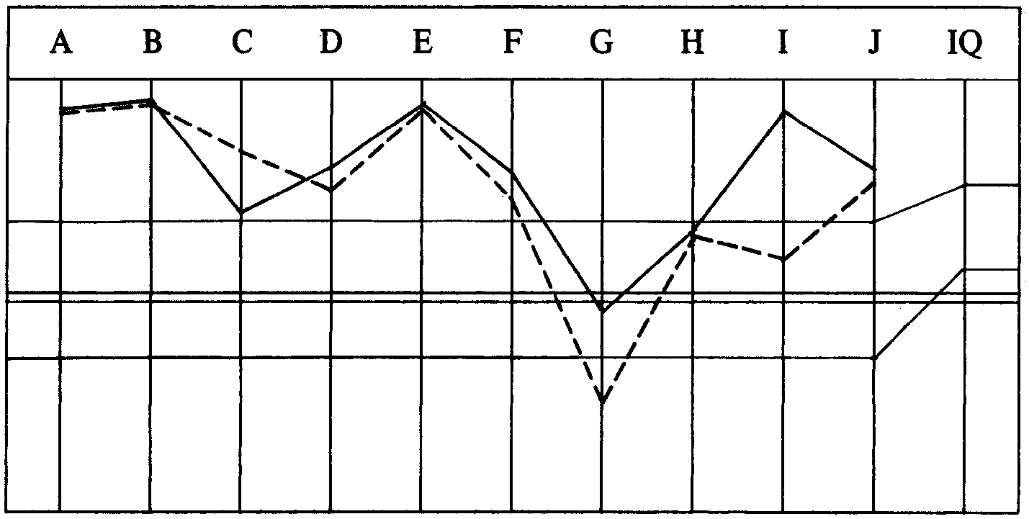

TOTAL NO. OF SESSIONS: 6.
TOTAL NO. OF HRS IN THE CHAIR: 13 hrs 46 min.
Compiled by:
Flag Dn Spec Team
BDCS:WS:MM:ntm rd for the
Copyright © 1972,1974 BOARDS OF DIRECTORS
by L. Ron Hubbard of the
ALL RIGHTS RESERVED CHURCHES OF SCIENTOLOGY

