B O A R D T E C H N I C A L B U L L E T I N
20 OCTOBER 1972
Issued 28 March 1974
Remimeo
Ex Dn C/Ses
Ex Dn Auditors

CANCELS
HCO BULLETIN OF 20 OCTOBER 1972

Expanded Dianetics Series 12
(Series Number Amended)

EXPANDED DIANETIC CASE E

OCA GRAPH 3.4.72—

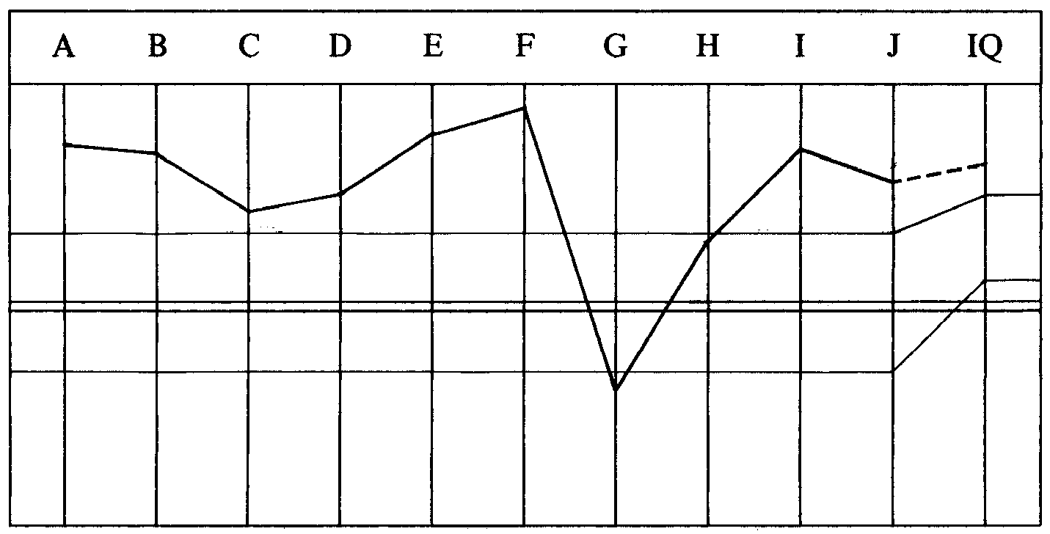

CASE NOTES AND EXP DN PGM BY DN SPECIALIST
Incomplete Dianetic pc with staledate LRH C/S from Dec 6, 71 for Dn FFT and
L3B RD—R/Sing on “postulate checks” “spinning” and “out-ethics”.
OCA low on right, up on left. Per Exp Dn lecture No. 1 FFT are only done if it
comes up or bogs running triples.
Case Level OT VII.
0. Declare M 1 WCing complete.
1. Havingness process found and run at end of each session.
2. Clear each word in L3 ExDn and R3R commands.
3. L3 ExD Rundown (M5 and handle to F/Ning list).
4a. L-10 Ev Purps run R3R Triple. (Added later.)
4b. 2wc PT Environment and note all BD items.
5. Take best reading items in 4 and get emotions and intentions connected to
items—R3R Triple to F/Ning list.
6. Assess Cl VIII list (C/S 6), get intentions, emotions connected to best reading
items R3R Triple.
6a. Emotional Stresses WF handle R3R Triple.
* 7. Clear and assess LX3 handle R3R Triple.
* 8. Clear and assess LX2 handle R3R Triple.
* 9. Clear and assess LX1 handle R3R Triple.
10. New OCA.
PROGRAM STARTED on 23.4.72.
LRH NOTE—
“This pc has had lots of Evil Purps found on L-10. These must all be R3Red Trip.”
(This step added to the Pgm.)
(On the auditor’s C/S LRH writes, “Well Done. C/S omits this Note which has to
be done as it’s this environ.”)
The auditor completes the Pgm. The pc runs very fast, so a new Pgm is written.
SECOND PGM BY EXP DN SPEC 25.4.72—
First program complete. There’s still plenty to dig up on him.
He’s not low on the left but has one point on the right that’s low. He is running
engrams and implants well. He wants his O/Ws handled so this should do a good
job on it.
0. Havingness at start and end of each session.
1a. Assess the Admin Scale.
1b. Get intentions connected to best reading items, R3R Triple, to F/Ning list.
2a. Assess: Games, rules, players, barriers, freedoms, possibility of winning,
possibility of losing.
2b. Get intentions connected to best reading items, R3R Triple to F/Ning list.
3a. Assess: Postulate checks, Gross Income, Income, bills, reserves, purchase
orders, crush sell, hot prospect reg, pirates, money, Ethics.
3b. Get intentions connected with best reading items R3R Triple to F/Ning list.
4a. Assess: Orgs, ASHO, USLO, Sea Org, AOLA, Execs, Org Officers, Product
Officers, C/Os.
4b. Get intentions connected, run R3R Triple to F/Ning list.
** 5a. Slow assess R-1C and note all BD items.
5b. Get intentions connected to best reading items R3R Triple to F/Ning list.
6. New OCA.
The auditor does the entire program with Ev Purps coming off nicely. The OCA
given at the end of this Pgm showed a slight drift of all traits except G which
remained very fixed as the low point of the whole graph.
LRH COMMENT—
“Very well done. Somebody missed the Ev Purps on him.”
________________________
*FOOTNOTE: Per a more recent LRH dispatch, the words of the LX lists are cleared before
assessing it and the reads taken as they appear.
**FOOTNOTE:See HCO B 4 December 1971, “R-1C Assessment by Dynamics”.
THIRD PGM BY EXP DN SPEC—
The right side of his graph is coming up slowly but surely. But there’s more work
to do—more O/Ws to get off.
0. Havingness at start and end of each session.
1. Pick up reading items from Admin Scale when previously handled and get
“another’s intentions towards you connected to ( )”.
Run R3R Triple.
2. Pick up reading items from list of games, rules, players, barriers, freedoms,
possibility of winning, possibility of losing. Get “another’s intentions
towards you connected to ( )”.
R3R Triple.
3. Pick up reading items from list (postulate checks, GI, income, etc). Get
“another’s intentions towards you connected to ( )”.
R3R Triple.
4. Pick up previously reading items from list (Org, ASHO, USLO, etc). Get
“another’s intentions towards you connected to ( )”.
R3R Triple.
5. Clear and assess Know to Mystery Scale. Get intentions connected to reading
items 3 flows to F/Ning list.
6. Assess A-R-C-U take biggest read and Curious About______
Desired______Enforced______Inhibited______No______Refused______
Broken______ Denied______ False______.
Run R3R Triple on best reading items. Reassess to F/Ning A-R-C-U.
7. Clear and assess the Awareness Scale levels. Run reading items R3R Triple.
Reassess and handle to F/Ning list.
8. Assess the Havingness Scale. Run reading items R3R Triple.
9. Assess: Failed havingness, failed interest, failed communication, failed control, failed help, failed overts, failed importance, failed leave, failed
protect, failed to abandon, failed to endure, inverted help, inverted control,
inverted comm, inverted interest, obsessive can’t have, no effect. Run reading
items R3R Triple.
10. Using above buttons substitute “desired” for “failed” R3R Triple. Then
substitute “enforced” and “inhibited” and handle—R3R Triple.
11. Assess Expanded Tone Scale and handle R3R Triple.
12. 2wc “What do you really want handled”—on that item L&N to BD F/N
item—”What intention would prevent you from (______)”.
R3R Triple on the intention.
The Pgm is started and goes quickly. At step 12 (Sanderson RD) after the session
the auditor writes “No real Wow”. The auditor’s C/S is to continue the Sanderson
RD.
LRH COMMENT—
“Well done. Being audited over out ruds and M/Us.”
LRH adds to the auditor’s C/S:
“1. Fly all ruds and overts triple.
1a. Check for MisU words M4.”
AUDITOR’S COMMENTS (Next Session)—
He got his wow. Looks like the EP of Exp Dn.
1. New OCA.
2. D of P Interview.
3. If OK declare.
LRH COMMENT 1.5.72—
“Very well done, Wow!”
D OF P INTERVIEW—
Very good.
OCA GRAPH—
Trait G in the same place, unmoving.
Auditor at this point examines the OCA questions answered wrongly by the pc and
works out the common denominator.
AUDITOR’S COMMENTS AND C/S—
Not OK to declare. Trait G still down. Looked up the questions on OCA and
common denominator is “Can’t take responsibility for the actions of those close to
him, is swayed by personalities”.
C/S and PROGRAM are identical.
1. 2wc to F/N.
2. L&N “Intentions regarding (terminal close to pc)”. R3R Triple on intention.
3. L&N “(Terminal close to pc’s) intention regarding you”. R3R Triple the
intention.
4. L&N “(Terminal close to pc’s) intention regarding others”. R3R Triple the
intention.
5. 2wc “The group the pc involved with”.
6. Steps 2, 3, 4, on hot terminals from 5.
7. 2wc “Personalities you’ve known”.
8. Steps 2, 3, 4, on hot terminals from 7.
9. PTS RD. Include “What persons have you really liked or admired”.
LRH COMMENT—
“Go ahead and try it.
That unchanging graph is pretty spooky. If no shift then he has done and is
doing things. Very ungood.”
Auditor does the Pgm up to the PTS RD (step 9) in one session.
AUDITOR’S COMMENTS AND C/S—
This didn’t bite. Pc showed signs of overrun.
C/S—PTS RD.
LRH PROGRAM 4.5.72—
“Mess in (U.S. Org) over his funds handling. Probably afraid of Ethics. Something
we don’t know about this pc. Need data. Not getting anywhere. Awful OCA.
1. LRH C/S of 4 May 72 (see below).
2. Pgm accordingly.”
LRH C/S 4.5.72—
“Well done.
Both he and (Org Exec) are very worried.
Note 1.1 remark to Examiner. This guy is Out-Ethics.
1. Assess: Out Lists (L4B if so)
Worried about Flag Worried about (U.S. Org)
Worried about Ethics
Concerned over (Org Exec)
W/Hs from Flag
Out-Ethics situation
PTS
Connected to a hostile person
Saying things to someone else
Discussing things out of session
Concerned about others’ intentions
Afraid of trouble
Failed purpose
Want to leave
Don’t feel safe
O/R on words
Misunderstoods
People not saying
Others withholding from you
Heard things
Something unhandled
2wc to F/N—best to worst reads in turn.
2. C/S 53RRR handle.”
The auditor does the full C/S.
AUDITOR’S COMMENTS AND C/S—
His biggest concern right now is finishing his auditing, getting a post and finding
out what’s going to happen with him. He’s stuck in a continuous PTP—Mystery as
far as what will happen to him. He’s also stuck in a win from a session with (....)
on 1 May 72.
1. Put him to work as an expeditor.
2. PTS Check and 5 Apr 72.

LRH PROGRAM—
“He needs 3 May 72 PL Steps.
D of P Interview to give him R-Factor C/S 5 May 72. Handle what comes up.”
LRH COMMENTS AND C/S 5.5.72—
“Well done. Conclusion reached is not the correct one for the case.
PTPs go with E/S, or Exp Dn. Also after a case F/Ns on a subject it’s usually
blown. The answers tend to be what’s wrong and the F/N says no longer that
wrong. Get it?
So now we can handle.
There’s an Out-Ethics scene with him. It F/Ned on worry about it but not what it
was.
The OCA says he’s still bad off and it isn’t changing.
And he was the person making trouble in (U.S. Org) with borrowings and
donations.
D OF P R-FACTOR:
The Commodore is trying to handle things so you can be sent back to (U.S. Org)
very soon. In order to do this he has to make sure things will be all right with you
and (U.S. Org). Your OCA is low and didn’t change.
There’s a new Rundown that handles this by handling the person’s personal life. If
you are willing to co-operate we will do this. The Commodore is trying to keep
Ethics off your back over the donations being irregular. This can be worked out but
only if you co-operate.
Are you agreeable to do this new Rundown?”
The D of P R-Factor is done.
LRH C/S 6.5.72—
“To Cl XII auditor.
Do it gently.
Please do the PL 3 May all steps on pc.
Work it out as you go.
*Step 3 L&N ‘The Out-Ethics scene’ item.
Step 4 L&N ‘How it would be a betrayal to Scn and Flag’.
And get him to apply the formula.”
The above C/S is done and gets a VWD and at this point the folder goes to Dept XII (Class XII auditing) where the pc gets his L-10 and L-10M checked over and fixed, which takes one 7 hr session.
Pc now gets new OCA (11.5.72). This crashes badly. Trait C down to -52, Trait G goes lower to -84 and Point A down also.
LRH COMMENT 12.5.72—
“May have caved him in or made him more honest or made him guilty or
something.
Needs Hav every session and will get the new PTS RD when it comes up.”
________________________
*FOOTNOTE: This is the incorrect L&N question. The correct question is “What Out-Ethics
situation are you involved in?” per HCO B 10 June 72, “Refer to HCO PL 3
May 72 ‘Ethics and Executives’ “.
NEW PROGRAM BY CL XII 12 May 72. OKed and added to by LRH.
OCA Graph crashed after L-10M Corr.
Something missed.
Got to finish him off.
Uneducated pc.
“Use Hav every session.”—LRH.
0. Standard PTS Check as per HCO PL 5 April 72. Handle.
1. Ruds triple of long duration, including overt.
2. 2wc “Was anything missed in the last auditing that you had”.
Get an answer. Handle what found E/S or by list.
3. Method 4 “On auditing” and “Scn in general”.
Really clean up every faintest doubt.
*4. Clear GF 40X words, assess Method 6, use 2wc (no recall/engram).
5. L3B Rundown on earliest engrams run. (L3 ExD.)
6. PTS Rundown “with new ‘Can’t Have’ RD”—LRH.
(Use terminals in PTS Check.)
6a. Triple Recall/Engrams of GF 40X.
7. Redo Method 1 W/Cing.
(Was cheated on it as words of assessment were cleared.)
8. Full Flow Dn Table to completion.
9. Complete Expanded Dianetics started.
Exp Dn Auditor does this program. All goes fine. Pc running and having very big wins on PTS RD. On completion of Can’t Have RD PTS Corr List, pc takes a new OCA.
The OCA recovers somewhat. The -52 Trait C comes up and the Trait G (Responsible) recovers. But only to its original stuck point.
Auditor continues and completes step 6a of the Pgm.
AUDITOR’S COMMENTS AND C/S—
He’s already had the GF 40X items handled and redoing them was an O/R. He also
was not quickied on either of his two M1 W/Cings so I left it alone.
1. 2wc to F/N.
2. Full Flow Dn Table.
3. Havingness.
ANOTHER LRH NOTE—
“This ‘stuck point’ of OCA is another Ev Purp, fixated. It will blow off or we’ll
find it.
He’s going according to standard reaction except for one stuck point on the right.”
________________________
*FOOTNOTE: Method 6 is a method of assessment used in Cl XII auditing where each question on the list is assessed by looking at the pc and asking him directly.
________________________
LRH COMMENTS AND C/S—
“Very well done.
He doesn’t need a FF Dn.
We’ve sort of lost our place in the book on the Exp Dn RD. I see it ‘started’ but no
Pgm.
Do new Pgm.
I see he’s had his L-10 Ev Purps.
This cat is nearly through.
He has a stuck viewpoint.
He has not had metalosis.
Exp Dn recovers graphs.
The stuck graph point is Responsibility Irresponsibility.
R-Factor: You will be here a few more days before leaving for (a U.S. Org).
1. Fly all ruds Triple (to get the air clean)—(Org associate) is leaving.
2. 2wc mark all reads and BDs as we want THE ITEM. ‘What would it be awful
to have to take responsibility for?’ (and let’s not have an everything’s okay
F/N). WC the hell out of the question backwards first.
There’s a trick of impinging such a Q after WCing. ‘Now I’m going to ask
you a very serious question and I want you to give it every thought.’ Then
ask it.
3. When you have the item that really read well, L&N ‘What would be the
intention of somebody who would do that?’ If the answer to Q2 above was a
goal or intention, omit this.
4. R3R Triple on it.
5. Havingness.”
The auditor does the C/S and pc has huge win, and goes exterior with perception.
AUDITOR’S COMMENT AND C/S 20.5.72—
WE FINALLY DID IT! ! !
His graph is beautiful. He totally changed—Ext + perception among other things.
Your C/S hit right where he needed it. He finally got the R/S and Ev Purp run that
was pinning him down.
Declare Exp Dns Complete.
LRH COMMENT—
“Very well done.
Absolutely classical. Exp Dn at its best!”
SUCCESS STORY—
I have never achieved so much. Boy!!!
This is a breakthrough beyond my belief. I feel clean, I have changed physically. I
feel healthier and more honest.
Sir, all my thanks.
GRAPH WHEN PC COMPLETE—

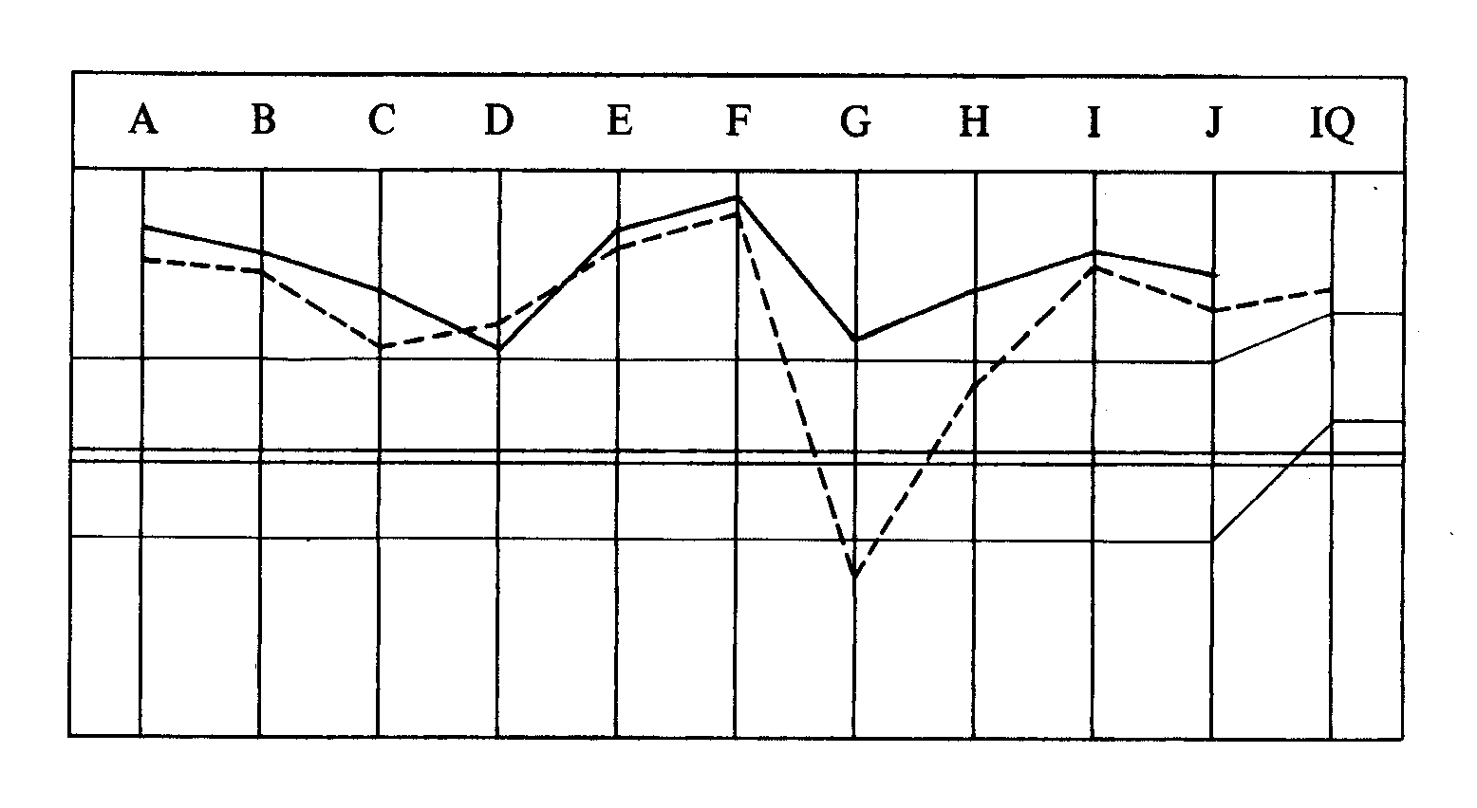
TOTAL NO. OF SESSIONS: 19.
TOTAL HRS IN THE CHAIR: 46 hrs 20 min.

Compiled by:
Flag Dn Spec Team
for the
BOARDS OF DIRECTORS
of the
CHURCHES OF SCIENTOLOGY
BDCS:WS:MM:ntm.rd
Copyright © 1972, 1974
by L. Ron Hubbard
ALL RIGHTS RESERVED

