B O A R D T E C H N I C A L B U L L E T I N
19 OCTOBER 1972
Issued 28 March 1974
Remimeo
Ex Dn C/Ses
Ex Dn Auditors
CANCELS
HCO BULLETIN OF 19 OCTOBER 1972

Expanded Dianetics Series 11
(Series Number Amended)

EXPANDED DIANETIC CASE D

OCA GRAPH—

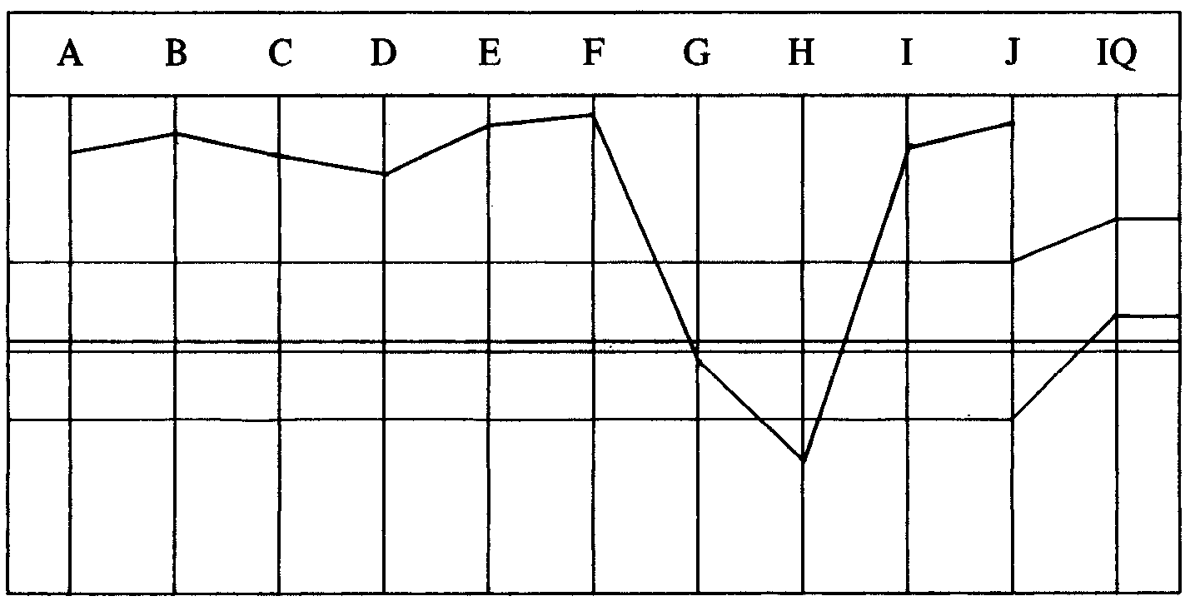

CASE NOTES—
In the white on the right of the OCA. But pc has been chronically ill for a year. Her
menopause started 2l/2 years ago and she has a suspected tumor of the uterus. In
present time pc is terrified that she has a malignant cancer.
Very low on the Chart of Human Evaluation on several points. She attested OT III
on 27.3.72 so she is out of the non-interference area.
Medical reports requested re pc’s cancer.
No sign of the pc ever having had a C/S 1.
EXPANDED DIANETIC PROGRAM by Dn Specialist. Approved and added to by LRH on 2.4.72.
0. Havingness before and after each session.
* “0a. WCC List, clear words, reassess and handle. WCM1 clear words, reassess
WCM1, handle.” Added LRH 2.4.72.
________________________
*FOOTNOTE: By HCO B 30 June 71, Issue II, Word Clearing Series 8RB (Revised 11 May
72) the list words of M1 are not cleared before assessment. The words of the
commands of M1 may be cleared.

“ 0b. TA Trouble C/S 53RRR” added LRH 8.4.72.
1. Full C/S 1, clear all words on L3B and L1C.
2. Expanded Dianetics
(a) 2wc her present time environment. Take best reading items and get her
attitudes, emotions and sens on it. R3R Triple. Exhaust list.
(b) Auditing—Assess Class VIII list (C/S 6) then Att, Emot and Sens on best
reading items, R3R Triple. “Intentions” added by LRH 21.4.72.
(c) Do a White Form stressing losses, R3R Triple Narrative. R3R Triple reading
emotions, and att towards illness and treatment.
(d) LX3, LX2, LX1, R3R Triple. PTS RD or PTS Interview if needed—added
20.4.72. (She is about .05 on Chart of Human Evaluation.)
3. New OCA—new program.
PROGRAM STARTED — M1 going very well, and huge amounts of charge and misunderstoods coming off case. Three sessions later pc finds misunderstood which had her stuck in an incident and pc blows it with big win! Auditor ends off.
Some trouble at the Examiner with a new one the pc doesn’t like. Re-exam requested by the pc. Gets wide F/N VGIs on the win. Pc goes to Success and writes voluntary glowing success story.
That night Auditor takes pc back into session and continues WCM1. After session exam TA high.
AUDITOR’S COMMENTS AND C/S—
Pc was doing fine on word clearing M1. I ended on a big win. (She wrote a success
story, I’ve just received it.) But she didn’t F/N at the Examiner, she did on second
exam which she requested. I took her in again tonight. We handled misunderstoods
and WCCL and back to M1 but TA up at Exams.
1. Indicate WCCL in last session was unnecessary action. “Rehab win” added
by LRH.
2. Fly a rud.
3. Continue M1 to F/Ning list.
4. Continue Program.
LRH COMMENT—
“You O/R even further past the win by the Correction. When she did F/N (2nd
Exam) you should have left it.
If no joy with 1 send folder to me rush.”
Auditor does the C/S, okay on 1 so continues.
AUDITOR’S COMMENT AND C/S—
Rehabbed the win and continued M1. Pc started to protest (page 18). Her attention
was on the big win again so I rehabbed it again. (Page 26 pc keyed in on counter-
postulates she has.) I ended the session after the rehab.
1. Fly a rud.
2. Verify M 1.
3. Continue Pgm.
LRH COMMENTS AND C/S—
TO D OF P AND LEAD AUDITOR
“Well done by Exams.
D of P: ‘What did the auditor do?’
Lead Auditor: Re (auditor) please find Why of forcing a pc and O/Ring and handle.
(Also pc may be an Advanced Courses pc who doesn’t belong to you. See request
in folders if [auditor] can’t do the history.)”
TO AUDITOR
“Well done by Exams.
There is an auditing error here. You don’t force pcs, particularly sick ones, never.
You overrode her protest.
An auditor mustn’t have a tendency to Force or O/R against a protest without getting
a Why of it.
This makes the C/S incorrect here as you would just force her further.
Auditing is for the pc.
Also when a TA tends to go up there’s something wrong, of which protest may be
just a symptom.
1. C/S 53RRR Assess. Then check for any misunderstood words on it. (As it
hasn’t been cleared.) Send to me. (If it has misunderstoods on it clear them
and reassess.)
Also verify folder if this is a failed Adv Cse pc. If so give details.”
D OF P INTERVIEW—
Pc says, “Possibly some overrun that’s all.”
LEAD AUDITOR—
Found Why on auditor as having lost sight of her purpose and took pc back into
session “to get her hours up”.
Report on pc in regard to Adv Cses—Audited 10 hrs on OT III finished in Review, has not had OT VII or OT IIIX.
LRH——Orders his “last C/S to be done.”
Auditor assesses 53RRR. Int and lists and others reading—Wrong item F, Upset
with giving items to auditor LF, Int tick and sF, TA between 3.0 and 2.8 during the
assessment.
Auditor also reports pc was seasick during voyage.
Auditor returns the folder to LRH.
LRH COMMENT AND C/S—
“A red tab with Out-Lists, was seasick but no dramamine.
* 1. Wrong Items L4B.
2. Upset with giving items to auditor—L4B.
3. Pc withholding—Pull all withholds triple.
4. Self auditing between sessions—2wc, then get the prior confusion that began
it.”
C/S is done the next day. There is a slight overrun at the end of session and no F/N at Exams.
AUDITOR’S COMMENT—
Outness was I went by the point of release to get prior confusion. Out obnosis, and
auditing the C/S not the pc.
LRH COMMENT AND C/S—
“You’re an Auditor not a student. So don’t act like a student learning to audit.
1. C/S 53RRR. Reassess with impingement with TRs in so you make any reads
happen.
2. Handle.
3. Clear Hi-Lo List backwards, questions backwards from last question up.
4. Assess.
5. Handle.”
The above C/S is completed to a nice result and M1 word clearing is continued and completed and Pgm continued.
Pc running very well on the PT Environment.
In session of 19.4.72 pc says, “Spot on leg that hurts, want to go to Doctor.”
AUDITOR’S COMMENTS AND C/S—
I noticed pc’s havingness drops very rapidly—would like to run havingness after
each chain.
1. Havingness.
2. Touch Assist.
3. Continue PT Environ.
4. Continue Pgm.
5. Hav before ending session.

LRH COMMENT—
“Well done. C/S suggestion of running havingness after each chain not OK at all,
would run a severe strain on pc extrovert-introvert wise.
I don’t see a PTS Interview or RD on this Pgm.
The auditing C/S is OK.

*FOOTNOTE: By Exp Dn Tape 4 Ext/Int reading on a list is handled by 2wc if the TA is in
normal range. Here there is no sign of Int troubles and TA is at 2.8 and Int
giving a very small meter read. It is omitted in the face of obvious out lists.
This pc is running great.
I notice mixed therapies present.”
(On 20.4.72 the PTS RD—if needed on PTS Interview is added to Pgm and on 21.4.72 Intentions are added to the Pgm by LRH.)
Pc continues Pgm through WF Stressing Losses. Pc goes to Doctor. Doctor can’t find any sign of tumor. Pc attests Exp Dn Chronic Illness Handling.
D of P Interview reveals there is more to be handled so a new Pgm is written.
AUDITOR’S NEW PROGRAM AND COMMENTS—
Per PTS Interview pc is PTS. Her graph has dropped on the left. Original program
completed except for LXs not yet done. Chronic Illness now handled.
1. Disconnect or handle present PTS Type A situation through MAA.
2. Havingness before and after major actions of the session.
3. Clear each word on LX 321.
* 4. Assess and handle LX lists R3R Triple.
5. Check for and handle hidden standards on the internal trouble. (Sanderson RD
added by LRH 2.5.72.)
6. Full PTS Rundown.
7. D of P Interview after RD.
8. Watch pc’s folder for any new signs of RC or illness and if they occur, PTS
RD Corr List and handle. New OCA.
The new Pgm is started and pc runs fine through LXs. On the LXs a bit of O/R occurs after a huge valence shift.
Auditor does step 5 of Pgm and comes up with more than one hidden std.
LRH COMMENT 2.5.72—
“Well done. She’ll need the Sanderson RD. I put it in.”
Pc finishes Sanderson RD and the PTS RD is started with a 3rd May PL.
The day after the pc is ill and writes a note and says she doesn’t feel out of Danger.
AUDITOR’S COMMENTS AND C/S—
No session but from pc’s note she’s rollercoastering. So I suggest:
1. L4B.
2. Touch Assist.
3. Havingness.
LRH COMMENT AND C/S—
“PTS is from suppression of some sort, is rollercoaster. But—she was put in what was to her a wrong condition. Will turn on somatics and is kind of suppressive. So knowing the THEORY of PTS makes all that difference in C/Sing.
_________________________

*FOOTNOTE: Per a more recent LRH dispatch, the words of the LX List are cleared before
assessing it and the reads taken as they appear.
_________________________
KNOW, FIND OUT BEFORE YOU GO IN C/Sing.
1. Assess: Wrong Why
Wrong Items
Physical Illness
Wrong condition assigned
Something else
PTS to someone
(Assess by stating it as a fact not as a question.)
2. 2wc on best read, E/S to F/N. If wrong condition tell her so after the 2wc and
tell you’ll handle.
3. Touch Assist.
4. Havingness.
Complete Pgm or correct it in light of any data above.”
The above C/S is done and new data arises on the pc’s past entanglements with Ethics and conditions over quite a few years. A new Pgm is written.
NEW PROGRAM BY EXP DN AUDITOR 12.5.72—
This program to be done before step 5 of 25.4.72 Pgm.
Touch assist was dropped off the last Pgm. Pc has now come up with a new
chronic condition of ear trouble (D of P Interview not mentioned previously).
Present time only 2wced before, not assessed. Intentions weren’t stressed.
1. Hav run before and after major actions in each session.
2. Touch Assist till body well.
3. Assess Flag, the SO, Ethics, Out Ethics, Being a SO Member, duties, hats,
schedules.
4. Get intentions—others to her, hers to others, others to others and R3R Triple
best reading items. Exhaust the list.
5. Assess: Difficulties, being suppressed, attacks, enemies, suppressing,
incomplete cycles, unmocking, defense, protest, make nothing of,
withdrawing from.
6. Same as 4 above.
A few sessions later the auditor runs two items which come from the PT Environment buttons (The SO and Attitude of Morals) and runs into trouble.
AUDITOR’S COMMENTS AND C/S—
Something very wrong here, she came in with F/N VGIs, did well on havingness
and Touch Assist, but rollercoasters on PT Buttons. On Ethics TA soars on clearing
intentions (this also happened before, she protested intentions in an earlier Pgm). I
feel this Pgm is too heavy for her.
I think we’ll have to handle her current Ethics situation before continuing with
auditing.
She is still legally married to a psycho, who has had shock treatment several times
and who she admits has SP characteristics. She has also mentioned she would like
to handle her children’s Out Ethics.
1. Handle all out 2D Ethics situations concerning her family properly— by
returning to Australia if necessary for a divorce.
2. Report to MAA when this is complete. Fitness Board.
3. PTS RD plus Can’t Be, Do, Have Steps.
LRH COMMENT 16.5.72—
“Well done by Exams only.
The purpose of an auditor is to handle the pc. You did something goofy beyond
belief.
Ran ‘Interest’ as an item. Then had trouble with the pc, then said offload her. To
me this means you have decided to offload.
This is one of the goofiest sessions I’ve seen for a while. You can’t audit out
pleasure moments. It hasn’t been possible since 1950, and I don’t know why you
chase ‘Interest in the Sea Org’ as a bad thing and tried to R3R it. Positive don’t run.
So Auditor to Ethics for a 3 May 72.
Pc being audited who is PTS and unhandled. D of P Interview to see if handled in
any way.
Interest as an Item ? Morals as an Item ?”
At D of P Interview pc says doing very well, much better, VGIs, etc; but needle
tight and sluggish and rises from 3.0 to 3.8.
LRH COMMENT AND C/S—
“Red tab.
Probably O/R on ‘good’ items that would have no aberration in them.
0. 53 RC to handle.
1. List out in chronological order all SP items found.
* 2. Run the ‘Can’t have, enforced have’ motivator repetitive then overt repetitive, then Flow 3, terminal to others, others to terminal. (4 flows of 2 commands each.)”
The auditor queries the C/S and states the PTS RD was mistakenly ticked off on the Pgm and not done yet.
LRH COMMENT AND C/S 18.5.72—
“All this randomity made me lose my place in the book. The check off threw it. Now I’m not sure where we are on her.
Do a new Pgm picking up the old one and steps already done. Finish whatever major cycle she was on in Exp Dn then PTS RD, then Metalosis, then Ev Purps from L10.
C/S 1. 53RC and handle.
2. L1C Recently.
3. Havingness.”
________________________
*FOOTNOTE: This RD is covered fully in HCO B 9 Dec 1971RA, “PTS Rundown”.
It is sometimes referred to as the Can’t Have Steps or the Can’t Have RD.
________________________
Auditor does above C/S and finds a wrong PTS item and handles and also writes a new Pgm.
LRH COMMENT 18.5.72—
“Very well done (for session). Pgm OK.”
AUDITOR’S NEW PROGRAM—
New Pgm as per LRH C/S 18.5.72
Touch assists to be run each session and havingness.
1. Complete the Sanderson RD.
“1a. LRH C/S 20 May 72” added by LRH on that date (see below).
2. PTS RD plus Can’t Have Steps.
3. Metalosis.
4. R3R Evil Purps from L10.
5. New OCA, new Pgm or declare.
Next session auditor completes Sanderson RD and begins the PTS RD.
AUDITOR’S COMMENTS AND C/S—
Went fine but on PTS RD she can’t remember having had any S&Ds (two lots of
S&Ds recorded in folder summary, but missing from folder).
I could start doing R3R on terminals from D of P Interview, while I sort out the
S&D scene.
1. 2wc to F/N.
2. Hav.
3. Select terminal from 2wc on who she’s known this life that has troubled or
worried her.
4. R3R Triple, Ruds and Overts.
5. Hav before ending.
LRH COMMENT AND C/S—
(Add to Pgm 20.5.72)
“Well done (C/S error on your C/S).
She had 2 lots of 3 S&Ds. This could be out lists yet they are missing. Look harder
to see if pulled forward for a list correction. If still can’t find still do C/S (i.e. LRH
C/S). If can find list do C/S.
An S&D list error can make a person sort of PTS with a Wrong Item!
Don’t audit over a suspected out list. Not even touch assists or Hav.
1. Reconstruct (or use) previous S&D lists. Verify items or correct.
2. L4B on S&D lists.
2a. Hav.
3. When fully assured it’s correct and cool, use these items to begin the PTS
RD.
4. R3R on those Former Life Known.
5. D of P Int taken items.
6. PTS RD Steps.
7. Hav.”
Auditor starts PTS RD. Runs fine then on Can’t Have TA soars and doesn’t come down. Auditor runs Hav to F/N and ends.
LRH——“D of P Rush: ‘What did the auditor do?’ “
D OF P INTERVIEW—
Well, could have gone past a sort of Release Point.
Felt very good at one point, yes (F/N) felt OT (VGIs F/N) was playing around OT,
yes (F/N IND).
LRH COMMENT AND C/S—
“Learn to see F/Ns, you just missed on the F/N that’s all.
1. Check F3 Jupiter. Did it erase, rehab point of erasure.
2. If no joy do L3 ExDn on F3.
3. Verify if any further terminals, if so handle.
4. If all cool havingness.
5. Declare PTS RD complete. (Next is Metalosis RD.)”
C/S is done. Pc declares PTS RD and Metalosis RD is started. Next session (just cleared words) auditor mentions TA going high, but coming down.
LRH COMMENT—
“Well done. You worry too much about TA. It has to go up to get TA action.”
Metalosis is continued and completed. Auditor suggests declare.
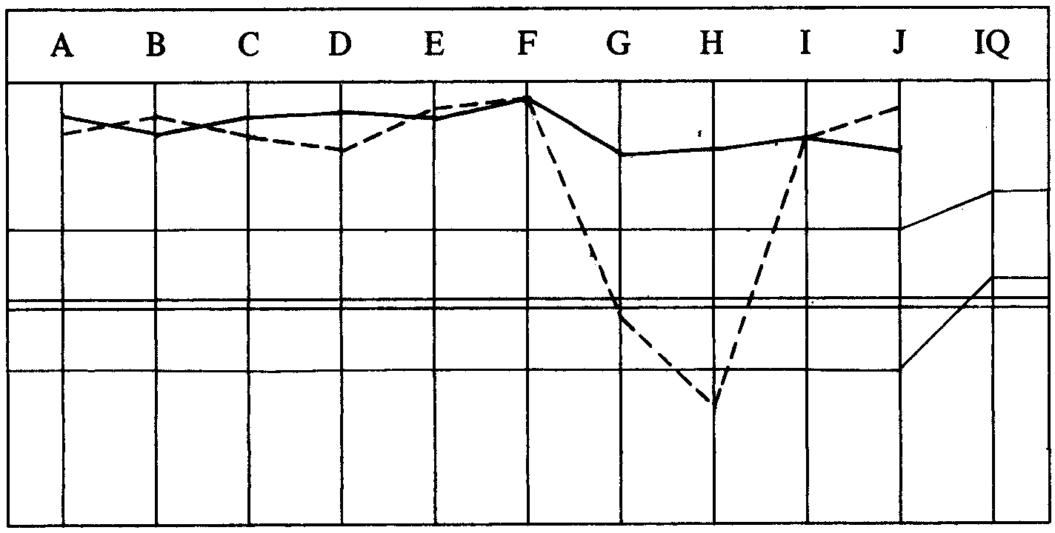
LRH COMMENT—
“Well done—25.5.72. Need D of P Interview. MO check and OCA before declare.
Question is, is she a cured person.”
MO REPORT—
Pain in tummy on and off. Little bit of bleeding after the pain. Either she still has
cyst in stomach or she’s mocking it up.
D OF P INTERVIEW—
Indicated something left to handle.
OCA—

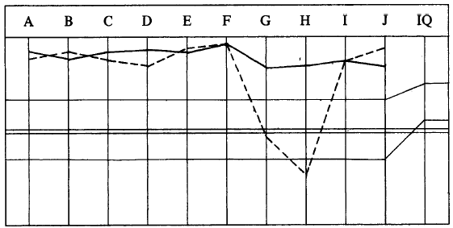

Very excellent change.
LRH COMMENTS AND PROGRAM 27.5.72—
“Incomplete product. Remains ill. Obviously PTS to other things. Illness— PTS.
Could be out ethics and PTS. Metalosis not finished. PTS incomplete.
Finish what we are on and then do more PTS RD. (Full steps not done and
very shallow.) Then 3 May PL.
* 1. 2wc ‘Tell me about your illness’ (for data). 2wc ‘What metal would one have
in that area?’ Choose item R3R Triple. (Chastity belt is the obvious answer.)
2. 2wc to fish for electric fields in the area. R3R Triple.
3. Recheck all possible angles of field distortion of body in ill area.
4. When all angles of fields and metal exhausted in area:
4a. Ev Purps from L10. R3R Triple.
5. Go on with any missing steps of PTS RD. I don’t think ‘Who she’s after’
was done. Can’t Have RD.
6. Check a Can’t Hav assessment on: Bodies, babies, sex, Doctors, trouble,
upsets, sexual oddities, sexual practices, etc. List intention L&N regarding
object, R3R Triple.
7. Check an enforced have on: Bodies, illnesses, ovaries, womb, guts, sex, etc.
Int, L&N, R3R Triple.
8. If all cool, 3 May PL.
9. 2wc ‘On how she’s doing, what she wants handled’.
10. L&N Intention or purpose regarding 9.
11. R3R Triple.
12. 2wc on how she’s doing, what she wants handled.
13. L&N Intention or purpose re 12.
14. R3R Triple.
15. 2wc on how she’s doing.”
LRH COMMENTS AND C/S 27.5.72—
“Well she’s still PTS.
This is just a case of not really completing anything on the pc.
Pgm calling for Ev Purps from L10 still not done apparently.
PTS RD short changed (step missing apparently).
Metalosis not really bled for the works.
She’s also mixing practices. Nothing a Medic can do for her.
1. 2wc ‘Tell me about your illness’.
2. 2wc ‘What metal would one have had in that area?’
3. Choose best items R3R Triple.
4. Word clear electromagnetic field fully. Clear field distortion.
5. 2wc ‘What could cause a field distortion in that area?’ Get items.
_____________________
*FOOTNOTE: This is the “Metalosis RD” and will be covered more fully as to theory and
application in HCO Bs later in the Exp Dn Series.
_____________________
6. R3R Triple.
7. Havingness.”
Pc is sent to the Examiner for “What did the Auditor do”. Pc says, “Overran me on some things and seems to be handling same stuff and re-running.”
LRH NEW C/S AND COMMENTS 28.5.72—
“Run this before 27 May C/S.
See Exam report. Pc looks very bad, much too bad for this much auditing, so sent
to Exams by C/S for ‘What did the Auditor do’.
You’re O/Ring F/Ns and running things twice. This pc better start looking good.
We’ve cured 3 of these cysts in the last couple of years, a 100% record.
1. L1C M3 on Recent Auditing.
2. C/S 53RC. Handle.
3. L3 ExDn to F/Ning list.
Then do 27 May and DO NOT by-pass F/Ns or run unreading items on this pc or
run same chains twice! “
The above C/S 28.5.72 and the 27.5.72 C/S are done and continued and the pc doing very well. Metalosis is completed and the PTS RD.
On 11.6.72 the Can’t Have, Enforced Hav Assessment steps are completed.
The 3 May PL is done.
The illness is attacked from all quarters with the Sanderson RD.
On 20.6.72 pc attests to Thetan Exterior.
She completes the Wants Handled RD (Sanderson) to F/N VGIs.
The pc is sent to declare Exp Dn complete but fails the Exam.
The next session the PTS Corr List reveals that pc is still dependent on her SP husband for support, as divorce = loss of money. She had disconnected in every way except through this House = Money Line.
Pc has 5 Apr PL handling and decides to get the divorce.
D of P Interview to see how she is doing. VGIs, all illness fine. Doing very well. Tone 3.5.
Pc sent for re-declare. Wide F/N VGIs 21.8.72.
LRH COMMENT—
“Very well done. Nice change, Love Ron.”
SUCCESS STORY—
I was one of those tough cases, but I knew if me and the Auditor kept handling the hell out of it that one day we would get the last little bit holding it in place. Thanks to the Auditor we uncovered it and within a few days the illness miraculously disappeared.
My illness has gone.
Many, many thanks to LRH and my Auditor and the D of P.
TOTAL NO. OF SESSIONS: 56.
TOTAL HOURS IN THE CHAIR: 132 hrs 20 min.

Compiled by:
Flag Dn Spec Team
for the
BOARDS OF DIRECTORS
of the
CHURCHES OF SCIENTOLOGY
BDCS:MM:WS:ntm.rd
Copyright © 1972, 1974
by L. Ron Hubbard
ALL RIGHTS RESERVED

