B O A R D T E C H N I C A L B U L L E T I N
18 SEPTEMBER 1972
Issued 28 March 1974
Remimeo
Ex Dn C/Ses
Ex Dn Auditors
CANCELS
HCO BULLETIN OF 18 SEPTEMBER 1972
Expanded Dianetics Series 10
(Series Number Amended)

EXPANDED DIANETIC CASE C

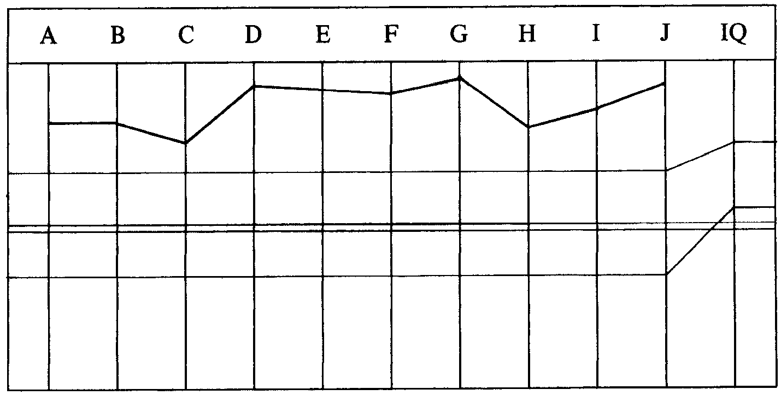

CASE NOTES—
Had upper level Flag auditing, has attested OT III. Also has had PTS RD. Pc
currently ill in bed. Has to be set up for Exp Dn. Get him out of bed and then
handle misunderstood words.
EXPANDED DIANETIC SET-UP PROGRAM by Dn Specialist. Step added by LRH. 10.4.72.
0. Touch Assist to F/N, daily until MO okays to get up.
“0a. HCO PL 9 April 72, Ethics Danger Assessment.” LRH.
0b. Hav before and after each session.
1. When up—Clear all words in rudiments questions and WCCL (What is the
definition of .......?).
2. Assess WCCL and handle to F/N list.
*3.Clear all words on 8RR (Ml list).
4. Assess and handle M 1 to F/Ning list.
“4a. PTS Check” added by LRH on 19.4.72.
5. To Exp Dn Program.
PROGRAM is started. Touch assists are given for five days and then the Ethics PL (Danger Assessment). Pc gets back on post with VVGIs.
_________________________

*FOOTNOTE:This action is now out-tech as designated by HCO B 30 June 1971 (Revised
11 May 72), Word Clearing Series 8RB.

Step I of Pgm started 19.4.72, clearing words incomplete, F/N at exams.
AUDITOR’S C/S—
0. Hav to F/N.
1. Finish clearing words on WCCL.
2. Continue Pgm.
3. End on Hav.
LRH COMMENT—
“Very well done. This case roller-coastering like mad, note 4a on Pgm.”
Auditor continues program, pc declares Ml verification.
MO REPORT—Pc’s temperature is staying low 35.8 (37 normal).
PTS Check done by D of P. D of P says, “He is not PTS Type A or Type 1.”
LRH COMMENT on D of P Interview—
“Not accepted.
Interview not okay. Merely failed to find it. Redo interview.
He’s been sick, incapable and is terrified of past crimes on track.
He says he’s broken off with everybody.
D of P’s cue should have been to query just this. He has not formally disconnected
by the book. Just went into hiding.
Find out who amongst all these was antagonistic or, in any event, find the SP
group, person or thing.
For instance, even my slight data on him shows him PTS to the U.S. Navy.”
D of P redoes interview. Finds terminal.
LRH—— “Excellent and thank you.”
EXPANDED DIANETIC PROGRAM written as further set-up to finish up his PTS RD on 6.5.72 by Dn Spec.
PTS Disconnect written. Has had PTS RD Jan 72. D of P interview Apr 72 has
uncovered new terminal on the case.
1. 2wc “Attention on” to F/N.
2. R3R Triple and Ruds and Overts on terminal if known before this life.
3. PTS Correction List to F/Ning list.
4. Attest and program for Exp Dn.

Program started. Terminal not known before this life so not run. Auditor assesses PTS Corr List and handles. On question 10 “It can’t be handled anyway” pc says, “Has to do with exterior bit we went through before. I get down tone every now and then. I want to be exterior with full perception.”
AUDITOR’S C/S AND COMMENT—
Doing okay. List has not F/Ned—may have attention on something.
He has a Hidden Standard of long duration on going Ext with full perception since
he was a child.
1. Fly each rud.
2. R-Factor “We need to take the PTS Corr List to an F/Ning List.”
3. Assess and handle the F/Ning list.
LRH COMMENT—
“Well done.
You don’t fly ruds over an out list. Int—Lists—Ruds is the only handling sequence
there is. Don’t alter sequence.
Use suppress and inval on the list and if any trouble do an L4B.
C/S otherwise okay. (LRH scores out 1 of Auditor’s C/S.)”
The next session the auditor continues with the PTS Correction List. Pc says, “I’m
not a PTS—feel blowy occasionally and worthless.”
AUDITOR’S COMMENT—
He now needs PTS interview. He’s not any easy Type A. He hasn’t spotted himself
as a PTS but he feels “worthless” and “blowy” and has just recovered from
sickness.
MAA does another PTS Interview.
Pc makes voluntary statement to D of P, after PTS Check, to the effect that he is not
PTS, has had all the rundowns, and he lied his way through the last interview.
Heavily asserting he is not PTS.
AUDITOR’S C/S AND COMMENT—
MAA PTS Check came up with terminal. Then pc comes to D of P and says it was
all PR.
*1.3 May PL including full R-Factor. When full formula written up—
2. Check last terminal found for known before this life. If so do PTS RD steps
and Can’t Have on it.
3. If not do PTS Corr List to F/N list. Use Supp and Inval each line if needed.
LRH COMMENT—
“Boy, I’ve seen PTSes before but seldom as much as he is.
Probably doesn’t know the words.”
Auditor continues, F/Ns the PTS Corr List and Pc declares.

EXPANDED DIANETIC PROGRAM written 27.5.72.
PTS now handled and declared.
*FOOTNOTE: When this part of the C/S was done, the auditor could not get a read on the
Listing Question. Pc said he was not involved in any out-ethics situation F/N,
and so the action was dropped.
1. Sanderson RD (Exterior with full perception is a Hidden Standard).
*2. PT Environment Handling.
3. Auditors, Auditing, etc handling.
4. Emotional White Form and handle.
5. Any Ev Purps R3R.
6. OCA and Pgm.
AUDITOR’S C/S—
1. Start Sanderson RD with
**(a) L&N “What intention wd prevent being exterior with full perception” R3R
Triple.
(b) L&N Intention “another towards you” (F-2) R3R Triple. Then F-3.
(c) When above done, 2wc “What do you really want handled?”
(d) L&N Triple Intentions and R3R on any BD area.
Auditor starts program and continues doing Sanderson RD as stated in above C/S on BD areas.
AUDITOR’S C/S AND COMMENTS—
Doing fine but he hasn’t made his laudable H. Std. of “Ext with full perception”.
Says the charge is off it but still wants to do it.
Seems to me he is sitting at the end of a problem—the solution of deciding to be Ext
with full perception. If so, intentions prevent would only get the other half of the
later problem and not the earlier one.
If so, the suggest would be:
1. L&N “What problem might being ext with full perception be a solution to”.
2. L&N “What intention of yours is connected with (item)”.
3. R3R Triple.
LRH COMMENT AND C/S—
“You’re trying to run 3GAXX and calling it Exp Dn.
All these prevents on significances. You’ll spin him.
You are really only correctly Exp Dn if you run Intentions on TERMINALS.
You better get all cleared up on this before auditing him again. I don’t think you
ever read or studied the Sanderson RD.
There is such a thing as a standard action. It’s done the way it’s done.
We’re not auditing in Keokuk on hunches and alter-ises. This is Flag.
You keep this going and you’ll be doing R2-12.
_______________________

*FOOTNOTE: This program is a bit sparse as it does not include the depth at which the pc is
going to be run, for steps 2 and 3.
**FOOTNOTE:This is out-tech as indicated by LRH later in this HCO B, and in HCO B 28
March 1974, Exp Dn Series 21, in that it lists an intention on a significance
not a terminal.
Further the purpose of Exp Dn is to cure people or handle insanity.
The standard way to handle a hidden standard (which is not just a physical or
mental difficulty but one by which the pc measures his case gains).
The Sanderson RD is a Wants Handled or Hasn’t Been Handled. Not a hidden
standard which by the definition of its words is a case measurement thing used
secretly by the pc.
We will admit this is a hidden standard. It’s different than Intentions behind
Somatics.
To convert this to Exp Dn R3R:
1. 2wc to F/N.
2. L&N ‘Who or what would want to be Exterior with full perception’ (this gets
it to a terminal).
3. L&N ‘What would be the intention of (item found)’.
4. R3R Triple on Intention found. (If it goes ‘me’ for 2 and back to ‘Want to be
Ext’, drop it as it will run late in the engram like in Ext.)
5. Hav.”
Auditor does C/S and it goes “me” and back to “Wants to be Ext” in 3.
AUDITOR’S C/S
1. PT Env 2wc. Triple assess and R3R.
2. C/S-6 list, Triple assess and R3R.
3. Emotional White Form and handle R3R Triple.
LRH COMMENT AND C/S—
“Well done. We’ll try another basic approach.
1. 2wc to F/N.
2. 2wc ‘What physical situation do you use to measure case gain by?’
3. Get what it is. Some BD Item. Use same phrasing he uses in doing L&N.
4. L&N ‘What intention is connected to (item in 2). (If he comes up with the
same Ext thing, run it R3R and watch it, be sure to call E/B.)
5. Hav.
This is auditing by basic definition.”

The auditor did the above C/S and continued with the program, doing PT Env and C/S-6.
On 3.6.72 auditor receives note from pc that auditing “going in circles” and indication of no- case-gain, and out-ethics situation. This note was from pc to his senior and contained a list of overts and omissions on post.
AUDITOR’S COMMENTS AND C/S—
All PT Env 2wc items handled.
He wrote up the note before the session but I did not get it till after. May still have
some ruds there.
1. Triple Ruds plus overts “on post”. Get it all off.
2. Emotional White Form.
3. R3R Triple.
LRH COMMENT AND C/S—
“Well done. C/S is incorrect. You are about to start a major step (W/F Emotional)
on a pc whose Ethics are out. Ethics go hand in hand with PTS RDs so 3 May PL
comes before or after it.
This is one of your ‘In the org SPs’ in that he has only 1 SP who’s in the org. Yet
the U.S. Govt and Navy smashed him. Means a wildly PTS OUT OF VALENCE
person on a wrong flow. The ‘SPs are in the org’, get it? So he’s outside the Org
criticising the Org so ......
Learn to audit-C/S cases by fundamentals not rules or orders. You would have
missed this product a mile. He’s still so PTS he’s out of valence and in an enemy
valence. Those overts listed prove it.
Requires a fast change of Pgm. I wondered where this case was at. Now I know.
And so should you have.
R-FACTOR: The next thing on your program is a 3 May 72 PL.
1. 2wc ‘What do you have to say about that?’
2. R-Factor: You are in Danger due to omissions.
3. Step 1.
4. Step 2. WC.
5. Step 3 L&N to BDF/N.
6. R3R Triple on item.
7. Step 4 L&N to BDF/N item.
8. R3R Triple on item.
9. Tell him to write up formula.”
Along with this C/S LRH wrote a Pgm 4.6.72.
LRH PROGRAM—
“PTS to Org Terminals only. Has out-ethics on post. PTS RD ‘complete’ but no
real item found.
1. LRH C/S 4.6.72 (above).
1a. Triple Ruds on post.
2. Look up every unhandled (R3R) Ev Purp. Include those located and D/Led.
Use these. R3R Triple. (Don’t run ones twice.)
3. L10 Multiple Flow Ev Purps step.
4. R3R Triple.
5. PTS Corr List. Any additional and Can’t Have.
6. Prior Confusion to beginning to goof. Find it and R3R it Triple.
7. OCA.
8. To Pgm Include Metalosis.”
This program was successfully completed by the auditor to Exp Dn completion.
PC’S SUCCESS STORY—
When the Commodore handles someone he handles the hell out of them, and the
hell that came out of me was cracked by fantastic auditing.
I’ve had more case gain than I ever imagined possible. Thank you Sir.
GRAPH when pc complete.

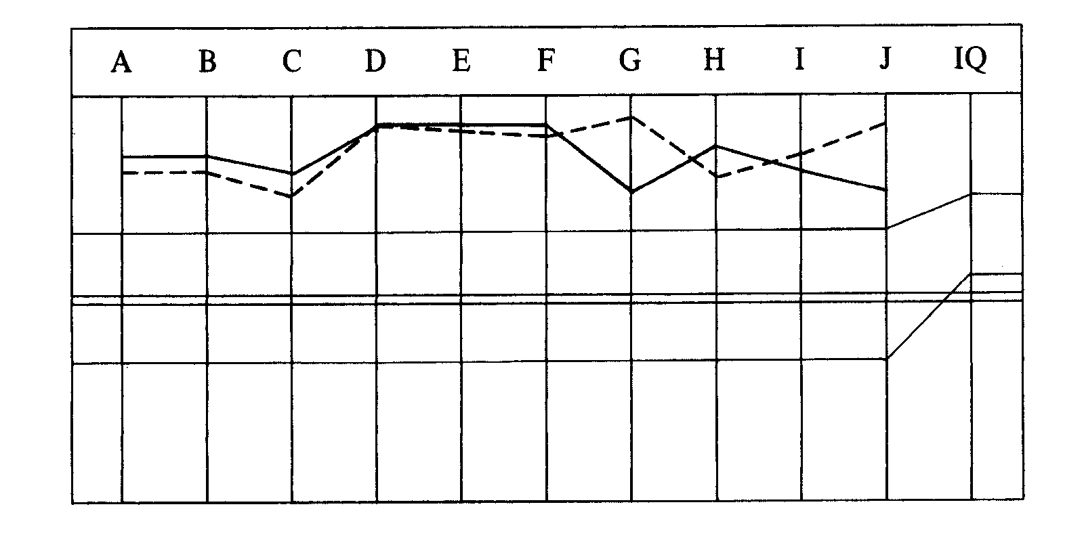

Total No. of sessions 26. Total hrs in chair 38 hrs 28 min.
EXP DN TEAM NOTE—
This pc remained stably off MO lines. The drop of three of the points on the right-
hand side of the graph was due to “no interest” in running R3R on all of his Ev
Purps. See HCO Bs Exp Dn Series 7 and 9.

Compiled by:
Flag Dn Spec Team
for the
BOARDS OF DIRECTORS
of the
CHURCHES OF SCIENTOLOGY
BDCS:MM:WS:ntm.rd
Copyright © 1972, 1974
by L. Ron Hubbard
ALL RIGHTS RESERVED

