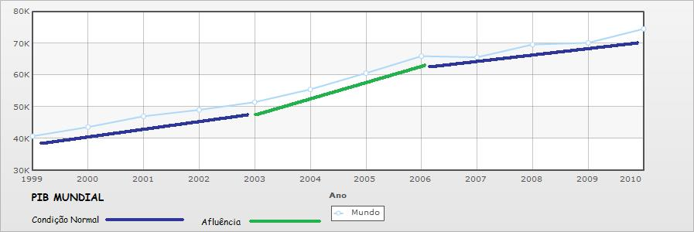

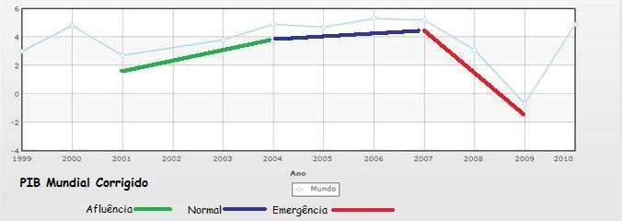

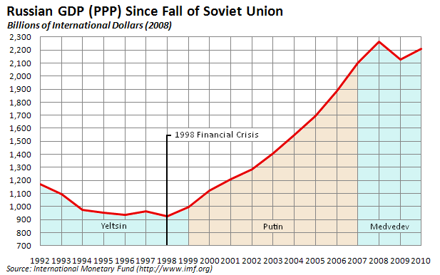

"Ano","Bielorrússia"

"1999","55.2"

"2000","78.8"

"2001","84.8"

"2002","85"

"2003","62.56"

"2004","70.5"

"2005","73.09"

"2006","82.94"

"2007","103.5"

"2008","114.1"

"2009","120.7"

"2010","131.2"

"Ano","Brasil"

"1999","1057"

"2000","1130"

"2001","1340"

"2002","1340"

"2003","1375"

"2004","1492"

"2005","1536"

"2006","1655"

"2007","1849"

"2008","1993"

"2009","2010"

"2010","2172"

Country19992000200220032004200520062007200820092010[Brasil](http://www.indexmundi.com/pt/brasil/produto_interno_bruto_(pib)_per_capita.html)6.1507.4007.6007.6008.1008.3008.8009.50010.20010.10010.800

"Ano","Brasil"

"1999","6150"

"2000","7400"

"2001",""

"2002","7600"

"2003","7600"

"2004","8100"

"2005","8300"

"2006","8800"

"2007","9500"

"2008","10200"

"2009","10100"

"2010","10800"

"Ano","Índia"

"1999","1805"

"2000","2200"

"2001",""

"2002","2660"

"2003","3033"

"2004","3319"

"2005","3666"

"2006","4156"

"2007","2966"

"2008","3297"

"2009","3680"

"2010","4060"

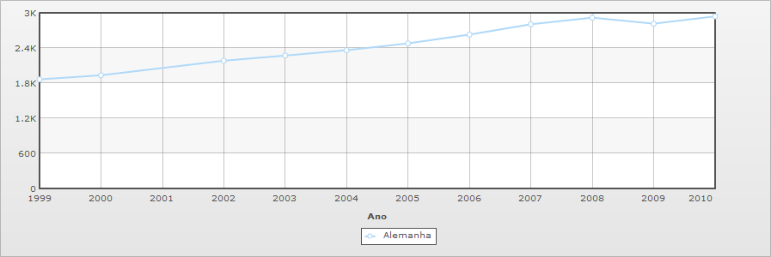

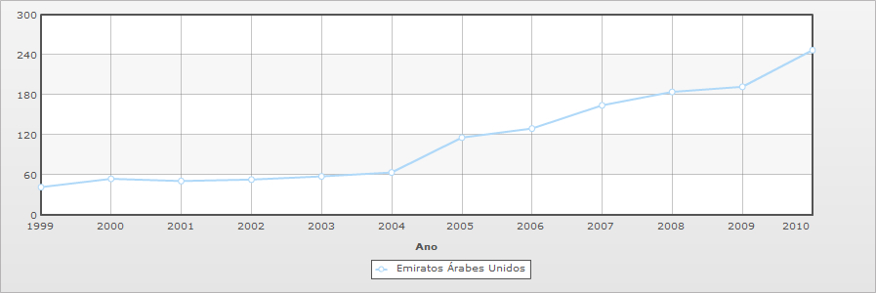

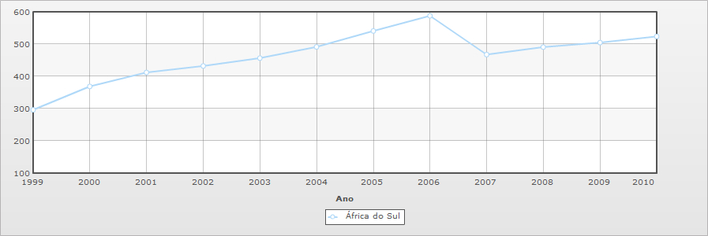

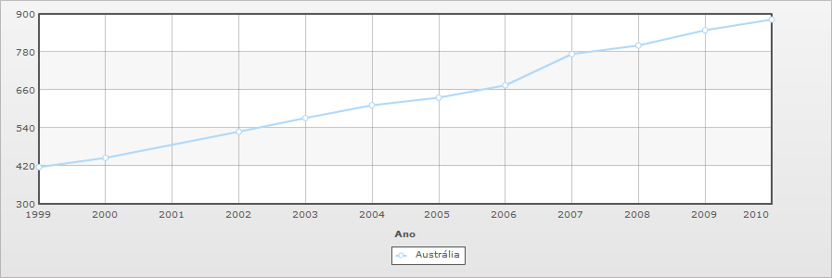

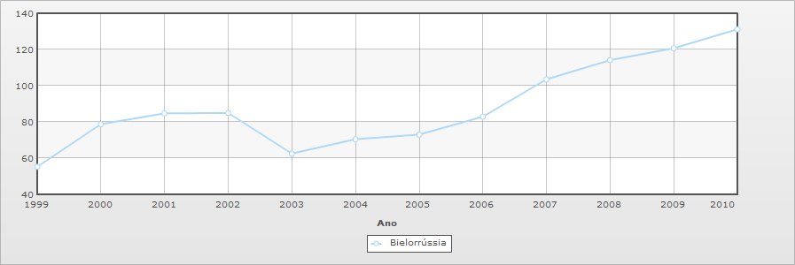

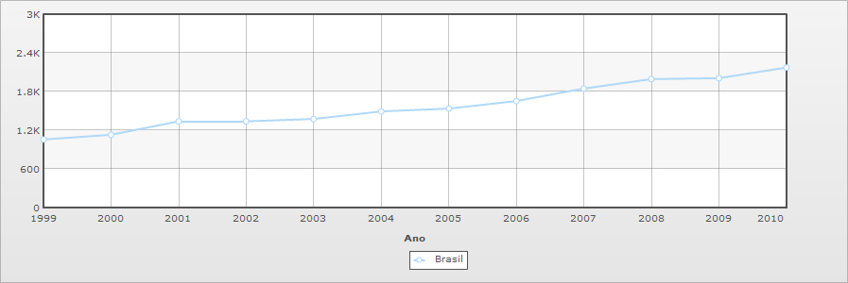

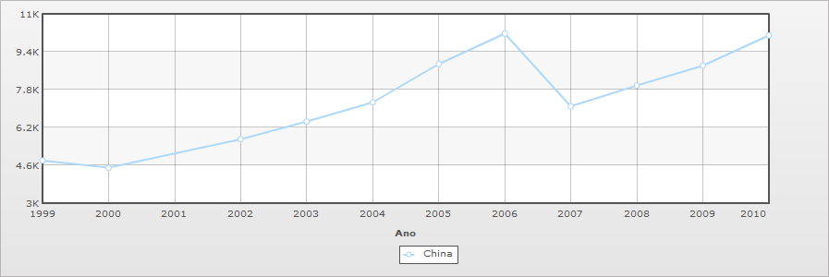

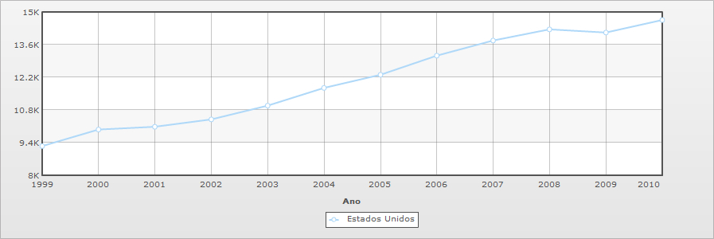

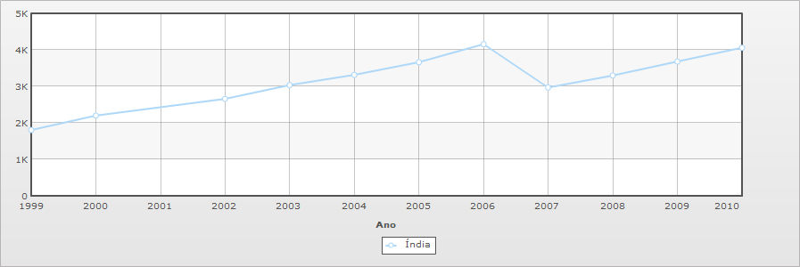

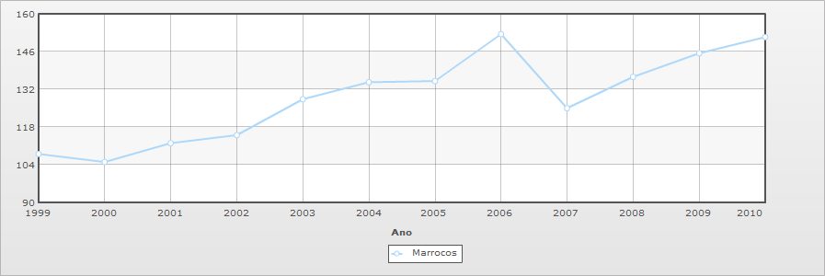

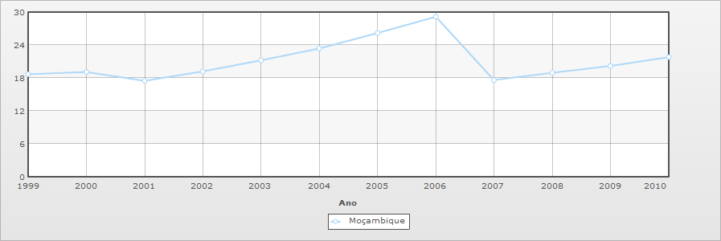

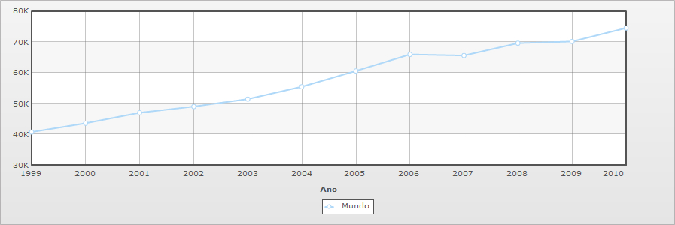

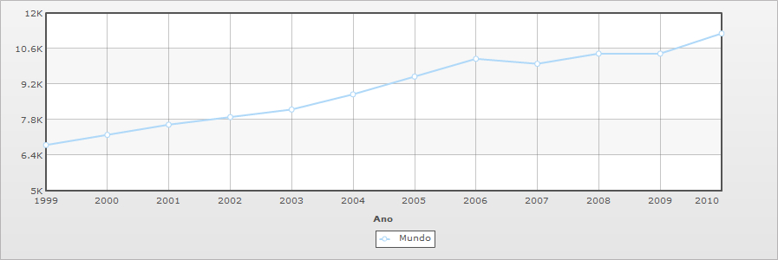  
PIB Mundial

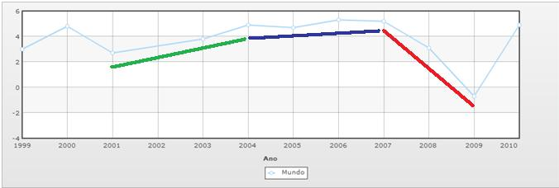  
PIB Mundial Real

