THE BRIDGE - THE ANTAKARANA
THE LINK BETWEEN MATTER AND SPIRIT - SCIENCE AND RELIGION

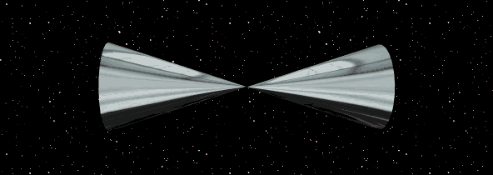

As humankind approaches the convergence of many great cycles, we wonder what lies ahead at this great juncture. We are approaching a New Age. The great Mayan cycle of 5200 years quickly approaches its terminus. Many sources, both scientific and spiritual, have spoken of great changes that are to be expected in this coming Great Cycle. And yet we still have wars and rumours of wars. Mankind totters between utter hopelessness and promises of a world filled with Light and Love.
Science and religion have for ages fought against each other. Great men and women have worked tirelessly for the fruition and joining of the scientist and mystic. We are now at the threshold of a new paradigm. It is the time for matter and spirit to be realized as One. This can only be accomplished by bridging the gap between these seeming two opposite realities. The Bridge, the Antakarana must include within itself both matter and spirit.
We offer the CONE EFFECT as the true Bridge that will in effect bring spirit and matter together. We take no credit for this reality as it was given to a man in a vision from the Higher Realms. We intend to show that the CONE EFFECT contains within itself all that is or ever will be. For it may allow, among other things, the Essence of the Creator to be manifest here in this third dimensional reality.

We intend to prove this mathematically, scientifically, geometrically, and spiritually. For if it is truly the Bridge, then it must satisfy all these disciplines.

We give honor and respect to the worlds scientists and theologians who have envisioned throughout history this Effect in their dreams. And yet the dream is no longer a dream.
The CONE EFFECT is here.

Additional Information
How the Cone Effect Came to Be
Cone Effect Theory (volume 1, number 1)

Any questions or comments? Please email us at: coneeffect@thegrid.net

