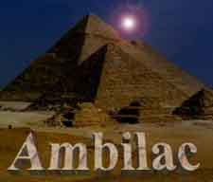

THE AMBILAC CORPORATION
Official Website
"SEARCHING FOR THE TRUTH"

Introduction
The material contained on this web-site has been carefully selected from the much larger works of the Authors involved. We will be selecting and presenting segments of the entire work over the course of the next several months. We are now in the process of moving all of our web publications from other sites and centralizing them here. When this is completed our visitors will be able to browse all our works in an more organized manner. New releases are now in progress and will be presented on this site soon.
During your visit, please sign our guest book. Leave your comments about our site, what you would like to see included and other input that you may wish to make. Your Feedback is important in helping us to serve you better. To visit our Guest Book please click here
This material is protected by international copyright agreements. This material may not be used by others without the express written permission of the Authors.
© James M. Wilkie
© Howard Middleton - Jones
With Additional Research by Julie King
Such permission is generally granted only to subscribing members of the Ambilac Newsletter Program.
Please consider subscribing to the Ambilac Newsletter. You will get up to date news and information delivered right to your email box. Our newsletter contains Breaking News that is not presented on our Web- Sites. We offer a weekly subscription for a small fee.

April 2001:
The Upcoming Energy (Magnetic) Shift
Ambilac Corporation
WWW.AMBILAC.COM
(NOTE: Most links on this page will open in a new window to aid in your navigation.
Most pictures will open to a full-size representation in a new window.)

Shortly, there will be a shift of Earths Magnetic Energy field, this in turn will advance our Time Line. Several changes will occur as a direct result of this shift in energy, particularly occurring on the earth’s outer crust due to the alterations as our planet makes its necessary adjustments down, and through towards the core. This sharp shift in the adjustment will cause our polarity (pole axis) to shift very quickly. Many events will come about during this controlled shift, or as a direct result of this shift.
Thus, in this article we explain how this shift will affect the Spirit or Soul when this occurs. In this explanation we will cover such topics as the weighing of the Heart, the reading of the Book, and explain exactly what the circumcision is, and how this ties directly into our personal responsibility in carrying out our part of our Covenant with GOD.
As stated above this will be a controlled shift, we will now explain why this is a necessary event and MUST occur, within a very narrow window of opportunity.

ESAU would see this world and it’s inhabitants completely destroyed, rather than allow us the opportunity to exercise our Free Will choice, that being to move forward following GOD’s WILL. God’s will, therefore, his Law, allows for the physical in addition to the non-physical to co-exist in a harmonious fashion. The heartbeat of the physical Earth itself is presently out of sink with the Galactic and Universal heartbeat. This occurred as a direct result when the Dark side encased the planet within the artificial “RED” Grid. What this Red Grid did in effect was remove this planet so that it’s heartbeat was no longer allowed to grow and be strengthened, or keep pace with the rest of the Universal bodies, of which it was previously beating in harmony with. This soon to be realised ‘controlled shift” will be executed in order for the Earth to swing back into the Universal harmonic pulse timeline.
“IF” this controlled shift were not to take place prior to Dec. 21st 2001, the Earth would be destroyed as it approaches the present “Universal” timeline, which it must do in order to prepare itself for the transition, which it must undergo prior to the “End Time” of Dec.21st, 2012. This is the date that the “Universal Heartbeat” will once again begin, requiring all that must be in harmony at that time. In Earth time the, “0” time is the time relative to Earth which will pass is equal to the pause between the present Universal heartbeat and it’s next heartbeat. Keep in mind that it is a full year (one complete rotation) both going into this “0” time as well as exiting it.
At the present time the Earth is under extreme pressure as a result of the very existence of the “Red Grid”, having removed the planet from it’s natural ability to adjust itself under normal growth rate etc. When the “controlled” shift takes place, the entire world will shake and vibrate violently. In addition we will witness that TIME itself will seem to come to a standstill, this aspect will be short lived however, as the Earth swings back into the Universal Timeline. If this shift were left to occur on it’s own in December, this shift would definitely cause the planet to dislodge itself from it’s present orbital path. However, as previously mentioned this event will be a very “controlled” shift, and much help has been brought into the inside of the “Blue Grid” in readiness to stabilise the Earth, and allowing to maintain its orbit. This help is presently sitting in readiness in the 4th and 5th dimensions, making them impervious to any attack from the dark side working within this 3 Dimensional world.
This particular assistance entered into our space immediately prior to the large quake that occurred in India at the end of January. As these people were “Lifted” and rescued, it was found that their SOULS were extremely distressed and required much counselling. It was then decided that people MUST be made fully aware of what is happening so as to help them by removing this FEAR through understanding. On the LIGHT side there is no fear present as all is understood and the Dark side is forbidden to enter. It is imperative that those whom have made their free will choice emit a feeling of Love rather than Fear, for those emitting Love will be easily recognised and lifted quicker (KEEP IN MIND THAT WHEN YOU GET THAT DISORIENTED FEELING THAT YOU JUST RELAX—LET THEM DO THE WORK). Those whom emit fear make it much harder for those helping with the lift to know of your choice and consequently they must then read the AURA, to determine one’s intent.
The only other point that MAY hold one back is Negative Karma. This negative karma is caused by the failure to have dealt with past events which one’s soul is therefore still connected to those events. To DISPOSE of this Neg. Karma, at this time, it is as easy as asking the following: Forgive us our trespasses, as we forgive those whom have trespassed against us.
Over a period of several years many people have been given implants, these implants were embedded into various people for the purpose of control. This alien technology is compliments of the GREYS. A negative group of humans has used the Montauk program to facilitate the procedure by allowing them to remove the subject into another time frame, implanting them, then returning the subject back into the subjects’ real time (but only a few seconds later). This is not so hard to believe when one questions events such as HOW do they get to a downed crash site seconds after a crash, in addition no one actually sees them coming, or going!!
These implants are generally implanted for one or two reasons…the first to control all those who work unknowingly on these Black Projects. This also includes those in the public sector who would have come forward and made public that which THEY did NOT want anyone to be aware of. This same “time hopping” has been implemented to divert public attention from any news releases that were destined to draw public awareness to the events going on around us.
MOST of the GREYS have vacated this planet, as we explained in a previous article, there is however, a small contingent remaining presently housed in Nevada. They will be dealt with soon enough. But one of the advantages of this Energy Shift will be that all the implants that they have been placing into peoples’ bodies, will no longer be functional….. MANY will AWAKE!!
This Energy Shift has already occurred and was successful! However, we have not arrived into that Time Frame yet. That is when ESAU began to dig into Phobos (we will explain this scenario in a later article, for now first things first), but to help to explain in the meantime, an interesting and extremely relative article may be found under the title; THE STRANGE CASE OF FOBOS-2 (“Fobos” being the Russian spelling) which can be found at
http://www.space.com/sciencefiction/phenomena/fobos_mystery_000630.html
Here on the planet itself the Dark side pawns (The NewWorld.Order or NWO) are instituting a collapse of the monetary market, and as history will tell you this will help them to launch a WAR. This scenario, as they will soon find out will not go as they planned.
Some of the 2Dimensional diagrams we will be utilising throughout the rest of this article are borrowed from our work on the DNA, and how its process is calculated (or spelt out) once the overall Giza model is deciphered. Although we would suggest that people work with the diagrams to help visualise the material, we caution that some of the diagrams may not be those best suited for exactness in relation to the material. But these were stock material pictures that sufficiently offer the visual as it relates to the topics discussed. The variance comes about due to the capture of the angles of the 3Dimensional model. We have attempted to use only the pictures which were top view, as they offer the best angle for 2D viewing, however some of the angles are shot from offset angles. We might also reiterate that the measurements and placement of all Pyramids, Temples, Causeways etc. located on the Plateau….DEFINITELY support the information, which we now put forth.

Pi and Phi
Both Pi as well as Phi is precisely depicted on the plateau using the FULL model, in that the precise size and location of the various structures etc. mark VERY SPECIFIC points.
Khufu- centre point (point in question)
Khefre- represents the pi element as it relates to Khufu.
Menkaure- represents the phi element as it relates to Khufu.
The Queens Pyramids- of both Khufu and Menkaure are used to show how both pi and phi are incorporated into the Duality of the Living Earth (and/or man).
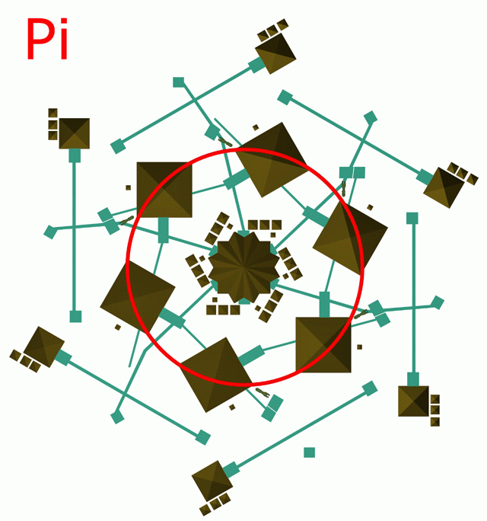

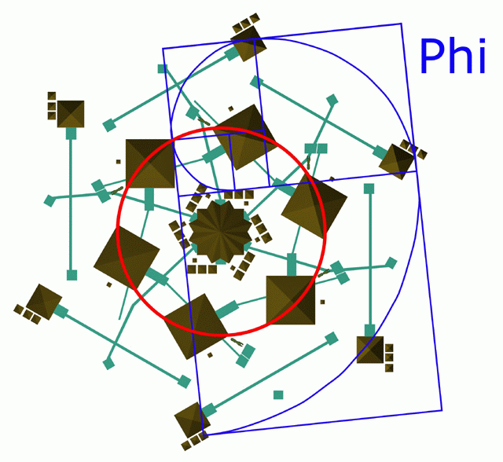

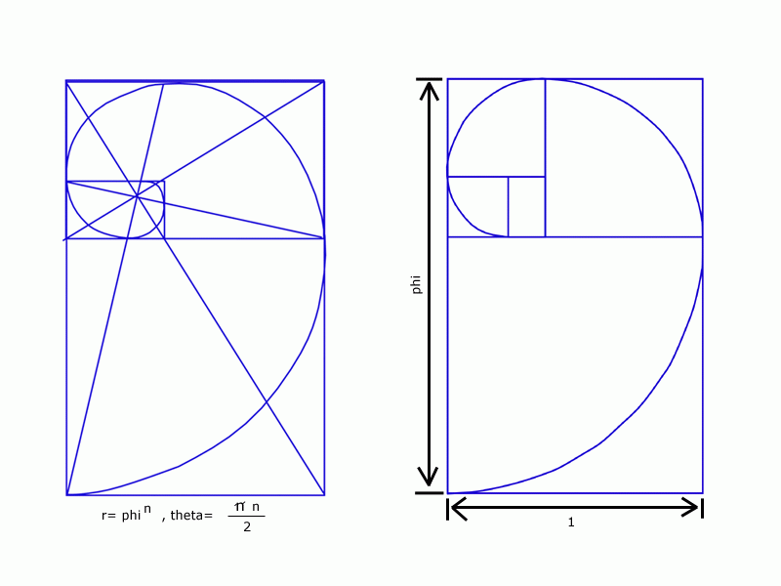

Re: DUALITY
The Sphinx that sits just above the PI, is a fair representation of MAN in his Duality. The depiction should be viewed as follows; The Body of the Sphinx is that half representing the animal/beast in ourselves, and rising above the physical body of the beast is Man. Meaning that the physical (or the Beast) is the equivalent of PI, in that it’s cycle is that which is born –lives and then dies. The Head which rises above the “Beast” is that representing the SOUL of MAN, that which only the PHI can breath the Breath of Life into the physical body of the Beast. PI being a closed system and PHI a forward spiralling system, beyond that yet incorporated into the PI cycle. This is definitely NOT to say that animals are without souls or life force, for they are all Gods creations. Whenever the Double Helix is present in the DNA makeup the Duality is present.
Many years ago we were informed through one of Edgar Cayce’s readings, that the Hall of Records was located BENEATH the RIGHT paw of the Sphinx. This is very important as well as being VERY symbolic, that being the history of man laid beneath the Right paw verses the Left. There is a HUGE distinction to be drawn between the left verses the right.
The distinction is contained within both the Biblical texts and Egyptian symbolism – as depicted through hieroglyphic and the diverse visual Egyptian art forms.
As a demonstration relevant to our article, the prime example used in the Book of Genesis is non other that the story of the birthing of ESAU and JACOB.
Genesis 25:25
Now the first came forth red all over like a hairy garment, and they named him ESAU.
25:26
Afterward his brother came forth with his hand holding on to Esau's heel, so his name was called Jacob; and Isaac was sixty years old when she gave birth to them

As the Beast was born first, that being Esau, clutching onto his right hoof /foot clung Jacob as he too was pulled from the womb. This is the story of the History of the Duality of Man, first the PI (or Beast) emerges and due to very existence of PI it is there that PHI comes into being…thus the duality of man begins.
The Right side represents the “BEAST” for it is the flesh that is first created. The Left side follows and with it carries the other half of the Duality, that being the “Breath of life” or the “SOUL. Thus it is found that the History of man would lay beneath the “Right” foot, in this case the right paw of the Sphinx. The next is the Left, to symbolise the potential future of man, as the Left foot is placed forward on its journey towards Ascension.
One will notice that in most Egyptian statues of standing figures they are depicted with the “Left” foot forward. This symbolism is to help the subject “GET OFF ON THE RIGHT FOOT”- that foot is the LEFT foot towards its journey in the afterlife. This leaves our animal or physical body behind on one’s journey to Helopolis (City of Light).
Later in the article we will be drawing our attention to the Egyptian symbolism as it is found in Egyptian art forms.

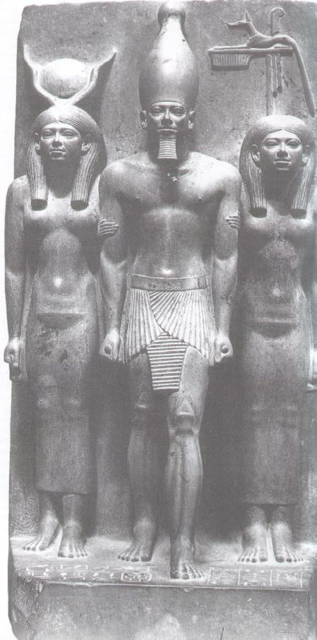
Menkaure, with the goddess Hathor on his right, and the personification of the 17th Nome of Upper Egypt on his left. It was discovered in the valley temple of Menkaure at GIZA in 1908.

SACRED GEOMETRY AND BIOLOGICAL IMMORTALITY
A highly relative article to our ongoing research at Giza is the above title by Dan Winter at www.danwinter.com/introduction. In this article it explains how sacred geometry and biological immortality are connected by PHI, or the golden mean ratio. It has been discovered that PHI has been found in the frequency between harmonics of the heart at the moment of sending love. In addition, it is found in the frequency between the harmonics of the heart at the moment in the ratio of the moment of maximum pressure in the shape of the hug or squeeze you give to send love.
To make a succinct overview as related to our overall related research, the PHI wave is and can be embedded on other waves, or lineages. For example the earth wave (lineage) is embedded on our sun’s wave (lineage), which in turn is embedded on its star point of origin and so on. The result is recurrence and perfect sustainability; therefore, the key to our ascension process is the perfect wave of love – phi frequency –, which brings us to the ancient Egyptian ceremony of the “weighing of the heart”.
In this ceremony, as we have previously discussed in detail, the heart weighs lighter than the feather and thus the soul of the deceased is “allowed” or “qualified” to pass through into the Duat, the afterworld, where Osiris reigns. This then is the embedding of our souls, we embed our souls to the creator and in so doing one carries the frequency of our ancestors within our own soul.
Thus in effect is the process of how the covenant, and our lineage are fully carried forward onto the next level. This “chain” can never be broken, but on occasions may be halted at any point in time/space by the mere decision of “soul choice”.
Keep in mind that the human heart is located on the LEFT side.
LET YOUR SOUL BE FREE
In our last article, Lift up Your Hearts, we made the stunning revelation of the true identity of the entity whom has been our source and guide of much information since HIS awakening under the Giza Plateau on May 5th 2000. We also pointed out that a given sign will be witnessed and discussed the understanding of the soul and free will choice, and so it is now in this update where we will offer an explanation of the process that will set our soul energy free.
Thoth, the judge of right and truth of the Great Company of the Gods who are in the presence of Osiris, saith: Hear ye this judgment. The heart of Osiris hath in very truth been weighed, and his Heart-soul hath borne testimony on his behalf; his heart hath been found right by the trial in the Great Balance. There hath not been found any wickedness in him; he hath not wasted the offerings which have been made in the temples; he hath not committed any evil act; and he hath not set his mouth in motion with words of evil whilst he was upon earth.
THE SPEECH OF THOTH:
From the BOOK OF THE DEAD…or PAPYRI OF ANI
In one of our previous articles THE EIGHTH DAY we also included the following;
Genesis
17:9 And God said to Abraham, "As for you, you shall keep my covenant, you and your descendants after you throughout their generations.
17:10 This is my covenant, which you shall keep, between me and you and your descendants after you: Every male among you shall be circumcised.
We explained at length the meaning of the above and its connection with our lineage, where the circumcision as relates to Genesis, symbolises the covenant made between Yahweh and his people. This symbol is often found in much ‘older; civilisations, but in Biblical Hebrew it literally means to cut a covenant.
We also gave this message from one Euphraim (Joseph’s second born)
THIS MESSAGE FROM EPHRIAM....
Send my message to all those who now suffer. I am here to bring FREEDOM. FREEDOM and FREE WILL are one. A message also to those Tyrants, "you know who you are" you will be suppressed as you have suppressed others. Be warned...the time is now. The choice is yours. The choice is FREEDOM.........
And from OSIRIS...
We love you...regardless of everything else we will push through the Love
From Update – a given sign

THE COVENANT
THE BALANCING OF THE HEART AND SOUL
Over recent months many have been enquiring as to the purpose of and the "qualification" for being of the COVENANT. In this section we will attempt to offer a brief overview in order that one may at least grasp some modicum of understanding, bearing in mind that this is an extremely complex scenario, where we do not profess to have all the answers.
Over the aeons of time our true ancestral ‘origins’, due in part to the many genetic interventions and variations, may never be fully realised. However, by reading through the ancient Egyptian and Biblical texts, and applying the analysis that we consistently followed, we may be able to open a crevice towards an understanding of this subject.
Before we submit our understanding of what people term the COVENANT, a few pointers may be helpful.
We must initially point out that we do not really know who’s names are written in the book of the Covenant, it is basically a personal thought on belief or faith. However, it is believed that in the main it would be the original tribes of what we call ‘human kind’, those possessing human DNA. In addition, those people who agreed to keep the spiritual connection, and have continually done so, including those who have asked to be saved and forgiven.
Which brings us onto our last point, those whose hearts balance out to the feather of truth, Mayet.
By examining the Biblical texts and comparing those of the ancient Egyptian texts for example, we may be able to see a substantial amount of similarities. Indeed, are they but the same record, but over long periods of time, interpretations and translations confused and lost in the swirling mists of time itself.
According to ancient Egyptian "mythology" the beginning of our world rose from the primordial waste of waters, Chaos or Nun, known as infinity or ‘nothingness’. It was said that Atum rose from Nun and known as the ‘Father of the Gods’ and often represented as standing waist deep in water holding aloft his hands supporting a solar barque (boat).
Continuing with our example, we have Nut, the sky goddess who was married to her brother Geb, the earth god, and as a result of their union, conceived two daughters, Isis and Nephthys, whom we shall now explain in this scenario of the COVENANT.
Nephthys was married to Set (Seth), but her loyalties were to her brother Osiris, god of the underworld and resurrection. It is understood that Nephthys bore no children with Set, so disguised herself as Isis and committed adultery with Osiris, consequently she bore ANUBIS, god of embalming.
Nephthys abandoned Seth after he had brought about the death of OSIRIS (who split Osiris’s body into many parts) lamenting over the death with her sister Isis. Indeed it
was the custom at Egyptian funerals for two women to impersonate Nephthys and Isis and lament over the body of the deceased.
The baby ANUBIS was discovered by Isis in reeds in the Delta marshes of Lower Egypt and adopted him. A familiar theme one may ask?
The parts of the body of Osiris were scattered over Egypt, but found and put together by Isis and thus with the help of Anubis resurrected. Horus, their son, took revenge on his father’s demise and killed Seth.
This is the essential background to understand the part that Anubis, Osiris and Thoth play in the ceremony of the WEIGHING OF THE HEART, or SOUL upon death.
In ancient Egypt people who died were known as OSIRIS X, and once pronounced dead were judged in the hall of the judgement of the underworld, whereby the dead person was answerable to himself. Located in the centre of this hall, (the hall of two truths or double justice) would be a large weighing balance. Beside this balance would be Mayet, the personification of spirit of justice or of world order, and ANUBIS to ensure the scales are balanced and that the heart of the deceased used no trickery in the weighing procedure.
Thoth would be in attendance to record the outcome and to ensure the heart had a fair chance to justify itself.
Anubis would weigh the heart against the ostrich feather of truth, Mayet, while below waits AMMUT (a hybrid, part lion, part hippopotamus and part crocodile) to devour the heart if not justified!
SPEECH OF THE DWELLER IN THE EMBALMMENT CHAMBER (ANUBIS):
Pay good heed, O righteous Judge to the Balance to support [the testimony] thereof. Variant: Pay good heed to the weighing in the Balance of the heart of the Osiris, the singing-woman of Amen, Anhai, whose word is truth, and place thou her heart in the seat of truth in the presence of the Great God.
The heart was considered the seat of intelligence and therefore responsible for man’s actions and conscience. If the heart was equal in weight to the feather, truth, the soul
was then proven innocent, thus the great Enniad of gods ratifying a favourable verdict. Thoth would then record the results kept in THE BOOK.

The meaning of the weighing of the feather:
Many will recall the Testament advice that there shall be NO OTHER GODS BEFORE ME. NO CRAVEN IMAGES and so on. This is because MANY have forgotten the Covenant with HIM, they still have yet to believe in the ONE GOD!! MANY follow or worship false God's and Deities, and yes, even Money is worshipped. Thus, this worshipping of these false God's adds weight to the HEART...Until one truly lets go of these false God's their individual Hearts will weigh more than that of the feather....
Once these initial events have taken place, the "SEVENTH SEAL" will be opened and all those wishing to depart this time event will leave. Others will then arrive and the seal closed.
The seventh seal will be opened no later than December 21st. 2001 as this is the point in time that the window of opportunity to do so will close. This being when the Sun’s “0” alignment and the Earth’s “0” alignment time will intersect. The following Diagrams are in addition to those found in our article “Turn up the Tunes” but in addition are from our work on the DNA modelling.
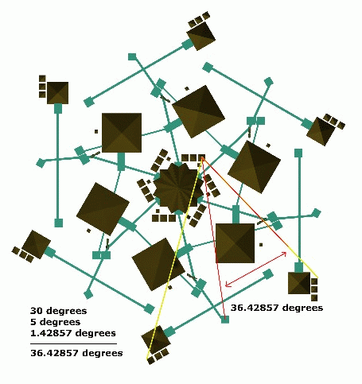
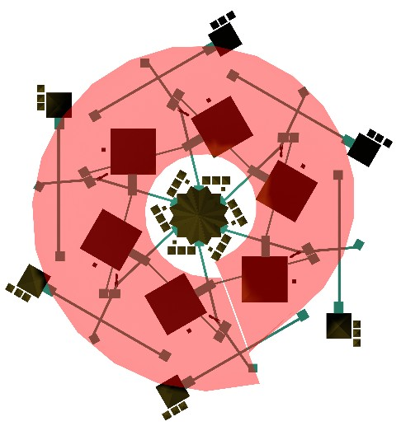
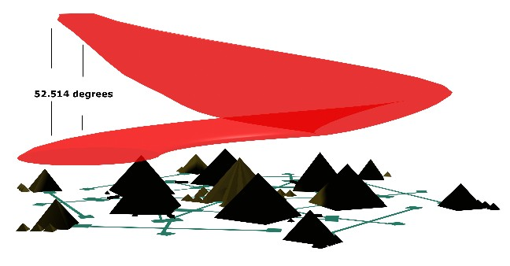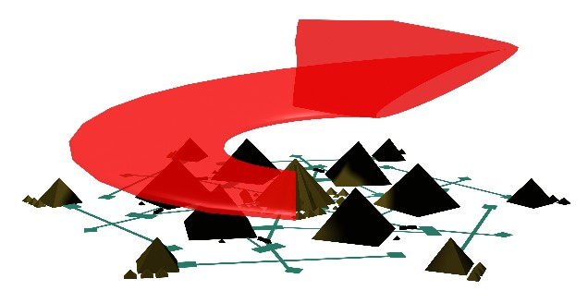

It is believed that the sixth seal opening was the arrival of the comet Kahoutek
http://www.millenngroup.com/repository/cometary/marshit6.html

While for a fuller explanation as to the possible scenario about to unfold link to question 15 and answer on the site of the LITTLE PEBBLE
http://www.shoal.net.au/~mwoa/important_events/frequently_asked_questions.html

THE FLAIL AND CROOK - SLAVERY OR FREEDOM?
(The Mark of the Beast)
In this section we will explain the relevance and importance of the “Royal Regalia” (the flail and crook) often seen in figurines of Osiris and that of the representation of Pharaohs on their outer coffers, where they are seen to hold these symbols in either hand. It is the method and by which hand they hold and represent these symbols that we will discuss below.
The main concept that we intend to explore (and for you to understand) is the idea that the flail and crook (traditionally considered to be symbols of government and authority) are in fact symbols of slavery and freedom, opposing concepts of the spiritual. We then go one further and suggest that the flail, a symbol of slavery, may have its origin in what the Book of Revelation termed “the mark of the beast” or the number of man.

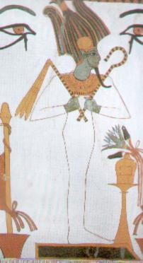
However, to understand the complexities of the depiction of art in ancient Egypt, and therefore to come to an understanding of our conception one must understand the contemporary concepts of daily life, afterlife and culture.

FRONTALITY IN EGYPTIAN ART
It must be realised that the style and purpose of Egyptian art make little sense without a detailed understanding of the culture. Essentially, all art forms were functional, whether painting or sculpture, and were concerned primarily with the continuance of life. That is, not to reflect reality but to replace and perpetuate it.
The aesthetic achievement varied, but the purpose remained the same – to represent, influence and manipulate the real world.
The portrayal of each individual element of a subject was made from the most representative angle. For example; the human torso and the eye were best viewed from the front, while the arms, legs and face best seen from the side, thus confusing the overall effect. This often causes Egyptian depictions of human figures to appear distorted and inconsistent to the modern eye. This is also evident when we come to view depictions of figures in relief on stone and Pharaohs on outer coffins, where we observe their arms in a cross over position covering their chest. In this pose the flail and crook is also evident, being held in each hand, and it is this representation of which hand each is held brings confusion to many.
Like Classical Greek statuary why then did they not discover the geometric rule of perspective, and why was left and right muddled? This has nothing to do with the skill and imagination of the artist, but everything to do with the purposes for which they were producing their art!
The Flail and Crook.
In ancient Egypt the flail, or flabellum, was known as Nekhakha, and associated primarily with the Gods Osiris and Min, while the crook was termed Heka.
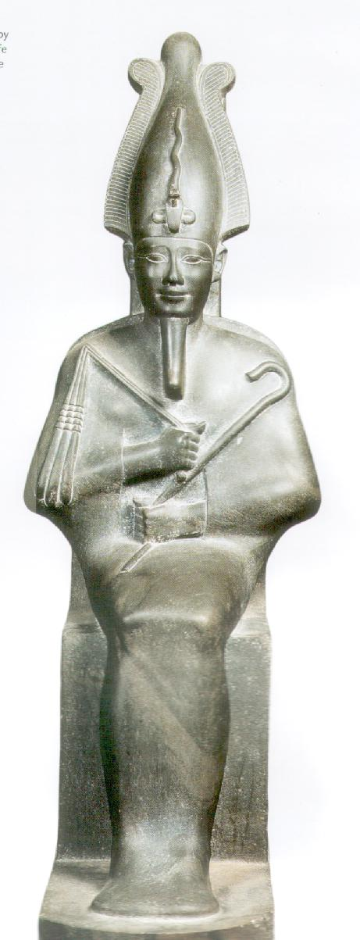
As we mentioned above, these royal regalia symbols are often seen being held in the hands of figurines of Osiris and on the outer coffers of the representation of the Pharaoh.
In the case of the Osiris figurines, all are usually observed in a standing position with the flail in the right hand and the crook in the left hand. In the prone Pharaoh, the majority of cases one can observe the hands crossed over the chest area, where the flail is held in the right hand and the crook in the left hand. In this case the right hand is held to the left shoulder, while the left hand is held to the right shoulder. Having said that, there are cases of the Pharaoh merely clenching each fist while bringing up the arms to rest on the chest, without actually crossing the arms. So, to all intent and purpose in this case the right hand is held to the right shoulder and the left hand held to the left shoulder.
Bearing in mind our earlier artistic explanation, it is this representation that can offer some confusion in a few cases. However, it is our finding that the flail, representing slavery, is always held in the right hand, and the crook, representing the shepherd staff leading to freedom, held in the left hand. This is meant to depict that HE is leading HIS people.
It is interesting to note that upon a Pharaoh being entombed, small wooden figurines (known as shabtis or ushabti’s) are placed in the tomb with the Pharaoh. These shabti figures are also seen holding the flail in the right hand and crook in the left hand. Ushabti means “answerer”, and they were placed in the tomb to spare the owner from menial corvee’ labour in the afterlife. Some are decorated with the text of chapter 6 of the “Book of The Dead”, and thus known as the “Shabti chapter”.
We now go one important step further and suggest that the flail, or symbol of slavery, held in the right hand is in fact the depiction of the mark of the beast as mentioned in Revelation. It is this “sign of man” who would endorse slavery, thus those who embraced the flail are of the “right hand” and so marking them on the right arm.
Further, and equally, the mark of the beast on the forehead relates to those whose mindset is one belief of the slavery concept.

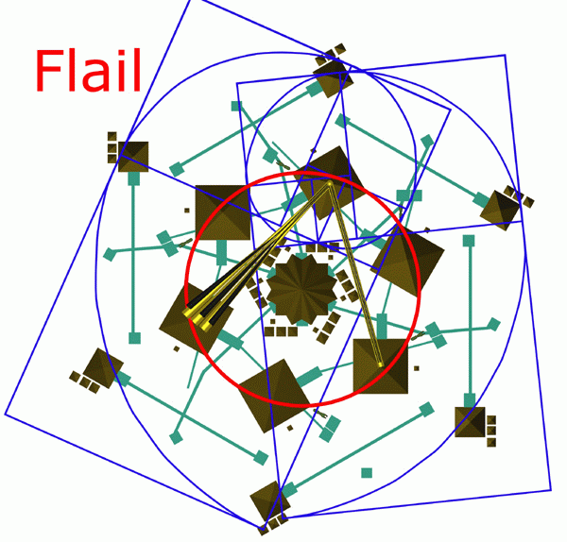

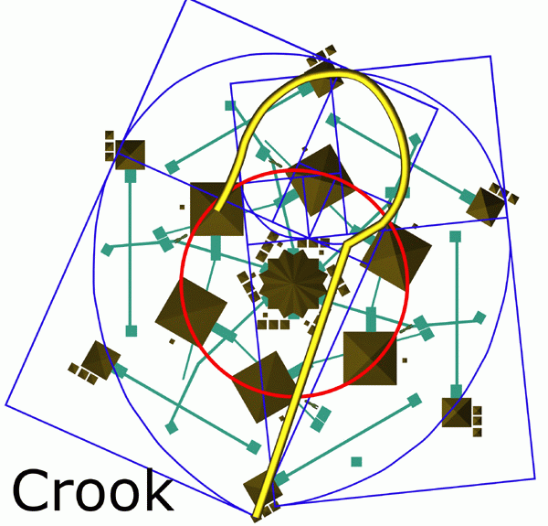

Revelation 13:16
And he causes all, the small and the great, and the rich and the poor, and the free men and the slaves, to be given a mark on their right hand or on their forehead.
13:17
and he provides that no one will be able to buy or to sell, except the one whom has the mark, either the name of the beast or the number of his name
13:18
Here is wisdom. Let him who has understanding calculate the number of the beast, for the number is that of a man; and his number is six hundred and sixty six.

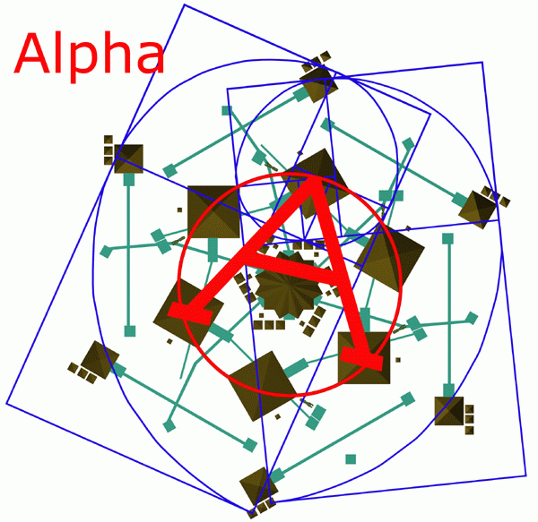

Paternoster
In 1868 it was reported by Berem Saklatvala, in The Christian Island, there was found in Cirencester (England) a small piece of wall plaster from a Roman building. On this plaster were the following words making a word square.
ROTAS
OPERA
TENET
AREPO
SATOR
In 1926, Felix Grosser suggested that the above could be used in the form of a cross to write – ‘Pater Noster’ twice – thus

A
P
A
T
E
R
A PATERNOSTER O
O
S
T
E
R
O
The A’s and the O’s are the Latin equivalent of the Greek letters ALPHA and OMEGA that were used as a symbol of Christ.
Interestingly, a similar square was discovered at Pompei and four versions at Duro – Euopos on the Euphrates. Pompeii of course was destroyed in AD 79, thus the square must be related to that year or earlier.
Notes
Latin English
Pater Father
Noster Our or our /for us. So Pater noster = our father
Opera Service or work
Sator Sower/planter or father

In the following diagrams, the Red circle represents the closed cycle and consequently referred to as Pi. Overlaid on the Pi are the Phi sets (of which there are three). The reason for these three sets is that there are three lineages, which we have explained in detail in earlier articles.
The Queen’s Pyramids located alongside (the outside edge of the model) the pyramid Menkaure give us our three points of measurement, that being the centre pyramid is our direct lineage, or our “0” line. The pyramids on either side of the centre one give us our point of measurement to which the other two lineages align. To make it two-dimensional we have drawn in the two lineage sets on the flat plane rather than at their proper angles, for the time being this is sufficient in order to visualise the information. Also, take note of the location (of each corresponding endpoint) at which each finish. For it becomes obvious that all three outer Queen’s Pyramids end up aligning to the Inner Queen’s Pyramids, which are found located on the plateau alongside the primary pyramid on the plateau, the Pyramid of Khufu.

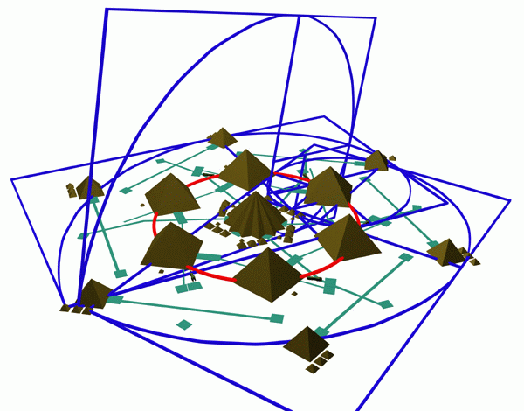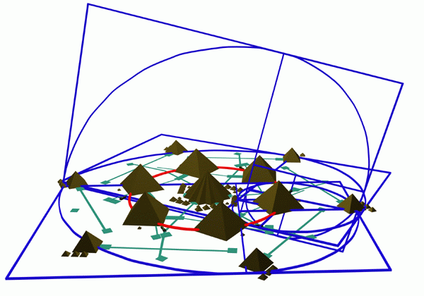
Remember that Christ was physically staked on the cross. This is to say that his physical body was put to death within the world of the lesser Pi or often called the ALPHA. But Christ is the Alpha and the Omega.

For far greater is the life which Phi breaths into us, and this we call OMEGA

As an aide, we will briefly show how the ancient Mayan’s derived their Long Count Galactic Calendar, and how they arrived at the 13th Baktun (or the square of one).

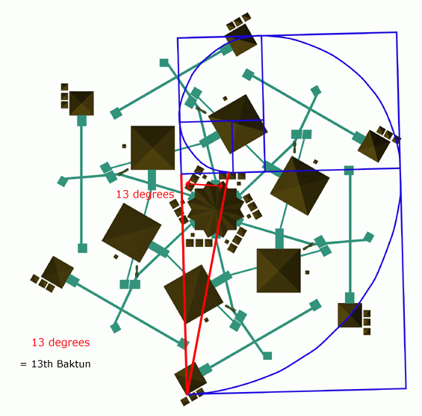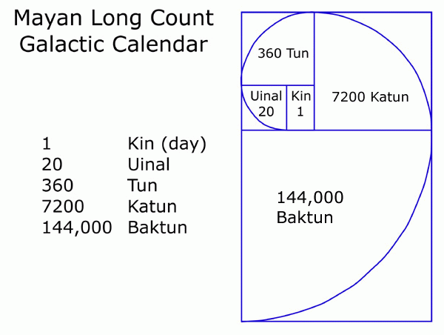
The solar field captured below is from an image dated May 6th 2000. As we have stated in our previous article we are ONE year removed from the Galactic Timeline. The question then remains did we enter this Stargate last year and have yet to realise the effects of that event at our present point in time?? We will know in a few weeks, it would have to be prior (only a matter of days before) the 6th of May of this year….we believe as much as 8 or 16 days prior. One must always factor in the centre point however.

This final picture is a drawing that was created by a colleague whom was shown this imagery whilst he was in a lengthy coma. The symbolism contained in this drawing appears to us to be quite timely, as we prepare for the events to unfold shortly.
EMBED Word.Picture.8

BEAUTY AND THE BEAST –
THE CHOICE OF LOVE
Further to our discussion of the flail and crook and weighing of the heart, let us now consider the human body. To the left of the vertical mid-point of the body is our heart - to the right is our liver. Now consider what is the purpose of each of these organs. The heart we have already explained, being the repository of our thoughts and actions, while the liver is the organ for cleaning toxins from our body. Toxins, or poisons to the human body, taken in by eating foods that are not good for our body, we can relate this also to any toxic thoughts, which in turn affects our choice of food.
So what then is the purpose of the crook? And what is the purpose of the flail? The crook guides and protects, while the flail beats and punishes. Which produces the better effect? Certainly the shepherd through his crook protects his lambs, guides them to food and safety, and the lambs grow strong through the peace provided by the shepherd and his crook. The guard however, with the flail holds his charges with fear, causing pain and loss of appetite, even loss of life, certainly loss of free will, providing no peace for his charges.
On a higher level, the left side of the human body represents the higher GOD and the right side represents the beast. We have both in each of us. By strengthening our heart, through loving thoughts and actions, we can overcome the beast in ourselves. On a mass scale, by more people choosing GOD through love, the strength multiplies geometrically, causing enough love to overcome the beast in others, who have not yet made a choice.
Many will feel fear at the events about to occur. This of course serves its purpose, in that the fear rises up, allowing a person to know there is a choice between fear or love, beast or GOD. It is at this point that many will choose. Some will choose love and GOD at this point, but the strength of the beast in many will cause the choice to be made for fear and the beast.
WE CAN OVERCOME THIS AND HELP THOSE WHO NEED ASSISTANCE IN MAKING A CHOICE!
By choosing love now, GOD now, and overcoming the beast in ourselves before major events occur, we negate any fear that may try to rise in us. The geometrical progression of love, caused by the many making a choice prior to events occurring, overflows. This overflow of love and GOD will assist others, who have not made a choice and are fearful, to also choose love and GOD. In the case of the shepherd, the lost lamb will follow the shepherd of its own free will. However, if the lost lamb is found by the guard with the flail, it has no free will, but will try to flee the flail, and not succeeding, will be punished with pain.
The left side of the human body has often been called the “feminine side”. This does not relate to gender, but to nurturing. Consider a mother and wife, ever the nurturer, just as the shepherd is to his lambs. By choosing love and GOD, we will nurture the fearful ones.
We will overcome the beast in each of us, which will disallow our beast-fear energy to be given to Esau/Lucifer. Therefore, he will no longer be able to hold us as slaves to his flail.
BE READY TO HELP THOSE THAT NEED ASSISTANCE….WE WILL OVERCOME.
If someone requires sustenance, give it. If someone needs sleep, provide the means. If someone needs an ear or a shoulder, give them gladly. Through our own state of grace by choosing love and God, we will gladly help, protect and nurture those who come….which in turn will ease their fear and strengthen the energy of love, the energy which GOD requires to Free His People.
On a further scale, energy of the love we rightfully choose, the Covenant we rightfully uphold travels through the blue grid back to Giza. There it combines with everyone’s love energy, fed back through the blue grid to all and everything on Earth, even Earth herself. By choosing love, choosing God, we nurture all here and we protect all here by strengthening the blue grid. Can we strengthen the grid enough through our own personal choice, which geometrically magnifies, to prevent the entry of Esau altogether? It is all up to us. What will you choose?

Howard Middleton-Jones (UK)
James M Wilkie (Canada)
Julie King (Australia)
APRIL 2001
WE PRESENT :
THE GENESIS-GIZA CONNECTION
PART VII
....................
Ambilac Corporation
SUBSCRIBE to the Exclusive Ambilac Newsletter

" Plese Note ; This page uses clickable thumbnail images. Click on an image and you will be directly linked to an enlargement of that image. Please use the back button to return to this page. " Enjoy the Ambilac Voyage of Discovery!

HORUS - THE KEEPER OF THE ARK OF THE COVENANT
The Giza Plateau Connection :
The connection between the Great Pyramid and the method of access to the " Ark of the Covenant " - The Crystal, deep below the Giza Plateau.

PREFACE:
Those of you who have been following the articles and regular updates on our websites, will have realized our true agenda, that is, the search for the truth, and to bring that truth, whatever the consequences and debate it brings, into the public domain.
We have introduced, via diverse means, the many complex and, at times what may have appeared to be bizarre, revelations in our search to reach the ultimate goal that is, to offer you the background and real purpose behind the complex construction and layout of the Giza Plateau. In analyzing this ancient pyramid complex, it has appeared, that we have in front of us a veritable plethora of data to prove out our very origins on and off, this planet and to the make up of the cosmos itself.
As the dawn of the new year 2000 materializes, we too would like to offer an enlightened revelation of literally cosmic proportions. The evidence and research displayed below is the culmination of many years research and investigation.
It is hoped in offering this material it will help to dispel the many rumours and rumblings of the purpose and purport of the so-called ‘pyramid complex’ located on the Giza Plateau, Cairo, Egypt.
Enjoy.
Howard Middleton-Jones
James Michael Wilkie
January 2000

From The Journal... ... ... ...Of Jim M. Wilkie
~~~~~~~~~~~~~~~~~~~~~~~~~~~~~~
~ My mind awakes From its burdened path
To find a sphere Devoid of knowledge, Adverted by Popular belief,
Inlaid by self hate, An enthralled trail of mystical wisdom,
Sprouting only unto thy seed, A laxness so tensely strung
So as to have removed the melody, And wisdom diminishes mechanically
Envision, envision a perfect peace, So totally alienated from now
Grab, grab that second hand, Of geologic time
And ride it back, back to the beginning Only then do I make sense
Belief – begins, Balance – withstands, Emotions - alter states
But knowledge is impeccable. ~
© James Michael Wilkie

WE BEGIN:
In the previous articles, ( see list below) we have explained the important relevance of the book of Genesis and the Giza Plateau pyramid complex, Egypt, as a blueprint as to the origins of planet earth and its inhabitants. In addition, we expanded on the importance of the date December 21st 2012 and the planetary alignment connected with the layout of the Giza complex. While in the update CRYSTAL CLEAR and in the more recent articles, THE FINAL COUNTDOWN and THE EXPERIMENT we explained the location of the main focal crystal below Giza and the connection via a GLOBAL GRID where crystals are to be located at other ancient sites.
In this vitally important update, we are placing forward an explanation as to the location, method of construction and opening mechanism of the hidden chamber that will lead to the so termed ‘Ark of the Covenant’ (or, more precisely, The Crystal!) that lies deep below the Giza plateau.
This essential and most sought after information is the ultimate goal of many researchers and agencies, which have been attempting to gain access and therefore control for some time.
The entry to this ‘hidden passageway’, which ultimately leads to the location of the ‘Covenant’, can be found via the Grand gallery within the Great Pyramid of Khufu. ( Cheops )
Image Of Cheops
.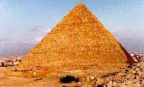
The following information will be the most important set of data released so far, where we will furnish the evidence and information required, in order to activate the mechanism within the Grand gallery of the Great Pyramid of Khufu, and thus provide access to the hidden chamber. This in turn will lead to the covenant, or crystal, whereby advancement of same (to stabilize the earth’s core thus to provide a ‘shield’ around our atmosphere) should be realised ASAP. The method of advancement and identity of the person/s who can effect this maneuvre has been dealt with in THE EXPERIMENT.
Prior to our divulging this information, it is imperative that the reader comprehends the Giza complex as a whole, that is the relation of the Great Pyramid (G.P), the Ark of the Covenant, and the separate location of the so-called Hall Of Records (HOR).
THE HALL OF RECORDS:
If one follows the article on the AMBILAC site (Ambilac news), the entrance to the HOR can be seen to have been established under the south paw of the Sphinx, but only when the Sphinx has been moved down to its calculated position. That is after moving the entire associated valley temples, etc to their aligned position.
This location was given as:
Lat. 29 deg. 58’ 29"
Long 31 deg. 08’ 28"
As we follow this important evidence, it may prove useful to bear in mind the following information. The present location of the Sphinx is exactly 15 degrees, when calculated from the west end of the right paw, up to the mid point of the bottom casing stone located on the east side of the Great Pyramid. From that very point, it is precisely 30 degrees in elevation to the centre point of the sarcophagus (the ‘Coffer’) located in the King’s chamber. This enables us to point out that from the Hall of Records we can establish the precise location of the tomb of ‘OSIRIS’! Indeed, the sarcophagus of Osiris and the sarcophagus of the King’s chamber are the same! Remember the adage of the Hermetic texts, ‘as above so below’, in this case it is ‘as it is inside, it is outside.
This same principle may be applied to the location for the SECOND tomb, as marked out in the case of Khefre. The location of this tomb is calculated from the data, which represents the corner angle, of the entrance to the Great Pyramid is derived from. Thus the location of the first and third ‘Queens’ pyramids adjacent to the Great Pyramid. More of these pyramids in the section below.
THE COVENANT, OR THE CRYSTAL:
Having now established the location of the HOR, in the following article we are now imparting to you the knowledge of the separate location of the ‘Covenant’. We consider this to be one of the most important pieces of knowledge divulged so far, and rightly should be shared with those interested and concerned with the future of this planet and all that dwell upon it.
The hidden chamber, as we will explain in detail, is accessed through an opening in the Grand Gallery, from where an access point, under a thin rock located in the floor of the room, will ultimately lead to the ‘covenant’. This chamber, where the ‘Covenant’ can be found, is formed by a natural cavity within the limestone below the Great Pyramid.
However, this structure, known by most as the ‘Covenant’, is in fact The CRYSTAL, of which we have discussed in detail in our previous updates. This complex crystal emits the BLESSING, or the shield as explained in our article THE EXPERIMENT.
On the eastside of the Great Pyramid are located three smaller ‘satellite’ pyramids, known as the ‘Queen’s pyramids’, as they were thought to be associated with the wives of the Pharaoh Khufu. The middle pyramid of these three lies on the line which precedes the chamber of the Covenant, which in fact is located under the adjacent southern pyramid known as Horus, or Isis. Link to AAA for a view from this pyramid. It is this room which is only accessed from within the hidden chamber via the Grand Gallery. The passageway leading from this hidden chamber to the inner room is shown inside the Great Pyramid by the presence of the WELL, both in its method of entry as well as its exit. That is, the doorway leading out to the horizontal subterranean chamber. All of these ‘measurements’ and markings are incorporated into the Great Pyramid’s overall design.
Bearing this revelation in mind, we continue….
The information below is intended to enlighten certain agencies and researchers as a catalyst, in which to instigate proceedings towards timely access to this site of extreme importance.

DECIPHERING THE INTERIOR OF THE GREAT PYRAMID:
The site must be deciphered in its entirety.
Entrance to the hidden passageway must be exact, but on the other hand must be constructed so as to avoid accidental detection. Therefore, the construction of a mechanism to access the inner sanctum must be made to ensure any attempt at entry would be a major undertaking, a co-ordinated team effort.
A "key" or code of great complexity would have to exist in order to gain access to this subterranean site. Thus the following information has been deciphered, understood and mathematically applied, so as to give the location leading to the hidden passageway and in turn access to the "covenant" or crystal.
THE PHYSICAL EVIDENCE:
To comprehend as to what this is all about in our search for the hidden chambers and thus to the stored ’covenant’ under the Giza plateau, we must begin by identifying and deciphering the intricacies involved in the layout of the Giza Plateau once more.
For your convenience, and ease of understanding we have placed a number of illustrated links, thus it is essential to view these graphics in association with the text to understand this complex layout.
In addition, it would prove useful to have read the AMBILAC site, (Ambilac news section on the Giza layout) and taken on board the related graphics.
We commence at the point on the baseline due east of the satellite (Queen’s) pyramid of the Great pyramid, termed as Horus, coincidentally between which can be found the Temple of Isis. From this point on the baseline, a line is drawn directly to the intersecting point, where the procession way (of Khufu) abruptly changes direction by 15 degrees and then heads on up to Khufus’ mortuary temple. This angle is found to be precisely 50 degrees (Using our baseline as 0 degrees). Interestingly enough we find that a line drawn out in the opposite direction (using the baseline as 0 degrees reference point) at 51.42857 degrees not only crosses over the right paw of the sphinx but it crosses over the exact point we previously described as the entrance point to the ‘Hall of Records’.
The above figures of 50 and 51.42857 degrees are highly significant figures as we will soon see, while the other notable angle is the 15 degrees shift in the procession way. It is this 15-degree angle we will now explain.
Remember, the original angle as it left Khufu's’ Valley Temple from the Southwest corner was originally 30 degrees as it heads out directed towards the pyramid of ‘Horus’, the 15-degree correction we find is now culminating to the centre of the Great Pyramid. The original angle of 30 degrees being split exactly in half resulting in being directed at the centre of the east side of the G.P. We then start back at the Valley Temple and begin to extend a line out from the centre point of the West wall at exactly 15 degrees to find that the end point intersects with the N.E. corner of the G.P. "Shades of Mirror Imaging." To be exact it lines up precisely to the centre point of the corner casing stone.
Once that single point was identified, the entire complex then opened up completely for decipherment, doing so in the following manner.
Recalling the 50 degrees and the 51.4285-degree angles and where they were shot from, it transpires the angle of the incline of the Great Pyramid when measured from that centre point of the casing stone is precisely 50 degrees. The angle when measured from the outside edge of the casing stone is a very precise 51.4285 degrees. (It is worthy to note that from the point we measured up and found the 50 degree incline there is a very precise 10 degree arc spread between our 50 degree angle and the angle of the incline on the outside edge of the casing stone).
Next, taking the small pyramid up from the bottom baseline, incline it inward placing the mid point on the centre of the casing stone measuring point. It is then sized so that it's end points align to the centres of the north and east face of the Great Pyramid. Bear in mind the small black pyramid (in the Ambilac diagrams) that was brought up was extended out along the original baseline and terminated in the exact spot of the much larger red pyramid (And was also used to locate the H.O.R.) Further evidence demonstrating that this had to be constructed in this manner is the shadow of the small black pyramid which gave us the date of Dec 21st, is showing the sun sets in the West, not in the North. By moving the side of the small black pyramid to the east face of the Great Pyramid the shadow would then fall in an Easterly direction.
Finally, the north side. The Valley Temple side of the small black pyramid demonstrates that entry is made in the centre of an above ground structure or temple. The remaining elements on the plateau we will explain when we disclose the events and the physics which drive them as they will occur on Dec 21, 2012.
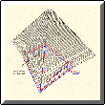
(click to enlarge)
We will now show you how to locate the entrance to the hidden chamber.
As with the plateau complex overall, one simply had to compute and read the layout and distinguishing features. We will also explain how to activate the opening mechanism.
We list below the important elements that demonstrate the calculations arrived at, after which an explanation as to how this all fits together will be described in detail.
1. First, prior to entry one is aware that the entrance is offset
24 feet or 1.42857 degrees from due North.
2. The angle of the Descending passageway is 26.28571 degrees, which should be 30 degrees (30-3.714285=26.28571)
3. The angle of ascending passageway is 26.28571 degrees, which should be 30 degrees (30-3.714285=26.28571) 3.7142857= arc spread of zero when 3 zeros intersect at 30 degree angles. Thus 1.42857= Value of zero
4. The Passageway leading to the Queen's Chamber from entry point of passage to the point where step down occurs and drops down to floor level, is equal
to 1.42857 degrees of arc.
5. From the corner when one first enters the Grand Galley and on the same level as the passageway leading to Queen's Chamber 30 degrees of arc, is the height of the top of the parallel ledges which run up the Grand Gallery.
6. From the outside edge of the G.P.'s casing stone at a level equal to the floor in the Queen's Chamber it is exactly 30 degrees of arc to the top of the roof of the King's Chamber.
7. The five (5) tiered niche inside Queen's Chamber begins at floor level, while the top of the peak of the King's 5 level ceiling has an arc between the 2 of 30 degrees thus the connection to the two.
8. The top tip of the roof over Queen's Chamber is offset from the centre of the hole in the floor of the Subterranean Chamber by 3.714285 degrees of Vertical arc.
9. The two stacked up, inlaid peaked rocks found above the entrance to the pyramid, point to the following. The peak of the lower one is exactly equal to the height of the floor level of the passageway leading to the Queen's Chamber. The upper one is exactly equal to the maximum height of the walkway in Grand Gallery where the passageway to Queen's Chamber begins, the point where the abrupt wall starts.
10. The angle correction to the existing ascending passage, measured from the point where the ascending and descending passage intersect to an exact 30 degrees, intersects the Grand Gallery walkway at the precise level as the base of the 34th. tier of the Great Pyramid. The 35th tier is equal to the floor level height below the 20th mortise.

Before we proceed to the understanding of how one can open this hidden passageway, via the grand gallery, the basic methods of construction must be understood. In addition the materials utilised, the location and the reasoning behind the builders’ selection.
In the Grand gallery are located 50 mortises, 25 on either side, into each of these a wedge is positioned, located between the post and adjacent wall. Each wedge is driven downward, causing a pivoting effect, thus pushing the bottom of the ledges outward while simultaneously causing the top to lean inward.
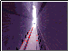
click to enlarge
The east and west ledge stones, lying either side of the gallery, are cemented together so as to move the whole as one stone, under these ledges is a layer of sand, deposited for a definitive ultimate purpose. The recent discovery of this sand, especially in the Queens chamber, and its purpose will be dealt with later.

METHOD OF OPERATING MECHANISM:
A continuous downward pressure from each of these wedges causes a rock at the lower end of each wedge to be forced out and subsequently fall. As these rocks fall, so does the layer of sand, thus creating a shifting surface below the ledges. This surface allows the walkways to rotate slightly, and it is during this process the two ledges separate further.
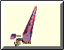
click to enlarge
This structure is composed of 11 rocks, but not all of these rocks will actually move, a few of the rocks along the top of the centre walkway will fall to expose the entrance to the passageway. The remaining rocks above and below this level will remain in place on the walkway. However, it seems that there are at least seven other rocks located beneath the walkway level, of which are best described as shaped, in part, like a girdle stone.

click to enlarge
These girdle stones are made of a harder granite rock and when released will slide along guides thus directing their fall, eventually landing on a bed of sand softening the impact, thus preventing shattering.
The main purpose of the granite rocks is to prevent accidental exposure of the opening itself, thus lessening the probability that a solid straight open cavity, or passageway, could be detected.
These granite stones have small wing-like protrusions extending out from the sides, and are there to hold the stones in place when the two ledges of the gallery are in the closed position.
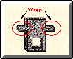
click to enlarge
This was accomplished by cutting cavities into the adjacent locations in the ledges themselves.
Initially, the ledges were built with their moveable rocks in place, in order to accomplish this the outside ledges were locked in an open position. As each rock was added to the ledge and cemented together, it was imperative that the ledges be left open as construction progresses.
The rocks themselves were held open by inserting posts up along the wall, adjacent to the ledges, finally wedging them into place.
To ensure that the walkway could be closed it was necessary to incorporate a method to release and remove these wedges and posts. This was realised by carving a cross-shaped indentation above each mortise.
Once the walkway reached the height to which the Great step was to be placed, a hole was drilled into both ledges and an iron pin inserted. Corresponding holes were then drilled into the Great step, which was then fitted to connect with the ledges. The great step now became part of the hinge mechanism.
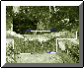
click to enlarge
Once the mechanism was in place, sand was poured in allowing the massive weight of the ledges to rest upon the sand, until such time when the opening be activated.
When the ledges were all in place, they were driven down into the horizontal section carved into the walls of the gallery above each mortise. These vertical sections of the carvings give the height and width of the posts required for operation to maximum efficiency.
Upon the wedges being driven down into these vertical slots, the posts and wedges could then be ignored and the capping stones of the centre walkway could finally be positioned into place.
By using the anomalies present (the various types of stone) in the passageway leading to the Queens Chamber, the total length of the hidden passageway can be calculated.
Upon entering the passageway, the type of stone changes to a much harder rock, while further along the passage it takes an abrupt drop of two feet. Thus the total length of where this harder rock begins, until the drop of point, is a significant factor.
Running horizontally, we find it to be equal to the length required for our new passageway to commence, carrying through to the point where our proposed point of intersection occurs.
The second clue is that in order to enter the existing Queens chamber one must step down, this is indicative that the passageway we are seeking must exist above this level.
Both ledges, which flank the opening, have five recesses cut into them directly opposite each other, these are all cut below the level of the walkway which runs up the gallery. Thus providing the evidence that the method of entry was present by the existence of these recesses that once held the centre walkway, and once the mechanism was activated, allowed them to fall.
If they had been free falling, the floor would have been anything less than smooth.
The next stage was the removal of the end of one of the side ledges so exposing the well shaft. It was near this entrance that the first iron pin was discovered. Further down the well, at the ‘Grotto’, a granite block is located with a hole drilled into it, this block was left to give the impression it had fallen down the well shaft from the entry point of the well inside the grand gallery.
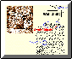
click to enlarge
The well shaft provided an area for the sand to exit into, thus allowing for easier pivoting of both side ledges. In addition, it is important to note that an additional pin was discovered embedded into the wall down towards the bottom of the well shaft.
There is also additional evidence incorporated in the great gallery. First, the moveable rocks located on the roof of the gallery are not cemented together, while the ceiling width is very close to being the width of the centre walkway running up the gallery. This allowed for the marking of the fifth corbel, which was previously established to be the fifth shaft, while also enabling the determination of the location of the sixth shaft and its point of intersection.
In addition, it reinforced the premise that when we lever out the two ledges on either side of the walkway, this would cause them to flare outward at their base.
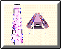
click to enlarge
This effect seems to have been caused as if the relative angle of the corbel ceiling had been wedged from above the ceiling itself. Thus driving down a one-inch wedge at the top would easily move the bottom of the rock out 3-4 inches.

Onward Inquisitor, Continue Your Reading At "The Great Step"

Click Here To Continue Reading On Next Page
SITE NOTES :
The Authors Of This Release
Howard Middleton-Jones
James M. Wilkie
» Please Send Us Your Comments And Ideas On What You Would Like To See Released On our Web - Sites. Send Us Mail Click Here
© . This web-site and the material contained herin is protected by international copyright agreements. Duplication and/or distribution of this material is prohibited without the express written approval of the authors. Such approval could be given, from time to time, to subscribers of the Ambilac Newsletter

Links :
For More Exciting Information Please Visit Directory And Find A Topic That Interests You.
This page was supported in part by The Driveway Corp. Visit the Driveway to Get Free Secure Online Storage! We thank you for helping to support our work.
