OTC WW |  | UK Conditions Order Nr. 1  28 May 1984

COMMITTEE OF EVIDENCE
FINDINGS AND RECOMMENDATIONS
INTERESTED PARTY: DAVID MISCAVIGE
[This is a back translation of the German Issue. The original is lost so far.]
We, the Committee met together on 5th May 1984 and verified all data and evidence regarding the charges of the Bill of Particulars which were given to us from people all over the planet. The following are our findings:
Note: The Interested Party missed to attend the meeting on 5th May as well as all other meetings which were convened by the Committee. Further, the Committee did not receive any material of evidence to the favour of the Interested Party.
Refusal or failure to attend by the Interested Party results in the recommendation of the highest possible penalty of the concerned Interested Party.

FINDINGS:

HIGH CRIMES
1. Mutiny: Guilty
Definition:
- Refusing work or persuading others not to work or refusing duty is a crime called mutiny – Admin Dictionary
- Revolt and often forceful resistance against a constructive authority – New World Dictionary
- Open revolt against constructive authority
Evidence by John Nelson, (ex-CO CMO Int. Dec. 81 – 82) shows that David Miscavige, at that time Chairman of the All Clear Unit, falsified in June 1981 a letter from LRH to take Diana Voegeding (CO CMO INT) off post. She was at that time David Miscavige’s constitutional senior.

2. Organizing a splinter group which takes and perverts Scientology materials or practices, in whole or in part, still calling it Scientology or calling it something else: Guilty
Definition:
- Splinter – a divergent group that breaks off from the main group.
- Dissent – refusal to keep up to rules and beliefs of the established church.
On 1st January 1982, the “Religious Technology Center” (RTC) was registered as a company in California. David Miscavige together with additional 6 staff were the “company founders” and “trustees”. No LRH policy existed with this order and until today there is no official issue written by LRH in regards to RTC.
From evidences which were given to the Committee we found that RTC is involved in many squirrel activities and perverted Scientology practices.

- Gang Sec-Checking: in October 1982, Jay Hurwitz the then T/ED LA Day, was taken to CMO Int.
“On the first day as I arrived at Int, I received a Sec-Check in Nazi-Interrogation style which was delivered by the highest authorities of Scientology. While I was on the meter, 4 interrogators who were in the same room, bombarded me with questions. These were - David Miscavige – one of the three highest Managers who lead Scientology today, Steve Marlow – Executive Director of RTC, Marc Yaeger – CO CMO Int, Vicky Aznaran – D/Inspector General.” Jay Hurwitz, 19.4.83
In October 1982, at the San Francisco Mission Holder conference, Mission Holders were also illegally sec-checked. The Sea-Org publication “The Sea-Org takes over” includes a picture of three people who were sec-checked in the same room by Sea-Org Officers. Violation of HCOB 30.11.78, “Confessional Procedure”.

- Declaration to Suppressive Person: The above mentioned Sea-Org Publication shows also a picture of David Miscavige who declared Mission Holder Martin Samuels. This was done right then and there and without convening a regular Committee of Evidence what would have been standard policy. (HCOB 16 May 1980 issue II, ETHICS SUPPRESSIVE ACTS, SUPPRESSION OF SCIENTOLOGY AND SCIENTOLOGISTS) Later in the meeting one of the Sea Org Officers, Norman Starkey (also one of the RTC-trustees), says “He, (Brown McKee, another Mission-Holder who was declared) will never, never ever again, which I promise you, in any life, ever again receive any Auditing or ever have a chance to get out of his trap and those who are on OT III know what THAT means! It means to die and die and die and die again.! “SO ED 2104 Int.
Kingsley Wimbush and Dean Stokes were also declared at the meeting.
Jay Hurwitz explains: “ During my stay at Int I was told repeatedly by the highest officers of the church that I would be hanged and excommunicated.” During this period was as well the idea implemented to legally pursue Scientologists (through RTC) – staff members and publics – as well as the policy of excommunication and the exclusion of OT levels and of any auditing and training for ever.” David Mayo, Letter of 8th Dec. 83.
This action of the exclusion for ever or “excommunication” is in contradiction to LRH’s teachings:
“It must be noted however that no matter how severe the case we never close the door entirely.” HCO PL 16 May 1980
“ You must keep the door open only if it’s just a crack.” HCO PL 16 March 1971 issue II.
Despite these policies RTC still keeps up the policy on “excommunication”.

- The “Running Program”: Many prior senior- and experienced church-executives including David Mayo, Kerry Gleason and Alan Buchanan were taken off post by David Miscavige and RTC and had to do the Running Program. This highly secure pilot-rundown was applied under the order of RTC and existed in that the PCs and OTs ran around a tree or pole until they were exhausted. Then they were requested to get up and run more often longer than 12 hours a day. As the result of these cruel programs the PCs suffered body injuries and impairments including sprained and swollen joints, strained muscles, physical exhaustion and loss of weight. This program of which they were told that was new LRH tech had to be done regardless of other case actions the PC was already on. This violates C/S Series 31, 38 and 42. For this program exists no HCOBs. Until now more than 300 people were sent to CMO Int, LA and Flag.

- Public statements against Scientology or Scientologists but not per Comm Ev’s duly convened: Guilty
At the San Francisco Mission Holder meeting on 17th Oct 1982, David Miscavige and other Sea Org Officers including Steve Marlow, Norman Starkey and Marc Yaeger, made many despised comments about leading Mission Holders as for example “Kingsley (Wimbush) is declared and actions were prepared to pursue him as a criminal. “These days of corruptions are over. These squirrel days are over.”
Three Mission Holders were verbally declared without Comm Ev.
After Diana Voegeding was taken off her post as CO CMO Int, David Miscavige gave an open statement in which he insults her: “… As Gale (Irwin) and myself were degraded he came specially out, stood himself up on the stairs with these people around him and yelled at us that he would personally make sure that we ‘never ever anywhere get back onto the Bridge’ and that we ‘never had done anything constructive’ “. Diana Voegeding Tape Debrief, Dec 1983.

- Reporting or threatening to report Scientology or Scientologists to CI VII authorities in an effort to suppress Scientology or Scientologists from practicing or receiving standard technology: Guilty
As already per the quotation from the San Francisco Mission Holder Meeting under complaint #3 shows, David Miscavige threatened certain individuals with police persecution. Larry Heller, a church attorney, employee of RTC said also at the Conference:
“If later one of you still uses any Scientology-Trademarks there will be reports of the offence to whatever criminal court it concerns because of unlawful business dealings with a possible sentence …. You will then get a fine or go to prison. “SO ED 2104.

- Receiving money, favours or encouragements to suppress scientology or scientologists:
The Committee has no reports in regards to this accusation.

- Pronouncing Scientologists guilty of the practice of standard Scientology, also pronouncing Scientologists guilty of the practice of the religion of Scientology.
The Committee has no reports in regards to this accusation.

- Engaging in malicious rumour-mongering to destroy the authority or repute of higher officers or leading names of Scientology or to “safeguard” a position: Guilty
David Miscavige and Steve Marlow took David Mayo (Snr C/S) and his staff members off their posts in August 1982. Shortly after this a black PR campaign was started to get the technical and personal reputation of David Mayo destroyed.
“David Miscavige told me about a month after my removal that he would destroy my technical reputation in case I would not ‘turn around’ to their way of thinking as too many people regarded me as an opinion leader.” David Mayo, 8 Dec 1983.
More technical investigations were conducted for this reason by Gelda Mithoff, Ray Mithoff and Mike Eldridge.
In August 1983 SO ED 2344 Int was published by the church. “Story of a Squirrel” which David Mayo publicly dammed in that they called him a Squirrel and enemy agent.

- Spreading false tales to invalidate Clears: Guilty
“Everyone who spreads around libellous comments and evil slender about the alleged behaviour of Clears should be declared as Suppressive Person from the first Ethic-Officer who hears about it. Investigations should look for a criminal background of person who spreads around such rumours.” LRH HCO PL 4. Aug 1966,.

- Spreading libellous and slanderous statements about the alleged behaviour of Clears: Guilty
As covered at Charge # 8.

- Seeking to splinter off an area of Scientology and deny it properly constituted authority for personal profit, personal power, or to “save the organization from the higher officers of Scientology”: Guilty
As in charge #2 explained, David Miscavige was one of the founders of the Religious Technology Center an organization that is not based on LRH policy. Miscavige placed his org on the top of the orgboards of the international church over the GO, ED Int, CMO Int and WDC. Charge # 2 gives evidence that they used Squirrel techniques to keep up their position.
To place RTC on the top of the orgboards, Miscavige had to get rid of many Senior Church Executives who possibly could revert his orders and stop his destructive actions.
In July 1981, Miscavige used falsified LRH Telexes and untrue letters of Church attorneys to remove Mary Sue from her post as Controller. In June 1981 he removed his senior Diane Voegeding, CO CMO Int, with a falsified LRH message. In December 1981 he removed Gale Irwin from his post as CO CMO Int in that he claimed to execute LRH orders. In August 1982 Miscavige removed Senior C/S David Mayo from his post. There were many more such incidents.

- Wilful misapplication: Guilty
Covered in charge #2.

- Bringing civil suit against Scientologists without first calling the matter to the attention of Ethics Officer: Guilty
Such procedures were exerted against Eddie Mace, Bernard Wimbush, Marian van der Linde, Don Hills and Lawrence West. Also covered in charge #3. See also crime #15.

- Organizing a splinter group to confuse people about the true beliefs and practices of Scientology or to deceive them into considering that they will be able to study part of all of Scientology or receive standard pastoral counselling from the splinter group: Guilty
We showed that David Miscavige was a main founder of the Squirrel group RTC. The Motto of RTC which is stated on top of all of it’s publications is: “ Protecting the only road to total freedom – the Religion Scientology”.
RTC Info Letter #3, 22 July 1983 states: “How did your case run on standard tech? You will find out and are certain in that you let your folder get send to the unit of RTC for Technical Inspection.”
The purpose of RTC per Info Letter #1 is: “to make sure that services which are delivered under the many marks and trade names in Scientology and Dianetics are 100% standard tech and that the Bridge stays clean, workable and reachable for all who want to become free.
The above is an attempt to cheat the public of Scientology to the effect that it thinks it could get standard spiritual advice and training from RTC or from organizations under their control.

CRIMES:
- Placing Scientology or Scientologists at risk: Guilty
Per the Auditor magazine that was recently published by the Church, 25 hours counselling cost now 5016 English pounds. The average person and with that the majority of people on this planet can’t afford this and the Bridge is definitely outside their ability to reach.
“By average pay is meant the average upper lower class or lower middle class pay scale.
One week's process (25 hours) should cost an average month's pay.” (HCO PL 23 Sep 64)
David Miscavige has set and enforced the current prices though RTC and the Int Finance Police’s illegally finance policy. These policies violate the above quoted LRH policy.
“It’s vital for a person who became clear to do the next necessary steps to go on OT I and get through until OT III. [Back translation, date of reference right now unknown.]
Clears who did not yet get though OT III and public who haven’t yet started on the Bridge were put in danger because of the current church prices which were enforced by David Miscavige and RTC and could not be paid by the public.

- Following illegal orders or illegal policies or alter-is, knowing them to be different or contrary to those issued by the International Board: Guilty
David Miscavige has failed to follow specific LRH policy in regards to prices and justice. He was a main founder of RTC which isn’t based on any LRH policy and which replaces approved management structure. He permitted the squirrel Running Program and was himself involved in squirrel Gang Sec-Checking. (See High Crime charge #2)

- Not directly reporting flagrant departures from International Board Policy: Guilty
See the above.

- Permitting a section, unit, department, organization, zone or division to collapse: Guilty
As the result of actions by David Miscavige to get rid of the majority of church executives and to put himself on top of the church organizing board, the Scientology Church collapses everywhere on the planet.
Since RTC was founded in January 1982 several Missions were closed or split off (Riverside, Omaha, Perth, Stockton, St. Etienne, Hannover, Palo Alto, Helsingborg are all split off) and there were many Suppressive Person declares. This has never happened before in the history of the Church of Scientology. Despite of this, RTC asserts that the Church of Scientology is internationally expanding!

- Condoning circumstances or offences capable to bring a course, section, unit, department, org, zone or division to a state of collapse: Guilty
See previous charges.

- Neglect of responsibilities resulting in catastrophe: Guilty
As covered in the previous charges.

- Being or becoming a Potential Trouble Source without reporting it or taking action: Guilty
As covered above.

- Using Scientology harmfully: Guilty
Covered in High Crime #2

- Using a local title to set aside the orders or policies of the International Board: Guilty
As covered in previous charges.

- Instigating a local power push against a senior: Guilty
As covered in High Crime #1

- Spreading destructive rumours about senior Scientologists: Guilty
See High Crimes.

- Falsifying a communication from a higher authority: Guilty
Covered under High Crime #1 whereby Miscavige falsifies a message from LRH to Diana Voegeding with which she was removed from her post as CO CMO Int.

- Causing severe and disreputable disturbances resulting in disrepute: Guilty
At the Mission Holder Conference in San Francisco Oct 82, Miscavige put the management of the Church of Scientology in bad repute in that he verbally and openly declared important Mission Holders, nattered about other important Mission Holders at that conference, insulted them and threatened them with imprisonment. Various Mission Holder of that Conference are since dropped out from the church and opened up several independent groups. (For example Bent Corydon and Serge Gerbode).

- Holding Scientology materials or policies up to ridicule, contempt or scorn: Guilty
Many HCOBs written by LRH with the help of David Mayo (during the time was David Senior C/S Int) are ridiculed and put out of force in SO ED 2344 Int “Story of a Squirrel: David Mayo”.

- Condoning the suppression of the word "Scientology" in its use or practice: Guilty
In September 1983 ordered RTC under direction of David Miscavige to take legal actions against Lawrence West of California because of the use of the word Scientology in his Scientology-practice.
“To communicate Scientology and to bring about a civilization for mankind.”
The activity to take legal actions against Lawrence West is an act of the suppression of the word “Scientology”

ADDITIONAL CHARGES:
- Forgery of Documents: Guilty
As shown in High Crime #1, David Miscavige falsified a message from LRH to the then CO CMO INT Diana Voegeding.
Based on additional evidence, which was handed over to the Committee, we have evidence that David Miscavige was an accomplice to the falsification of LRH’s signature on legal documents.
Irmgard Wassard, graphologist and member of the Danish Graphological Society, was presented with two original signatures of LRH, one written 1970 the other beginning of the seventies and two signatures which were done on the so called LRH/RTC agreement.
After thorough examination of all four signatures she explains:
- that the two signatures (1982) were done by the same person and
- that the person is not identical with the person (LRH) who signed with his name on the attachment marked H (1971 and 1970thies) since the questionable signatures show a variety of differences of the authentic writing which is typical for forgeries.

- Forgery: Guilty
Diana Voegeding explains in a written and testified report, that David Miscavige, in exercising the activity as Californian Public Notary, received signatures signed L. Ron Hubbard without that LRH appeared there. This is an offence against his status as Public Notary and is forgery per the Californian law.

- Violent Attack: Guilty
During the investigations, three involved persons were violently attacked by David Miscavige in the presence of others – Steve Marlow included. The attacked were John Aczel, Roger Barnes and Steve Warren. Marlow held on to them and Miscavige punched. Aczel ended up with a laceration and bruise on the temple and Barnes had a swollen lip. Warren escaped the hold of Marlow and did not get hit though his clothes were torn in the fighting. Aczel said that Miscavige had told him he would like to cut him in 1000 pieces and dump him at the local hospital. It was ACTUALLY spat at the above.” Jay Hurwitz, 19 April 1983.
The committee has also evidence of other criminal assaults.

RECOMMENDATIONS
References:
HCO PL 4 Aug 66 ETHICS, CLEARS INVALIDATION OF
HCO PL 16 May 1980 II ETHICS SUPPRESSIVE ACTS SUPPRESSION OF SCIENTOLOGY AND SCIENTOLOGISTS
HCO PL 29 Apr 1965 II ETHICS, REVIEW
HCO PL 7 Sep 1963 COMMITTEE OF EVIDENCE

We, the Committee of Evidence recommend that David Miscavige of Los Angeles, California, should

- be declared as Suppressive Person for activities that intend to suppress Scientology and Scientologists.
- be assigned a condition of treason toward Scientology and Scientologists.

Respectfully submitted by:
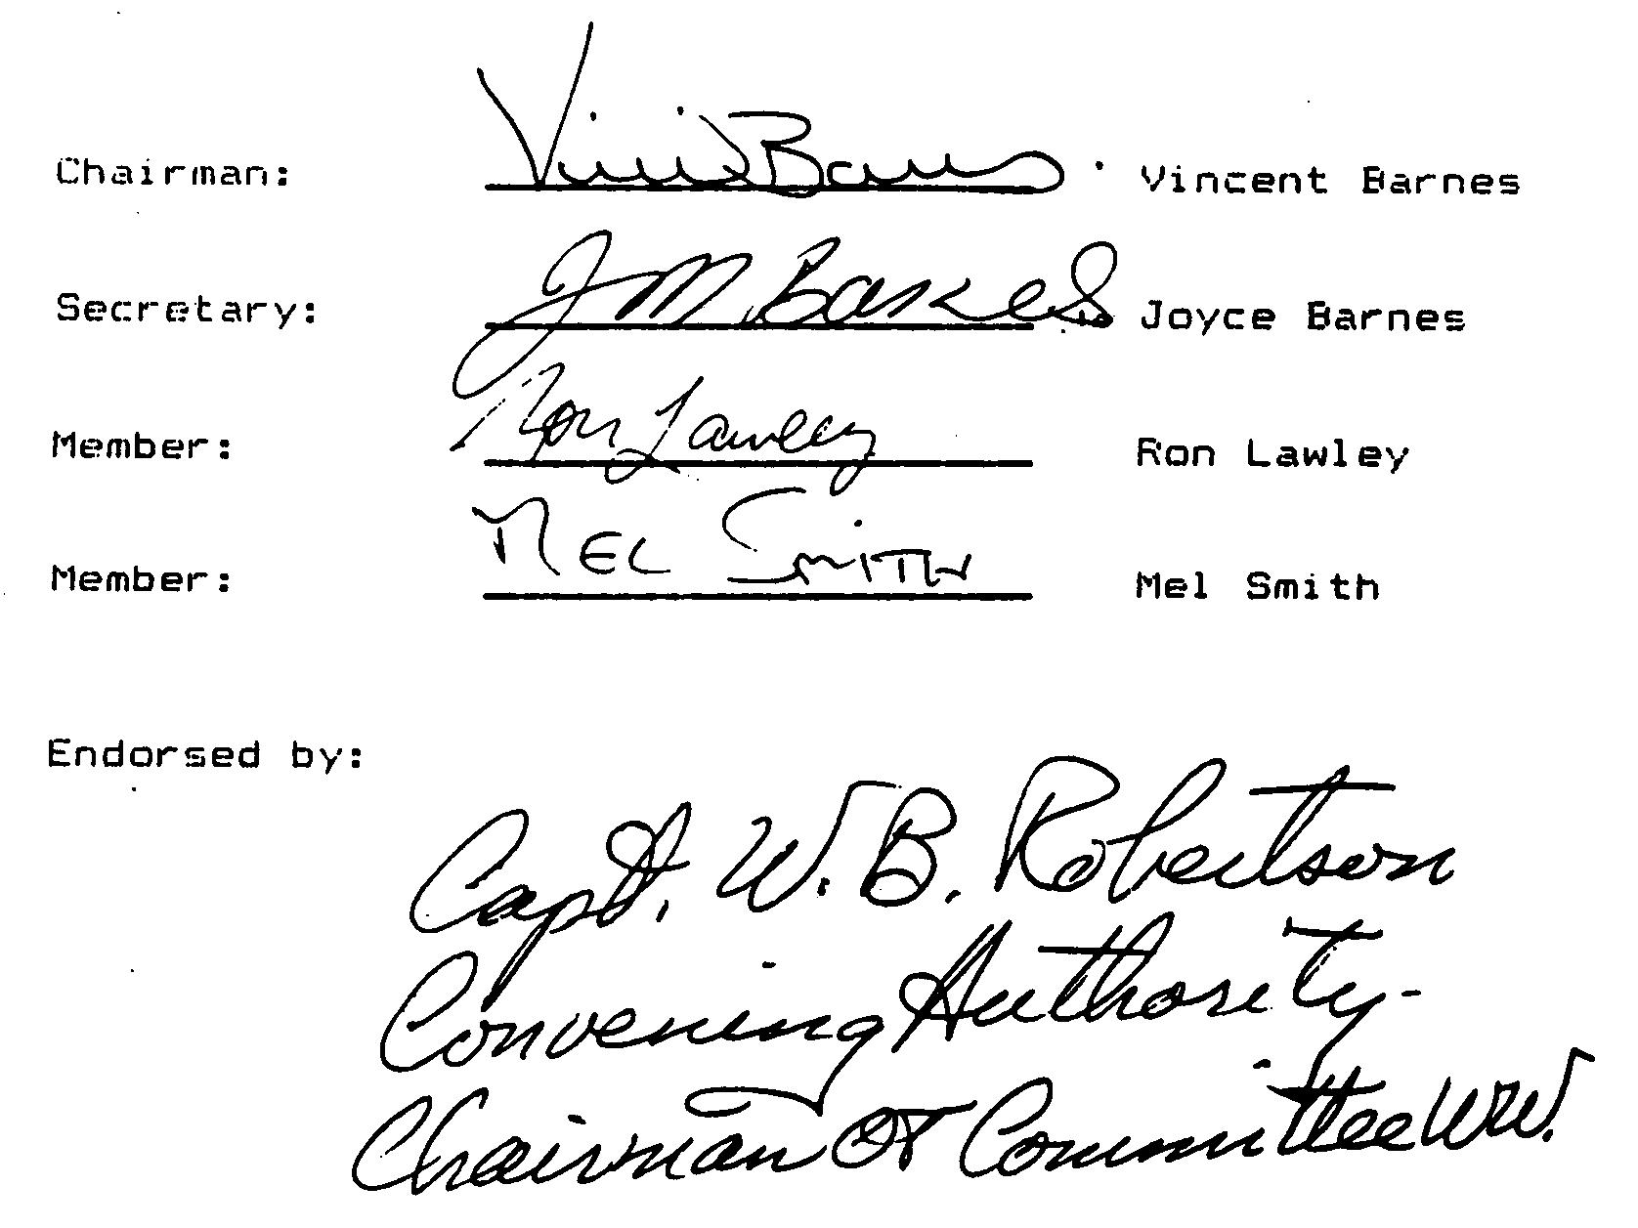

Chairman, Vincent Barnes
Secretary, Joyce Barnes
Member: Ron Lowley

Member: Mel Smith

Endorsed by:
Capt. W. B. Robertson
Convening Authority,
Chairman OT Committee WW

